

Draft

Communities and People

Involvement + Engagement Framework 2022-23

V2 – draft

May 2022 – in draft form for feedback as the ICB develops

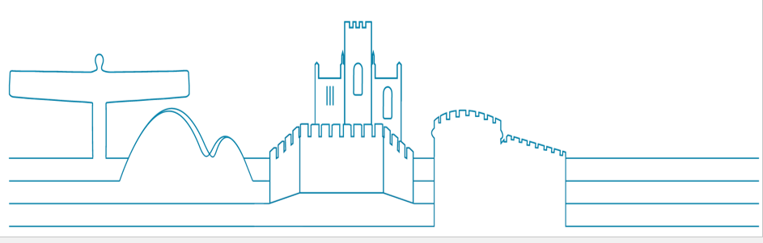

|  |  |  |  |  |
| --- | --- | --- | --- | --- |
| **Version control** | **Date** | **Author** | **Status** | **Comments** |
| V1 | 16.11.21 | SEWG | Mapping | Initial draft |
| V1.1 | 19.11.21 | SEWG (JC/LA/DB/JG/RH) |  | drafting |
| V1.2 | 22.11.21 | SEWG |  | Add sections |
| V1.3 | 26.11.21 | SEWG |  | Review |
| V1.4 | 30.11.21 | SEWG | Planning  Plannin | Review |
| V 1.5 | 03.12.21 | SEWG | Structuring | NHSE template |
| V1.8 | 14.12.21 | Following update by Jen C + then SEWG | Content | Review+format |
| V1.9 | 15.12.21 | Planning of next steps – principles and engagement with partners |  |  |
| V1.0.0 | 19.04.22 | Reviewing with feedback and restructuring and writing |  |  |
| V1.1.1 | 02.05.22 | Updated with definition information and local case studies | Draft 1.1.1 |  |
| V 1.1.2 – 1.1.5 | 09.05.22 | Group tidied | Draft for review |  |
| V.2 | 26.05.22 | Updated following feedback from Exec Director and NHS England | Draft for publication |  |

**Timeline and work so far…**

* Developed principles - December 2021
* Shared initial thinking with leadership – December 2021
* Identified draft principles and shared for feedback (via contacts and ICS website) – January and February 2022
* Developed powerpoint and shared with groups for input and thoughts – March and April 2022
* Check and challenge and development – internal / community / NHSE national team – February / March 2022
* Drafting framework based on feedback – April 2022
* Publishing first draft for further input and improvement – May 2022

This framework has been drafted by involvement leads across the region and reflects the ambition we have for involvement and engagement across our ICS. It is a first draft and should be read as a starting point to be further shaped by our partners and communities and we are grateful to all those who have provided feedback and challenge.

In line with the national guidelines and the very tight timetables this is to start the conversation and will be subject to change and improvement. There is work underway with our Healthwatch partners and the Voluntary Community Social Enterprise (VCSE) Partnership who play a key role in involvement and engagement. We are keen to involve our wider third sector colleagues; existing community and patient groups and forums; non-executive directors (NEDs), foundation trust (FT) governors and lay members; local authority partners and elected members. We will also seek to involve our staff, patients, carers and the wider communities we represent.

We have shared our guiding principles for comment and feedback which was subject to independent analysis and informed a more rounded approach which was shared with stakeholders, partners, and community and patient groups. This feedback helped shape the strategy which is still in draft form for further improvement.

We have encouraged people to get involved through their current clinical commissioning group engagement leads as the organisation develops.

It will align with other strategies as they are confirmed…. We expect this to include (but not be limited to):

* Tackling health inequalities and equity
* Working with partners such as Healthwatch / VCSE
* Working with volunteers
* Working with carers
* Communications
* Sub-regional ICP
* Provider Collaborative
* Other underlying bespoke pieces of work and action plans via ‘plan on a page’

**Work to develop this framework – action plan:**

|  |  |  |  |
| --- | --- | --- | --- |
| **TASK** | **Lead** | **By When** | **Progress** |
| Share principles with groups and collect feedback and refine / improve | ALL | Jan to Feb | **y** |
| Finalise Strategy – draft publication | ALL | April | **y** |
| Develop action plan for Citizens’ Panel scoping | ALL | Submission by Jan 7 | **y** |
| Scoping activity for Citizens’Panel | ALL | May | **y** |
| Scoping activity for NENC Insight Bank | ALL | Sept | **underway** |
| Develop mechanism for sharing feedback up and down system | ALL | April | **underway** |

**Contents**

Our Involvement Strategy Summary 5

Our ambition for North East and North Cumbria Integrated Care System (NENC ICS) 6

1. Context – who we are and how we work 7

2. Our principles as we develop 10

Developing consistency 11

What do we mean when we say involvement and engagement 12

What happens if the legislation is not followed? 14

Involvement and consultation 14

3. Priorities for 2022/23 15

4. People and communities in ICB governance and workstreams 16

Equality, diversity and inclusion 17

5. Roles, responsibilities and resources 18

Lived experience 18

Community voices 19

Use of community intelligence 19

Key relationships - (The groups identified may want to further develop the descriptions and we welcome that input) 20

Healthwatch 20

VCSE 21

Governors at foundation trusts 21

Elected members 21

Health and care staff 21

Public health teams 22

Patients 22

How will the Integrated Care Board support this work 22

6. Monitoring and evaluating the strategy 23

Appendix 1 25

Appendix 2 28

# Our Involvement Strategy Summary

The North East and North Cumbria Integrated Care System (NENC ICS) is the largest in England and is responsible for the health services of more than three million people across urban and rural areas. We are one of the youngest ICS areas and we know that relationships are developing. Involvement and engagement already happens across the region in many different ways.

Involving and engaging partners, stakeholders and the public in planning, design and delivery of our services is essential if we are to get this right. Wherever, and whenever, possible we will include meaningful involvement as part of our work. We want people to help us design, develop and improve services by sharing their views and experiences. The people we listen to and involve need to reflect the communities we serve.

This framework outlines our ambition to develop a consistent standard across the region for our Integrated Care Board (ICB):

* Building on what we do well and valuing local relationships
* Going to where people are – and knowing we have to try harder to reach some people we don’t hear from well enough
* Supporting people to be meaningfully involved
* Being open about the challenges and opportunities we face – being transparent with the people who run and use our services
* Ensuring the recent, relevant lived experience of people using our services (and their families and carers) can help to inform service change and improvement
* When people give up their time to share their input we should provide timely feedback about the impact it has had – you said, we did (or weren’t able to do because…)
* Use a range of engagement approaches
* Ensure involvement is part of all business case development and implementation
* Take opportunities to innovate – including exploring the creation of a NENC Citizens’ Panel
* Make information and opportunities to engage accessible to everyone in our community

We will only be able to do this effectively by working with our partners across the NHS and our local authorities, our diverse third sector and Healthwatch. We will regularly monitor and reflect on our activity to ensure we are reaching our audiences effectively and provide equal and appropriate opportunities for involvement and feedback.

On a project basis we will consider the following five key questions to engagement activity success:

* + - * 1. Did we identify clear objectives that support wider project, programme or organisational goals?
        2. Did we identify the right people and stakeholders (and any potential gaps)?
        3. Did we identify the right messages and methods for the participants?
        4. Did we identify a realistic set of outputs and activities?
        5. What did we learn and have we fed back to those involved

# Our ambition for North East and North Cumbria Integrated Care System (NENC ICS)

Listening and involving the communities that we serve through open conversations, to truly make a difference together with the aim of reducing inequalities, will be at the heart of our integrated care system.

We value trusted, transparent and ongoing relationships with the communities we serve at all levels of our Integrated Care Board (ICB) - neighbourhood, place and ICB - to improve and shape our services for better outcomes for all.

We will make it easier for all people to get involved, remove barriers from preventing people to get involved and meet people where they are.

We aspire to better demonstrate how this feedback and involvement has influenced the way services are planned and delivered.

While our engagement and involvement will be targeted to meet local (neighbourhood) needs, we will be consistent in how we share and report the feedback through the NHS system both at place and at ICB level, with an ambition to build, enhance, learn and improve - not reinvent.

We have heard from our communities and partners they want to the opportunity for meaningful involvement in service improvement and change. We will build the need to evidence the involvement of people in any service change.

# Context – who we are and how we work

The North East and North Cumbria Integrated Care System (NENC ICS) is the largest in England and is responsible for the health services of more than three million people across 5,313 square miles. It is one of the most geographically diverse areas from the Lake District in the west, to large urban areas in the north east and our many more rural areas.



*North East and North Cumbria Integrated Care System (NENC ICS)*

We have a strong and proud history of working together across health and care in our region. The quality of some of our health and care services is consistently rated among the best in the NHS and we have an abundance of great care delivered by highly committed teams of health and care staff. Despite this, overall health and health outcomes is still amongst the worst in the country. Our ambition is to change this by working together.

We are one of the youngest ICS areas and we know that relationships are developing. Involvement and engagement already happens across the region in many different ways. This framework outlines our ambition to develop a consistent standard across the region, while valuing local relationships and approaches.

Overall public health outcomes in our area is still among the worst in the country. Although there have been many improvements in recent years, for example the number of people dying from cancer or heart disease has decreased, fewer people are smoking and many are living longer; healthy life expectancy remains amongst the poorest in England.

*"We want to change this by working together as an Integrated Care System whereby every partner organisation is fully committed to and focused on creating a common purpose and joint determination to drive improvements in health, wealth and wellbeing." Professor Sir Liam Donaldson, chair designate of the North East and North Cumbria ICS*

We have high levels of unemployment, low levels of decent housing, and significant areas of deprivation. These contribute to some of the starkest health inequalities, early death rates and highest sickness levels in England, driving much of the pressure that health and social care struggle to manage. You can find out more about our ICS, population, demographics and challenges at: [www.northeastandnorthcumbriaics.nhs.uk](http://www.northeastandnorthcumbriaics.nhs.uk) More information on health inequalities can be found at: [www.thenhsa.co.uk/work-with-us/health-inequalities/](http://www.thenhsa.co.uk/work-with-us/health-inequalities/)

Recognising the significant health inequalities in our area, we will use an inclusive approach to working with our communities, and the groups within them, to hear and involve lived experiences as we focus on closing the gap.

We have worked to three draft key strategic principles of:

* valuing involvement
* developing consistency
* embracing innovation and improvement.

We sought feedback in January and February 2022 and commissioned some independent analysis of the views shared. You can read the analysis here: <https://www.northeastandnorthcumbriaics.nhs.uk/media/cptjpsi1/ics-north-east-north-cumbria-engagement-principles-findings-report-march-22.pdf>

In summary, the feedback suggests we are broadly following the right principles and suggests other guiding aims we should be considering, such as the equality standards, and urges us to be more ambitious in our approach.

Many respondents held positive views about the principles with over half perceiving that this seemed like the right approach. Feedback included comments around the need for greater detail and expansion of the principles, what this means for staff, stakeholders, patients and members of the public.

Some respondents referenced a need to be more inspirational and challenging, and some reflected on a lack of acknowledgement of partnership working at community level. Respondents were very keen to continue to influence and shape the strategy.

There was also strong feedback that we value our established local partnerships. While we explore ways to work on an Integrated Care System footprint, we should continue to acknowledge the importance of local relationships, bearing in mind most people’s experience of health and care is at a local level.

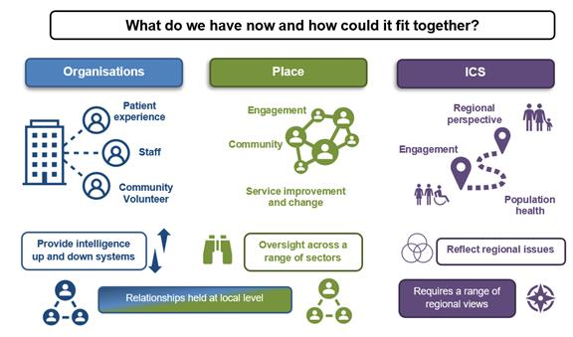

# Our principles as we develop

The purpose of this document is to describe a strategic North East and North Cumbria level approach to involvement and engagement.

This will constantly evolve as we learn more, working with partners and involving more people.

We want to make sure we can develop meaningful conversations with people (including colleagues), on the right issues at the right time.

Working alongside community organisations and communities, our approach will bring together health and social care organisations, including the voluntary community social enterprise sector (VCSE) and other care providers across the area to give people the best start in life with support to stay healthy and live longer.

Involving and engaging partners, stakeholders and the public in planning, design and delivery of our services is essential if we are to get this right. Wherever, and whenever, possible we will include meaningful involvement as part of our work. We want people to help us design, develop and improve services by sharing their views and experiences. The people we listen to and involve need to reflect the communities we serve. We know that many people are often not heard in our system and to ensure we meet the needs of all people, we will work creatively and accessibly to reach those whose voices, views and opinions are too often ignored or not sought.

This framework describes our ambition to embed involvement and engagement to ensure that we are putting all communities of the North East and North Cumbria ICS at the heart of everything we do.

Involving those that use and deliver our services will help ensure a focus on quality, safety and patient experience. Listening to patients and understanding their experience will support the improvement of outcomes.

The guidance also sets out 10 principles for how ICBs can develop their approaches to working with people and communities, and in doing so sets out how this collective knowledge and enthusiasm can help to tackle the health and care challenges faced by the population they serve, whether activity takes place within neighbourhoods, in places or across whole system geographies.

1. Put the voices of people and communities at the centre of decision-making and governance, at every level of the ICS.
2. Start engagement early when developing plans and feed back to people and communities how their engagement has influenced activities and decisions.
3. Understand your community’s needs, experience and aspirations for health and care, using engagement to find out if change is having the desired effect.
4. Build relationships with excluded groups, especially those affected by inequalities.
5. Work with Healthwatch and the voluntary, community and social enterprise (VCSE) sector as key partners.
6. Provide clear and accessible public information about vision, plans and progress, to build understanding and trust.
7. Use community development approaches that empower people and communities, making connections to social action.
8. Use co-production, insight and engagement to achieve accountable health and care services.
9. Co-produce and redesign services and tackle system priorities in partnership with people and communities.
10. Learn from what works and build on the assets of all ICS partners – networks, relationships, activity in local places.

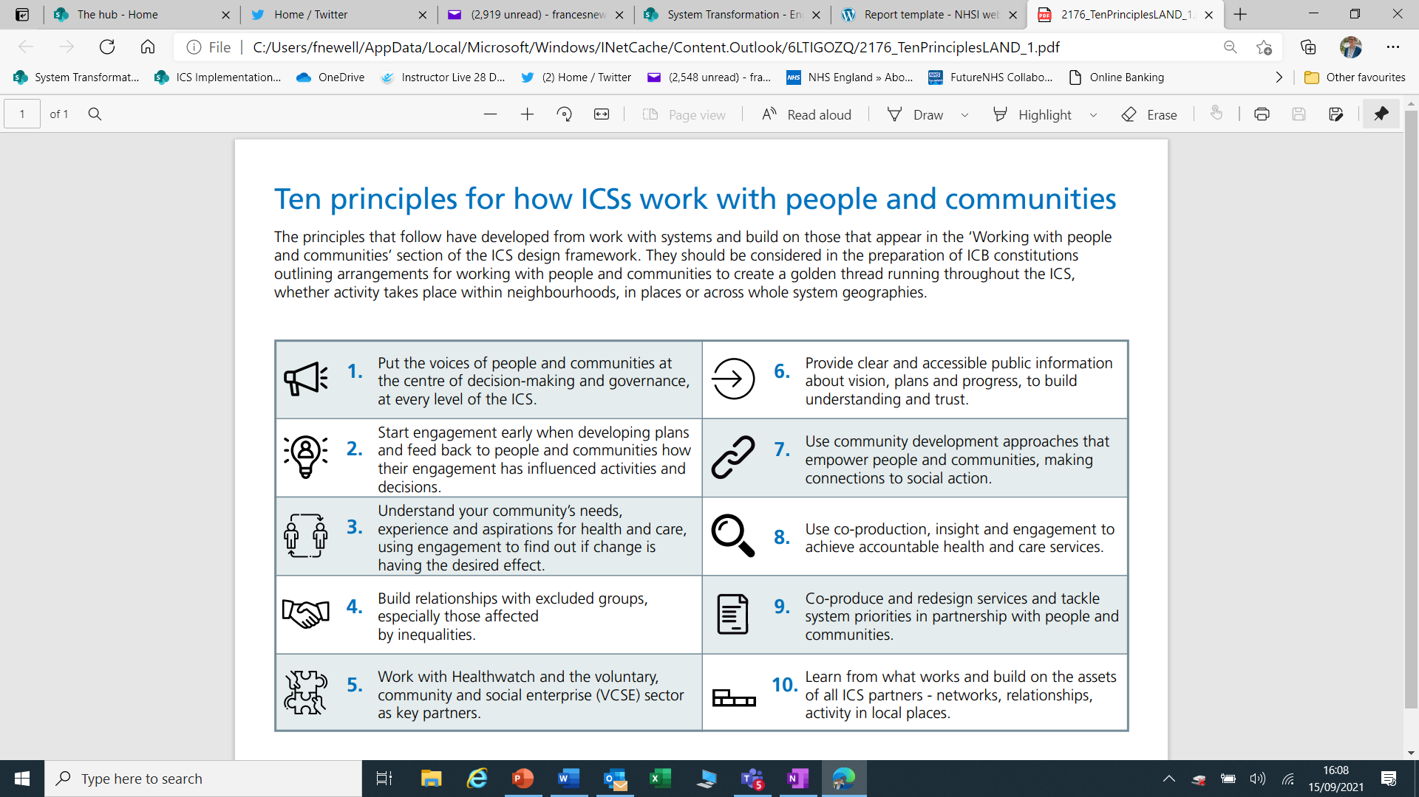

## Developing consistency

While there is excellent work across the region at a local level, we must establish a mechanism to ensure the ICB can both:

* hear the voice of our communities when setting priorities and making decisions
* ensure our communities know about the issues facing the NHS and partners.

We will continue to listen to the voice, views, ideas and lived experiences of our communities at a local level by developing a culture of continual involvement and engagement embedded in our commissioning and service improvement processes.

We have heard that NHS organisations should do more to be accessible and inclusive in our approaches and we will work harder to make it easier for people to be involved.

We have heard this should mean:

1. Spend time nurturing relationships with people at a local level – including groups and forums.
2. Build understanding and commitment from leaders to embed a culture of involvement as a key priority at every level.
3. Work across the whole of the health and social care sector, including voluntary, community, third sector groups, local authorities and Healthwatch.
4. Establish a formal mechanism for sharing that feedback and intelligence between placed-based partnerships and the ICB. This should be embedded in our governance and reporting structures to provide assurance.
5. Improve feedback to patients and the public – closing the loop to show ‘you said, we heard and we did’.
6. Creatively highlight the impact of lived experience.
7. We will ensure more diverse views are shared into the ICB decision making and assurance.
8. Explore the development of an inclusive, accessible, regional Citizen’s Panel/Assembly.

## What do we mean when we say involvement and engagement

Involvement is a statutory responsibility for the NHS and continuous community engagement is a best practice approach already seen across our ICS.

* Should be accessible and inclusive carried out at organisational and community level – through patient experience and organisational engagement with stakeholders and the community, to support and inform and drive improvement as well as identifying concerns and issues early.
* Should be carried out where people live – place / neighbourhood - with stakeholders and the community to ensure a broader picture of how services are working, promote collaboration and co-production and service improvement.
* Should happen at sub-regional Integrated Care Partnership (ICP) and ICS level to ensure and support community voice in the shaping of priorities and service development, and ensure that the themes, concerns and ideas discussed at a local level are visible at decision-making level.
* ICS involvement and engagement should complement, the existing work around patient experience, community involvement and co-production.

# 

**What do we mean when we say…?**

**ICS** – the Integrated Care System – this is all of us working together to improve health and care services and outcomes.

**ICB** - the Integrated Care Board – the board for our statutory NHS commissioning organisation within our wider partnership.

**ICP** - the Integrated Care Partnership – where the wider NHS sits with local authorities and other partners to set priorities and work through challenges.

**Sub-regional ICP** – we have four areas in our ICS – North Cumbria, North, Central and South (Tees Valley) which bring together larger areas where local authorities and health services can collaborate effectively – please see table below.

**Place** – this is a larger community area within our ICS in line with local authority boundaries. There are 13 areas of ‘place’.

**Neighbourhood** – this is where we live and may mean a very local area that could be defined by local government boundaries (ie, a ward) or in NHS terms (around a GP practice or primary care network (PCN) or a more natural community area (ie, a village or estate).

|  |  |  |
| --- | --- | --- |
|  | Sub Region | Place (Local Authority) |
| North East and North Cumbria ICB | Central | County Durham |
| South Tyneside |
| Sunderland |
| North | Northumberland |
| North Tyneside |
| Newcastle |
| Gateshead |
| North Cumbria | Currently: Cumbria – Allerdale, Carlisle, Copeland, Eden District. |
| South / Tees Valley | Darlington |
| Hartlepool |
| Middlesbrough |
| Stockton |
| Redcar and Cleveland |

**What do we mean when we talk about involvement…? \*\***

** More information can be found in **appendix 1** - Language and standards around engagement and involvement.

**Short definitions of what we mean when we say:**

**Communication –** providing and sharing information and updates on various issues.

**Engagement –** is a two-way process and gives people an opportunity to contribute to decision-making and service delivery, and can be done in many ways.

**Involvement –** ensures people can be more involved in service improvement and change, given more information and access to NHS process where their contribution and input is valued. Public involvement in commissioning is about enabling people to voice their views, needs and wishes, and to contribute to plans, proposals and decisions about services.

**Co-production –** there are many definitions of co-production, but we mean involving people early, sharing our problems, challenges and working together to help develop the solutions together. In north Cumbria the NHS, Healthwatch and the community developed the Working Together Toolkit

<https://northcumbriaccg.nhs.uk/get-involved/co-production-working-together-tool-kit>

We have learned the importance of early involvement, clarity about the scope and the benefit of alternative views and energy in finding innovative solutions.

**Lived experience –** is where someone who has recent experience of a service is able to (and is supported to) share that experience with the intention of making changes and improvements.

**Consultation –** is a formal process used in service change and has some statutory and legal requirements (explored further in this document). In the NHS the word ‘consultation’ has formal connotations and this isn’t the same for local government colleagues.

[The Consultation Institute d](https://www.consultationinstitute.org/)efines consultation as: “The dynamic process of dialogue between individuals or groups, based upon a genuine exchange of views, with the clear objective of influencing decisions, policies or programmes of action.”

## What happens if the legislation is not followed?

Anyone can take a decision ‘to change the way a service is provided or delivered’ to judicial review if they think that the process for formal consultation has not been followed.

The Gunning principles for consultation are:

* Consultation must take place when the proposal is still at a formative stage
* Sufficient reasons must be put forward for the proposal to allow for intelligent consideration and response
* Adequate time must be given for consideration and response
* The product of consultation must be conscientiously considered.

The Gunning principles only apply formally to consultation, though they are good principles to apply to any involvement situation. **It is important to note:** It is the process that is undertaken that determines whether a consultation has been robust (or not) and followed the legal obligations, not the decision of the outcome from the consultation.

## Involvement and consultation

No decision will be made about **substantial** changes to health and care services that people receive without talking and listening to people receiving those service or who may do in the future, about it first. It is important that people have their say to shape and improve local services.

The ICB will engage or consult, as appropriate, with its population on its system plan and will have regard to NHS Guidance on consultation and engagement and the ICB's Engagement and Involvement Strategy. This will be led at the most appropriate level (where relationships are held) with the ICB overseeing / seeking assurance. This will include the involvement of each relevant Health and Wellbeing Board and Overview and Scrutiny Committees as appropriate.

# Priorities for 2022/23

Our priorities include:

**Improving our services**

* Recovery of services from the impact of Covid-19.
* Improving services – including mental and physical health services.
* Developing an ICS-wide co-produced approach to improving the support for those using Personal Health Budgets (PHB) in their Continuing Health Care (CHC).

**Improving our community’s health and life chances**

* Reduce tobacco addiction and ensure a smoke-free NHS across the region by 2030.
* Reduce alcohol related harm.

**Reducing Health Inequalities**

* Support people in developing a sense of control and resilience in relation to their health and wellbeing.
* Better involvement of inclusion health groups to ensure their views are understood.

By listening to and acting on the views and ideas of our local populations at a place-based level, effective engagement will help to ensure the ICB develops robust, effective and meaningful plans based on the priorities identified and delivered with our communities.

One of the ICB’s priorities is around reducing health inequalities and there is much learning from the NENC Covid Vaccine rollout and how we worked with communities, volunteers, community groups and other VCSE groups in reaching out to those that the NHS doesn’t easily engage with.

# People and communities in ICB governance and workstreams

We have strong engagement at a local level and support workstreams in an ad hoc way. We want to systematise this approach to ensure a consistent involvement of the voice of people and communities.

The Commissioning Cycle involves people from the earliest stage and we have heard people want this approach to drive commissioning approaches.

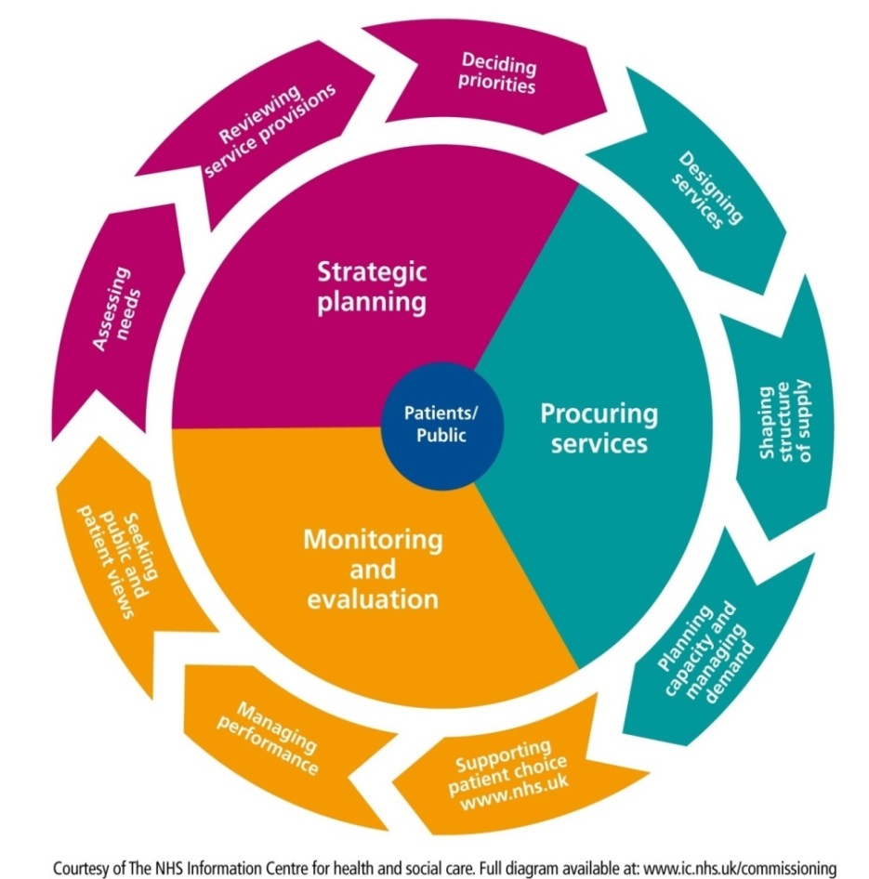

We have an ambition to ensure a productive relationship between the ICB and our communities.

* We have heard clearly that people want to be involved in improving and shaping services and want to know how their feedback and input has made a difference. We will prioritise effective feedback to those who have been involved.
* We will support conversations to help our community understand the challenges facing the NHS – and there are many including workforce, regulation, finances, Royal College frameworks and much more. By understanding our collective challenges, we may find better collaborative solutions.
* We will make the most of the information we hold collectively and evaluate it in line with best practice approaches.

As relationships are held at a local level, and we have heard clearly how important that connectivity is to the community, we anticipate that ‘Places’ will report bi-monthly on:

* Engagement activity
* You said, We heard, We have done (or not done) and what has been the impact
* What have we learned (what is working in our engagement activity AND what intelligence have we picked up)
* Hot spots – what are the issues.

This should lead into a collated report at sub-regional ICP level quarterly – this could include updates from our potential Citizens’ Panel. And then to a quarterly report to the ICB **for discussion and feedback** – NOT to be simply received.

We believe that **all** business cases brought to the ICB for support and approval should be able to demonstrate and provide assurance of meaningful involvement in several ways:

* Patients and service-users
* Staff working in the service
* Partners that work with the service (ie, primary care, acute, mental health, community, adult social care and third sector).
* Consideration of inequity and health inequalities.

This should by evidenced by:

* An involvement and engagement report in the business case.
* Include a commitment to ongoing involvement as the service develops and an ‘implementation plan’ which shows how this will continue.

We are exploring how to develop - and the potential impact of - a region wide:

* Insight bank
* Citizens’ Panel
* Potential for exploring perception insight research
* How to further develop the use of lived experience
* How to further develop behavioural influence impact.

## Equality, diversity and inclusion

As individual organisations we are passionate about championing a culture of equality, diversity and inclusion where people are able to be themselves in the workplace and in our services. Working collaboratively as a system will maximize opportunities and have a greater impact in tackling health inequalities.

We are committed to making high quality healthcare available to all the communities we serve. We are dedicated to delivering a quality service to all people irrespective of race; sexual orientation; age; disability; religion or belief; gender; gender reassignment; marriage or civil partnership; pregnancy and maternity status.

It is important to us that we listen, respond, and make every effort to involve individuals from all protected characteristic groups; for example, younger people, older people and lesbian, gay, bisexual, transgender queer, questioning and other (LGBTQ+) groups. It is also important that we listen to other inclusion health groups (acknowledging some groups may be seldom-heard), such as condition specific, homeless people, refugees and asylum seekers or people living in deprivation; to make sure we reach a diverse range of people to give them the opportunity to share their views. We know the NHS should go further, and try harder, to reach some groups that our standard methods may not. We acknowledge there may be issues that affect these communities across our ICS and the need for the NHS to have a local understanding of these issues.

We will use our equality impact assessment (EIA) process to help us understand which groups may need to be specifically targeted within programmes of work. We will also be informed by public health and their needs assessments and other evidence on health inequalities.

Equality impact assessments inform and are informed by involvement, they help us understand who uses a service and what views we have already heard, and which voices may be missing and how to reach those groups. Once completed, involvement informs the EIA on the views of different groups and the ways they may experience differential impacts and what can be done to mitigate or address these.

We work on a local level and tailor our messages and methods according to each individual group, to ensure we maximise opportunities for connecting with them by listening to, informing and engaging with our target audiences at a community level.

Examples include: inclusive meetings, providing good quality accessible information that meets the needs of all people, co-producing information or surveys with people with lived experience - such as those with learning disabilities - as well as providing information in other languages when helpful.

We make our involvement accessible to those we engage with to meet their needs and hear their views. Examples are inclusive meetings where we have hearing loops, BSL and language interpretation where helpful, as well as subtitles on videos and captions on Teams. We are also aware of our digital responsibilities and the government’s Web Content Accessibility Guidelines (WCAG).

We know we need to know our communities and reach out to more than those defined by protected characteristics.

# Roles, responsibilities and resources

How we want to see this develop.

## Lived experience

We want to ensure that the recent, relevant lived experience of people using our services (and their families and carers) can help to inform service change and improvement.

We want to ensure that lived experience is valued by all involved in commissioning and providing services.

We acknowledge that we must consider the impact of retelling their stories – which may have been difficult or caused trauma - for different audiences, and any additional trauma this might cause.

We also understand the importance of ensuring those that give their time to share their lived experience get regular feedback on the improvements they have helped support.

While input can be collected in a number of ways, value must be given to individual experiences.

## Community voices

We recognise the importance of organisations and community groups representing a range of voices across our local communities to support service improvement, understand the challenges faced accessing those services and ensure an open and trusting relationship.

* Our staff and the groups representing them from federations, trades unions and others.
* Our Healthwatch partners.
* Our diverse voluntary, community, social enterprise and faith (VCSE) groups.
* Condition specific groups i.e., Parkinson’s.
* Governors and members of our foundation trusts (including non-executive directors).
* Specialist groups including groups supporting unpaid carers, Maternity Voices Partnership groups, the Northern Cancer Alliance and many others.
* Elected members and neighbourhood groups supported by our local authorities.

## Use of community intelligence

As well as listening and seeking out information, views and ideas from our community we will also make good use of information about our services to help identify areas of concern.

This will include:

* Monitoring of social media about our services.
* Perception and insight research carried out independently to understand how people view our services and organisations.
* Using the full range of patient feedback to our organisations, Healthwatch and others to better understand the experiences of our community.

We want to develop a fair, impartial and transparent process to ensure representative patient and / or carer knowledge and experience shapes our priority programme areas of work.

We have also heard clearly that when people give up their time and incur an expense to work with us we must ensure they aren’t out of pocket we must make reasonable adjustment to involve people who may require additional support. We will explore how to develop an effective policy for the ICB and if it can be aligned with partners.

This can mean arranging meetings at a time suitable to all, and in an accessible way, as well as providing ‘out of pocket’ expenses and refreshments. It can also mean going further to ensure involvement of those who may need more support to ensure their voices are also heard.

We will commit to feedback to community members and ensure they remain involved in the process.

To involve people fully we will be mindful of the need to do this in a variety of ways and places to ensure we engage with people where they are, not just invite them to join us. We will also be aware of the challenges and opportunities around digital inclusion.

## Key relationships - (The groups identified may want to further develop the descriptions and we welcome that input)

### **Healthwatch**

There is a local Healthwatch in every area of England which acts as the independent champion for people who use health and care services. Healthwatch find out what people like about services, and what could be improved, and share these views with those with the authority to make change happen.

Healthwatch also help people find the information they need about services in their area, and we help make sure their views shape the support they need. Healthwatch will be an important critical friend to the ICS. Local Healthwatch have the following statutory functions set out in the Health and Care Act 2012:

* Obtain the views of people about their needs and experience of local health and care services. Local Healthwatch make these views known to those involved in the commissioning and scrutiny of care services.
* Produce reports and make recommendations about how those services could or should be improved.
* Promote and support the involvement of people in the monitoring, commissioning and provision of local health and care services.
* Provide information and advice to the public about accessing health and care services and the options available to them.
* Make the views and experiences of people known to Healthwatch England, helping us to carry out our role as national champion.
* Make recommendations to Healthwatch England to advise the CQC to carry out special reviews or investigations into areas of concern.

In the North East and North Cumbria ICS footprint there are 13 local independent Healthwatch commissioned by individual local authorities and serving the thirteen places in the system:

Healthwatch County Durham

Healthwatch Cumbria

Healthwatch Darlington

Healthwatch Gateshead

Healthwatch Hartlepool

Healthwatch Middlesbrough (Healthwatch South Tees)

Healthwatch Newcastle

Healthwatch North Tyneside

Healthwatch Northumberland

Healthwatch Redcar and Cleveland (Healthwatch South Tees)

Healthwatch South Tyneside

Healthwatch Stockton on Tees

Healthwatch Sunderland

The local Healthwatch are working together as part of the North East and North Cumbria (NENC) Healthwatch Network and also collaborating at sub-regional levels to share information and input into the ICS structures.

### **VCSE**

*We recognise the number and diversity of organisations that make up our vibrant third sector. There is great expertise, knowledge and advocacy within this sector. Engaging with the sector, its networks and the specific groups representing and supporting our community on specific issues across our region, will be vital. We recognise for many groups this can mean going above and beyond their core activities and we should limit the impact on their time and resources.*

### **Governors at foundation trusts**

Governors act as a link between patients, the public and the Board of Directors so have an ambassadorial role in representing and promoting their local NHS foundation trust. To do this, governors have to meet and engage with their members and have an important role to play in engagement at a local level. In addition, they provide a variety of skills and networks they link into, but also the feedback and intelligence they bring back to the NHS. Governors are passionate and a key link between the community and NHS trusts, ensuring that NHS organisations are rooted in local communities.

### **Elected members**

We recognise the strength of the local networks represented by councillors and the importance of involving them in conversations early, updated on developments and making the NHS accessible. This includes neighbourhood teams, and the statutory roles and responsibilities of Overview/Health Scrutiny Committees and Health and Wellbeing Boards.

### **Health and care staff**

Our staff are also service-users and have valuable insights into how services work and could be improved:

* Lived experience as providers
* Work with patients to improve the service
* Experience as service users.

### **Public health teams**

Connecting with communities at neighbourhood level on health, care and wellbeing issues.

### **Patients**

We are all patients and understand some patients are less able to share their experiences than others and it is important we listen and involve all those who want to share their experiences to improve services. We have many patient groups and community forums and value their insight and energy.

## How will the Integrated Care Board support this work

The establishment of an involvement team will:

* Drive the diverse ways we will ensure we engage with our community.
* Use the levers within the governance process to ensure the involvement of people in all service change and business case development.
* Support the involvement of people in service improvement and service change from the earliest point.
* Report this into the ICB.
* Report impact back to our communities.

The team will need:

* Resources to involve people.
* Budgets to cover supporting people to get involved, expenses of those people, room hire, the creation of accessible resources, wider engagement such as a ‘pulse-check’ roadshows, independent evaluation, independent insight checking and perception research.
* Training to ensure the teams have the skills to deliver the ambitions of the ICB and build strong relationships as the organisation becomes established.
* Resources to develop and support a Citizens’ Panel.

# 6. Monitoring and evaluating the strategy

Evaluation improves the effectiveness of our engagement work, helps to engage with target audiences better and allocate resources wisely. Situations change quickly and therefore strategies and tactics may need to change as well; ongoing evaluation enables this to happen.

It is vital that we are able to demonstrate that we listen to comments and suggestions from all our stakeholders, including seeking assurance from independent advisors, in order that people feel fully involved and engaged in the development of our plans and any subsequent transformation of services. Where necessary, we will continue to update the strategy to adapt to staff, clinical, patient, and public and community feedback.

We will regularly monitor and reflect on our activity to ensure we are reaching our audiences effectively and provide equal and appropriate opportunities for involvement and feedback. Through monitoring and evaluation, we will be able to learn lessons and gain insight into public and stakeholder behaviour, allowing us to tailor our methods accordingly. This should include monitoring the demographics of the people we communicate and engage with to ensure we reach out to inclusion health groups.

On a project basis we will consider the following five key questions to engagement activity success:

1. Did we identify clear objectives that support wider project, programme or organisational goals?
2. Did we identify the right people and stakeholders (and any potential gaps)?
3. Did we identify the right messages and methods for the participants?
4. Did we identify a realistic set of outputs and activities?
5. What did we learn and have we fed back to those involved?

**What we are doing**

|  |  |  |  |
| --- | --- | --- | --- |
| Phase 1 – Key actions | Timescale | Owner | Completed |
| Share the strategy for further development from our community | May to July | JC / CR |  |
| Create engagement network with local leads and their community networks (connect into communications network for the ICB) | May to September | CR with SEWG |  |
| Citizens’ panel scoping and planning | May to September | Lisa A / Jen C |  |
| Requirement for involvement plan as part of business cases and implementation plans formalised in governance structure | July | CR |  |
| Training programme to highlight the impact and importance of using lived experience – for engagement teams initially, further roll out to project managers (covering how and why as well as support for those sharing their experiences) | July to October | CLIC – developing how to involve lived experience in service change training (Building on existing co-production training)  (Suzanne Hamilton) |  |
| Develop single ICB involvement reimbursement strategy | July to October | ICB approach aligned across CCG areas / partners |  |
|  |  |  |  |

**Summary**

There is a good base to develop a regionwide approach to involving our community and partners in shaping services.

We want to see an ongoing approach to improvement and development and working with our partners to have the biggest impact on our services for our community.

# Appendix 1

**Language and standards**

Our North East and North Cumbria Integrated Care System (NENC ICS) engagement, involvement and communication principles are built on our ICS priority areas supporting what can be best done by working together. For this to be effective, there needs to be mutual accountability and responsibility – this is about place and not about commissioning intent or organisational barriers. We will localise and target engagement, involvement and communications at a place level via local leads and networks making the most of our collective communication and engagement channels.

**Engagement:**

* gives people an opportunity to contribute to decision-making and service delivery
* is a two-way process
* can be done in order to inform, consult, involve, collaborate and empower.
* can take place in a wide variety of forms and through a diverse range of approaches.

**Engagement standards**

We believe that engagement should be timely, inclusive and transparent. These are the standards people can expect when engaging with us:

* + - * 1. **Engage early –** we will ensure that engagement takes place at the earliest possible stage.
        2. **Clear purpose –** we will ensure that there is a clear purpose for the involvement of the public, patients, family members, carers and what we need to engage upon and the conversations they are involved in.
        3. **Full information –** we will provide information that is relevant, known and legally permissible to be shared, in order to support positive and effective engagement.
        4. **A range of opportunities –** we will offer a range of opportunities, in order for you to choose to engage with the conversations in the best way for you. This will ensure that we are able to capture as many views as possible and you are able to express your views.
        5. **Time and support –** we will provide sufficient notice on the items we wish to engage upon and will offer support, where needed, to help you engage meaningfully.
        6. **Feedback –** feedback will be proportionate to the type of engagement activity. We will let you know at the time of engagement, what feedback you can expect.

We are committed to meaningful conversations with patients, carers, public, staff and stakeholders and we have various ways in which we make sure that there is continuous involvement in all our work.

We use a range of engagement methodologies across the ICS:

* Patient groups
* Patient / public feedback
* Community forums
* Issue specific groups
* Collaboration with community partners
* As well as many others.

**Staff engagement**

Through effective staff engagement the ICS seeks to support cultural change so that colleagues across our partnership feel involved and part of something new. The ICS will engage with and provide support to staff who are directly impacted, through an effective partnership arrangement with extensive involvement from all partner organisations. This will provide opportunities for organisations and individuals to contribute and will include working with local trade union representatives.

**Insight**

It is essential that we audit previous recent engagement and involvement activities for learning to avoid duplication and involvement fatigue across North East and North Cumbria. We ensure that all involvement plans have a baseline of patient experience and involvement insight to support their work.

Where practical, local opportunities will also seek to harness the insights and experiences individuals have of our services, often through partnerships with VCSE organisations. Correlation of insight, such as that held by 'Quality' teams, across our organisations will also enable increased the effective use of information that is already known.

The insight we collect will ensure we meet legal requirements and:

* consider the views of patients, carers and the public as part of service redesign
* be representative of the communities we serve, where necessary taking additional steps to work with groups whose voice has not been heard
* ensure the feedback is considered in the development of any future options to change the way a current service is provided or delivered
* highlight patient and public priorities and ensure these are in line with current ICS priorities or are informed by feedback and insight received from patients, carers, public, staff and stakeholders.

Intelligence and engagement [r](https://www.wyhpartnership.co.uk/engagement-and-consultation)eports are developed which present the findings of all relevant engagement, involvement, consultation work, feedback and intelligence which has taken place or is underway across North East and North Cumbria to avoid duplication, highlight any gaps and to understand some of the emerging themes gathered from local people (including demographic information to detail reach and any gaps). Generic reports are produced annually with the addition of other specific reports as necessary.

**Feedback**

It is important to us that we feed back to patients, carers, public, staff, stakeholders, and our partners about their involvement. We will do this in several different ways, including:

* Stakeholder updates
* Involvement reports
* Liaise with patient carer and public Involvement networks – ongoing conversations
* Share public reports via the ICS website and any online communities.

In order to capture insight and feedback we will:

* develop clear engagement, involvement and communication plans
* use a variety of engagement methods, as appropriate
* produce reports of findings.

Other things to consider:

* Engagement timescales and planning
* Communications with Overview and Scrutiny Committees (OSCs) and/or Joint Overview and Scrutiny Committees (JOSC)
* Complying with NHS England transformation processes
* Governance and assurance processes
* Involvement with and understanding the role of local and national Healthwatch
* Stakeholder mapping to ensure appropriate involvement and communications with all stakeholders.

**Website**

We are committed to working in an open and transparent way and want to make sure that people can learn about all the work of the ICS. We keep our website up to date and publish current and previous engagement activity.

**Digital (online tools)**

We will use social media and other digital platforms to provide opportunities for genuine, open, honest, and transparent involvement with all stakeholders, giving them a chance to participate and influence the work we do.

It is recognised that digital exclusion is very real and affects many of our most disadvantaged communities so we will ensure that this is not the only route to involvement and arrangements are made to reach groups and communities.

# Appendix 2

**What are we doing already?**

**LIVED EXPERIENCE**

**Gateshead Long Term Conditions (LTC) Group**

This dynamic patient-led group is chaired by patient champion, David Hewitson. Members of the group have extensive experience of managing a wide range of conditions including asthma, diabetes, heart conditions, thyroid conditions, scleroderma, the after-effects of stroke, angina, high blood pressure, high cholesterol, ileostomy, COPD, Hashimoto's thyroiditis, Sjogren’s syndrome, lupus, osteoarthritis and cervical spondylosis.

Throughout 2021/22, the group held a number of informative online events that allow patients to discuss their own experiences and shared learning. The meetings are also of huge potential value to clinicians, who get honest feedback about how patients with LTC experience care provision in Gateshead.

In November 2021, the group undertook their own research of member experience, conducting a patient survey across members registered with seven GP practices in Gateshead. Their research found that there was significant support for the "Year of Care" model, which is designed to help people with LTCs work in partnership with clinicians to improve the quality of their care. The group believes that - done well- it can deliver improved clinical outcomes and improved self-care behaviour. For clinicians, it can also improve relationships with patients, deliver greater job satisfaction and improve productivity.

Following on from their survey, the group presented nine practical recommendations to clinical leaders across Gateshead, to help influence future improvements in delivering the Year of Care model across all GP practices.

The group has also made a number of talking-head videos, outlining their own experiences of living with a long term condition.

**Review health assessments for ‘children in our care’ procurement – Tees Valley**

Children and young people (and their families) were involved during the procurement of a new provider for Review Health Assessments (RHAs) for children in our care (formerly 'Looked After Children') across the Tees Valley.

Previously there were several contracts with differing service specifications across the Tees Valley, meaning the offer for RHAs was inconsistent. The new provider covers the whole of the Tees Valley, ensuring every child or young person receives the same high-quality service from 1 April 2022.

Children and young people were able to share their lived experience of health assessments while living in care and asked what they wanted from a new service:

* Consistency in the staff members seeing them.
* The need to build a relationship and trust between children and young people and professionals, to feel comfortable to engage in personal questions.
* More regular check-ins.
* Knowing they have support available if they need it.
* Ensuring RHAs are offered in a place/time which is accessible and young person friendly and age appropriate.
* Where appropriate, discussions remaining private.
* Sharing of health reports/health actions plans.
* Encourage and discuss benefits of an RHA when appointments are declined or ignored.
* Follow ups when referrals are made to other services.

All this feedback helped shape the new service specification, including creating a question which they marked when procurement bids were evaluated. This approach has led to the successful procurement of a new provider for RHAs which will improve health outcomes for children in our care.

**SERVICE CHANGE**

[**Shotley Bridge Community Hospital services**](https://countydurhamccg.nhs.uk/get-involved/current-conversations/) **- County Durham**

Triggered by the challenges faced with delivering services from an ageing hospital in County Durham there has been ongoing engagement around [Shotley Bridge Community Hospital services](https://countydurhamccg.nhs.uk/get-involved/current-conversations/) since early 2019.

Since the extensive engagement in 2019, the impact of the pandemic prompted us to revisit the conversation with the public. At the start of 2021, a series of service specific conversations took place. These focused on five key headings of services such as inpatient beds, outpatient services and urgent care and diagnostics.

Due to the persisting social distancing requirements a range of virtual sessions were held, with each session focusing on a particular aspect of the services being proposed for the future Community Hospital building (as well as general issues participants wanted to raise). The use of virtual sessions demonstrated the flexibility these approaches provided for members of the public in being able to attend around other work / personal commitments.

Following the 2021 engagement sessions, all of the participants who provided contact details were invited to join a 'working group'. This working group continued their involvement in discussions alongside commissioners as the designs for the future building were beginning to develop.

Early outline plans for the building were able to be shared and members of the public able to constructively challenge elements of the design. This input was able to directly inform future designs to take on board input from individuals as they considered how they (and friends or family members) would experience using and interacting with the new Community Hospital building.

Alongside this public working group, the project had included a dedicated 'reference group' since it began in 2019. This reference group was made up of councillors in the areas surrounding the existing Community Hospital as well as the chair of the Health and Well-being board to help keep elected members directly involved in the developments with commissioners and service managers.

**CO-PRODUCTION**

Developing a co-production toolkit in Cumbria following public consultation

Healthwatch Cumbria was commissioned to gather the learning from our service change implementation work to develop principles for involvement and practical support to help people develop the skills need to co-produce.

The learning was very honest and highlighted things which worked well and those that had caused barriers and we developed a toolkit with tips and resources to help other projects:

<https://northcumbriaccg.nhs.uk/get-involved/co-production-working-together-tool-kit>

Since it was developed in 2018 we have added to the resources working with other groups which helps people use resources most suited to their needs. Organisations working with young people with autism helped develop the ‘plan on a page’ resources which helps plan and understand the scope and activity for projects. The toolkit is used nationally.

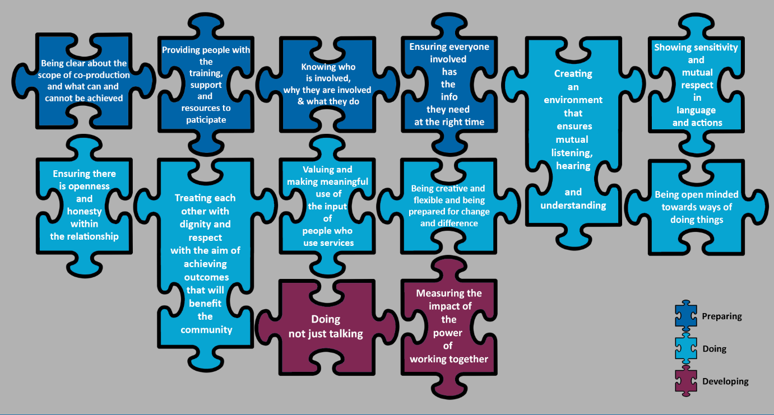

**Ramadan calendars – Newcastle and Gateshead**

Haref is a charity that brings together ethnically minoritised community organisations with broader community and public service providers to help address the numerous, often complex, reasons why ethnically minoritised communities face specific health issues and health inequalities. Each year we work with Haref to develop Ramadan prayer calendars that are distributed through the public through a network of 12 mosques in Newcastle and Gateshead. The calendars include safe fasting health messages. During the Covid-19 pandemic we also shared key 'staying safe' messages through this network.

Haref have also worked with the NHS Diabetes Centre, Glaucoma UK and Diabetes UK to ensure we share the right health information relating to fasting and managing diabetes and glaucoma.

We also work with Haref to distribute Ramadan calendars to GP Practices, health services, statutory services and community organisations. The calendars are popular and well received by the public and local groups, and also offer a great way to build broader relationships on health issues. The 2022 Haref Ramadan prayer calendars are also available online as well as print format. Almost 3,000 printed calendars were distributed through our mosque partners and a further 800 generic calendars via community-facing buildings.

**Northern Cancer Alliance – Public Involvement Accountability Forum (PIAF)**

The PIAF has been established for some time and meets online every eight weeks.

It reviews and scrutinises the Northern Cancer Alliance work plan, ensuring it is fit for purpose and supports the working groups on specific pieces of work. It also provides assurance to the board that the commitment to appropriate and effective public involvement is evidenced in all aspects of its core business.

Forum membership aims to be reflective health inequalities bringing together perspectives from across the region. This includes people with lived experience, Voluntary, Community, Faith-based or Social Enterprise organisations and a range of health professionals from the Northern Cancer Alliance core team and cancer system

The group has supported the co-production of an animation describing the Northern Cancer Alliance and providing an overview of its annual work plan; contributed to the development of the Northern Radiotherapy Network website and patient information films; contributed to the development of a research project to understand public preferences for multi-cancer early detection tests (MCED), as well as providing feedback on patient information publications such as My Guide to Prostate Supported Self-Management.

**INVOLVEMENT**

**Improving Access to GP Services in Northumberland**

During the pandemic there were changes made to the way GP services were accessed. Many of these changes were national requirements, with a purpose to manage increasing demand, such as greater use of telephone consultations, e-consultations, video calls and SMS texting. This engagement from January to March 2022 was designed to evaluate current experience of access to GP practice, including remote consultations, to ensure the views of patients can inform any future service changes in relation to accessing general practice. It also helped understand the current pressures in General Practice and public perception in Northumberland, and nationally, around the difficulty of securing face-to-face appointments with a GP.

NHS Northumberland Clinical Commissioning Group commissioned an independent market research which adopted a number of methods including focus groups and an online survey. The survey sought to understand patients’ views on issues such as which healthcare professional they would prefer to see, how quickly they want to be seen, whether weekend and evening appointments are useful, and how far they are willing to travel or would a telephone or video consultation be preferable.

It also included commissioned support from Healthwatch Northumberland and seven VCS organisations to specifically target inclusion health groups, such as carers, people experiencing language barriers or young people. These organisations either supported people to complete the survey or carried out focus groups to ensure as many people as possible had the opportunity to share their views.

Feedback from the research will be shared with stakeholders and the public in the near future.

**Developing an Adult Mental Health Strategy for Sunderland**

NHS Sunderland Clinical Commissioning Group spoke with over 1,000 people about adult mental health services in Sunderland. This included members of the public, carers, service-users and families of service-users, staff, large businesses, VCSOs, and commissioners. A range of engagement approaches were used to be as inclusive as possible. This included a desk top review, collaborative scoping exercises, key stakeholder interviews, online and paper surveys, interviews, and focus groups, and asset-based focus groups through VCSOs. To make the engagement accessible, easy-read versions of the survey were developed, and paper surveys were distributed to assisted living accommodations, care homes, food banks, refugee and asylum seeker support organisations, other VCSOs, and also to NHS bases. The final executive summary was also produced in sign-language.

The draft result report was shared, and people were asked if we got it right. We tested the research findings through focus groups with protected characteristic groups identified through the research. This included conversations with males, physical disabilities, autism and learning disabilities, LGBT, BAME, and the Deaf and hard of hearing community. From this a draft of visions and priorities for the strategy were shared, and we held further focus groups with members of the public to explore and develop these further. This project demonstrates an evolving process of engaging and listening.

**North Tyneside CCG Patient Forum**

North Tyneside CCG Patient Forum was established in 2013. Members represent their GP practice and act as a critical friend to the CCG. They willingly share their experience and expertise and are involved with service development from the beginning.

They help set the agenda and welcome presentations and field trips. They receive timely information and have always had an open and honest relationship with North Tyneside Clinical Commissioning Group.

Each member is an expert patient and have their community at the heart of every discussion and decision. The group demonstrates good patient engagement, collaboration and co-production.

**South Tyneside GP out-of-hours engagement for service design**

The GP out-of-hours service was coming to an end in March 2023. Between September 2021 and February 2022, a total of 216 individuals participated in the engagement as a key stakeholder, past service user and/or a member of the public, with an additional six members of the public participating in the service specification workshop. The information collected through the public engagement event, and the workshop contributed towards developing a service design for the GP Out of Hour service for South Tyneside CCG for 2023. It involved a range of methods including key stakeholder interviews, a survey and focus groups.

A key part of this research was a workshop with members of the public to help develop the service specification, which took place after the public engagement phase, and procurement engagement phase. The workshop shared some of the feedback from the two engagement activities and discussed potential options for the service. At the end of the discussion session, people were also invited to share any thoughts they had after the event via email or phone. This offer resulted in further engagement with this participant to ensure their thoughts were listed to. This directly shaped the service specification and is a good example of involvement to shape commissioning.

**Copeland Community Stroke Prevention Group**

A group of community activists who want to help reduce the prevalence of stroke in their area developed a programme of outreach testing events. The approach was ‘community led and NHS enabled’ and led to testing in a ‘tent in a field’ at several events:

<https://northcumbriaccg.nhs.uk/get-involved/co-production/building-health-partnerships>

The group works closely with Rotary and Healthwatch and adapted to old school supermarket displays and more modern online engagement during covid and lockdown.

The group has tested more than 200 people with around 10% advised to go to pharmacy and primary care for further monitoring, one person sent directly to A+E and many more reassured. All chatted to volunteers while they waited and were given good health advice and information.

**Partnership – Northumbria - Your NHS Online Community**

Covid-19 restrictions in 2020/21 meant the NHS couldn’t engage face-to-face. Northumberland Clinical Commissioning Group in partnership with Northumbria Healthcare NHS Foundation Trust invested in an online private community platform called 'Your NHS Online Community'.

The Online Community has enabled us to carry on ‘testing the temperature’ in communities and picking up specific feedback to improve our services throughout the pandemic and has gone from strength to strength in 2021/22.

In March 2021, membership stood at 184, and in one year it has grown to over 270 members that we are able to seek views from, test ideas and scenarios and actively involve. The Online Community enhances the way we engage with our local communities by enabling us to digitally communicate and engage in real time. It also helps us build up community insights by gathering questions and concerns about issues.

Topics for discussion on the Online Community have been varied including how to access remote NHS services, young people’s mental health services, Self-Care Week and general public confidence in the local NHS services – with high engagement levels which are consistently above national levels.

Recruitment to the Online Community continues via social media, existing CCG, Trust and VCS communication channels and we are actively targeting diverse communities, in order to achieve a representative demographic profile of the Northumberland population.