**Background Information Regarding St George and Riverside**

**APMS Re – Procurement**

St George and Riverside Medical Practice is an established GP practice with a list size of approximately 7100 patients.

The practice operates via an APMS contract which was awarded to Intrahealth Ltd following a procurement exercise and the contract commenced on 28 February 2015 and delivers essential, additional and enhanced services.

The contract was due to expire on 27th February 2022; however, there was the option within the contract to extend the APMS contract for a maximum of two years.

In March 2021 the then South Tyneside CCG made the decision to extend the contract for a 2 year period with agreement from the current provider. The contract is therefore due to expire on 27th February 2024.

The contract is delivered across two sites in South Tyneside

The main site is located at St George Medical Practice, New George Street, South Shields NE33 5DU and a branch site, Riverside Medical Centre, Flagg Court, Dale St, South Shields NE33 2PG.

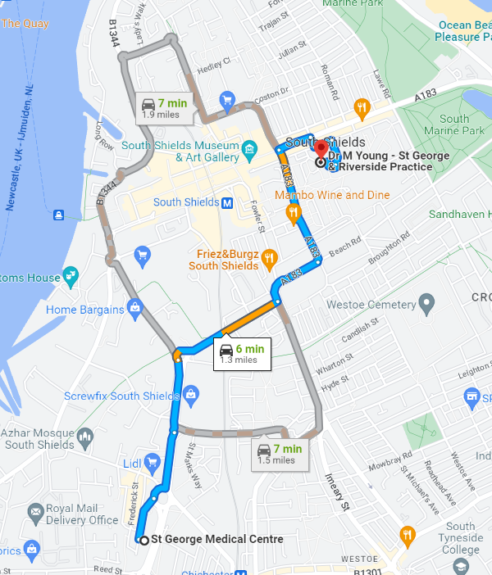

The map indicates where St George Medical Practice and Riverside Medical Practice are located.

Travel time between the 2 sites via car is 6 minutes, public transport (metro) 15 minutes, walking 24 minutes and cycling 8 minutes.

Websites for both sites are as follows:

**St George Medical Practice**

<https://www.intrahealth.co.uk/surgeries/st-george-medical-practice/surgery-information/>

**Riverside Medical Practice**

<https://www.intrahealth.co.uk/surgeries/riverside-medical-practice/surgery-information/>

St Georges Medical Practice and Riverside Medical Practice are both situated in purpose-built premises in South Shields which are shared with other services. All reception and consultation rooms are fully accessible for patients with mobility issues. An onsite car park is available which includes dedicated disabled parking bays.

St Georges Medical Practice is open at the following times:

Monday, Wednesday and Thursday and Friday 8am to 6:30pm.

Tuesday, 8am to 8:00pm.

Riverside Medical Practice is open at the following times:

Monday to Friday 8am to 6:30pm.

The telephones are answered by the practice during their opening times. When the practice is closed patients are directed to the NHS 111 service. This information is also available on the practices’ website and in the practice leaflet.

Appointments are available at St Georges Medical Practice at the following times:

​

Monday 8:45am to 12 noon and 12:30pm to 5:10pm

Tuesday 8:30am to 12 noon and 12:30pm to 7:20pm

Wednesday 8:15am to 11:45pm and 1pm to 6pm

Thursday 8:30am to 11.50pm and 12.30pm to 5pm

Friday 8:15am to 11:45pm and 1:15pm to 6pm

Appointments are available at Riverside Medical Practice at the following times:

​​

Monday 8:15am to 11:45am and 13:15pm to 6pm

Tuesday 8:15am to 12:30am and 1:15pm to 6pm

Wednesday 9:30am to 11:45am and 1pm to 5pm

Thursday 8:15am to 11:50am and 12:30pm to 6pm

Friday 9am to 11:45am and 1pm to 5:10pm

**Footfall at Sites**:

Approximate footfall across the 2 sites is @ 70% St George and @ 30% Riverside.

The practice has seen an increase in patients being seen and registering at Riverside (Flagg Court)

Patients when making an appointment are given choice of where they would prefer to be seen.

The availability of clinicians and medical staff at both sites is as follows:

|  |  |  |  |  |  |
| --- | --- | --- | --- | --- | --- |
| **Site** | **Monday** | **Tuesday** | **Wednesday** | **Thursday** | **Friday** |
| **St George** | GP  ANP  Pharmacist  Nurse  HCA | GP  ANP  Pharmacist  Nurse  HCA | GP x 2  ACP  Pharmacist  Nurse  HCA | GP  ACP  Pharmacist  HCA | ACP  ANP  Pharmacist HCA |
| **Riverside** | GP  HCA | ACP  HCA | GP  ANP  HCA | ANP  Nurse  HCA | GP  ANP  Nurse  HCA |

GP – General Practitioner

ANP – Advanced Nurse Practitioner

ACP – Advanced clinical practitioner

HCA – Health Care Assistant

The North East and North Cumbria Integrated Care Board (NENC ICB), formerly the Clinical Commissioning Group (CCG), will now need to procure a new contract for St George and Riverside, and as part of this exercise it is important that they listen to the views of patients and local stakeholders, to help inform the new contract.

The new contract may mean that in future, services are delivered differently to ensure they are sustainable in the long term and continue to provide high quality care for all registered patients.

The ICB is carrying out a five-week public engagement exercise from Monday 15 May 2023 to Friday 16 June 2023, to seek the views from patients and local stakeholders to help shape the service under the new contract.

As part of this engagement the ICB is asking patients to complete a survey: <https://www.surveymonkey.co.uk/r/StGeorgeandriverside>

Paper copies are also available from [nencicb-styn.enquiries@nhs.net](mailto:nencicb-styn.enquiries@nhs.net)

Patients and local stakeholders can also come along to one of the following drop-in sessions to ask questions and provide feedback.

|  |  |  |  |
| --- | --- | --- | --- |
| Tuesday | 30 May 2023 | 10.00 – 11.00am | St George Medical Practice, New George Street, South Shields NE33 5DU |
| Thursday | 1 June 2023 | 5.00 – 6.00pm | St George Medical Practice, New George Street, South Shields NE33 5DU |
| Tuesday | 6 June 2023 | 10.00 – 11.00am | Riverside Medical Centre, Flagg Court, Dale St, South Shields, NE33 2PG |
| Thursday | 8 June 2023 | 5.00 – 6.00pm | Riverside Medical Centre, Flagg Court, Dale St, South Shields, NE33 2PG |

In addition, feedback can be provided through Healthwatch South Tyneside by calling 0191 4897952 or by emailing [info@healthwatchsouthtyneside.co.uk](mailto:info@healthwatchsouthtyneside.co.uk). Healthwatch are an independent champion for people who use health and social care services, and can gather feedback, provide information, and signpost patients to local services.

**Paul Irving**

**Interim Head of Primary Care**

**North and North Cumbria Integrated Care Board**