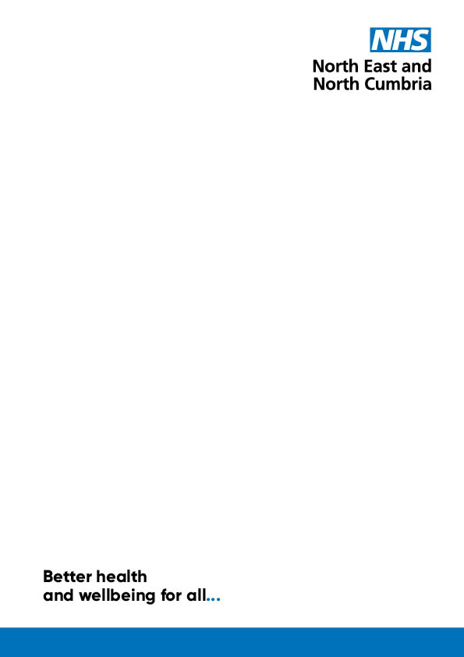

Involving People and Communities Strategy

2024-2028

November 2024

# Contents

Contents 2

Introduction 3

Context 4

Our region 4

Regional strategy 4

Legal duties 6

How we developed this strategy 7

How we will work - our principles 7

1. Involving people meaningfully 7

2. Removing barriers 8

3. Listening to feedback 9

How we will work – our methods 9

1. Listen to what is important to people 10

2. Inform people about what is happening 10

3. Engage people in conversations about changes 11

4. Consult people about big changes 11

5. Co-produce with people 11

6. Work with people with lived experience 12

7. Citizen engagement 12

What we will do with what people tell us 13

Working with partners 14

Healthwatch 14

The voluntary, community and social enterprise sector 14

Staff and structures which support involvement 14

What the involvement team does 15

Other staff who involve people 16

Groups and committees 16

Including listening in decision-making groups 17

Reviewing progress 18

Other strategies and ways of working 18

If you would like this document in a different format, email [necsu.icb.involvement@nhs.net](mailto:necsu.icb.involvement@nhs.net)

# Introduction

The North East and North Cumbria Integrated Care Board (ICB) is an NHS organisation. We plan how to meet the health needs of the people in our area. As an NHS body, we are part of an Integrated Care System (ICS). This means we work with the wider NHS, councils, voluntary sector, and others. [Better Health and Wellbeing For All](https://northeastnorthcumbria.nhs.uk/media/v2hchnti/final-nenc-integrated-care-strategy-16-december-2022.pdf) is the ICS strategy. This is a plan to improve health and care in the North East and North Cumbria. It also commits us to involving people and communities. Involvement is at the heart of our ICS. We will listen to the experience, wisdom, and expertise of the people we serve. We will involve them as partners in our work to make a difference together. In this document we describe how we will involve all people and communities. This includes people of all ages and backgrounds. It also includes families, carers, and parents.

We published the [Communities and People Involvement and Engagement Framework](https://northeastnorthcumbria.nhs.uk/media/ht2nwzdt/nenc-involvement-strategy-2022-23-final.pdf) in 2022. This set out our strategy for involvement. At this time, the organisation was new and developing. We said we would further shape this strategy with our partners and local people. We also said we would align with other strategies as they emerged.

Since we published our first strategy, we have heard from people that they want to get involved to help make the NHS better. We recognise the excellent work that already takes place across our region. We will build on this to put people at the heart of all we do. We value connections with the people we serve and with partners. We work closely with partners in the Integrated Care System. We need to be open and have ongoing discussions so we can keep building trust.

This refreshed ‘Involving People and Communities Strategy’ reflects on the feedback we have received. It also aligns with wider organisation and system plans. Our Strategy will help us to have more meaningful conversations. It will also help people know how their voice can shape our work. Engaging the public and partners is essential in planning and service delivery. Whenever possible we will involve people in a meaningful way. This will help us to deliver [Better Health and Wellbeing for All](https://northeastnorthcumbria.nhs.uk/media/v2hchnti/final-nenc-integrated-care-strategy-16-december-2022.pdf).

We will know we have done what we say in this document when:

* we are working with people and communities
* we are more inclusive, working with many kinds of people
* people's views are informing improvements in health services
* we are hearing about issues in healthcare early on
* we recognise together the issues faced by local people and the NHS.

# Context

## Our region

The North East and North Cumbria is a large and diverse area. It includes rural, urban, and coastal areas with a lot of different health challenges. This includes stark health inequalities in some areas. Understanding diversity of both people and place is important to involvement. We must learn the issues different groups face in using services and where there is inequality in health. We will work with local people to make sure different voices are heard. This will help to support fair access to services. It will also help make sure people experience the right outcomes.

## Regional strategy

[Better Health and Wellbeing for All](https://northeastnorthcumbria.nhs.uk/media/v2hchnti/final-nenc-integrated-care-strategy-16-december-2022.pdf) is our Integrated Care Strategy. The NHS, local councils and voluntary, community and social enterprise (VCSE) organisations wrote it together. It is a plan to improve the health of people living in the region. It commits to involving people in decision-making at all levels. It says we must involve people and communities in delivering the strategy. After publishing the Integrated Care Strategy in December 2022, we worked with partners to produce our delivery plan. This is called [Better Health and Wellbeing for All: Joint Forward Plan](https://northeastnorthcumbria.nhs.uk/media/44njo3g4/joint-forward-plan-2324-final.pdf). The plan focuses on delivering:

|  |  |
| --- | --- |
|  | Longer and healthier lives |
|  | Fairer outcome for all |
|  | Better health and care services |
|  | Giving children and young people the best start in life |

The Joint Forward Plan says we must involve people to co-produce the best solutions. The plan also says that involvement is central to improving healthcare. These documents show commitment to involving people at the highest level of decision-making.

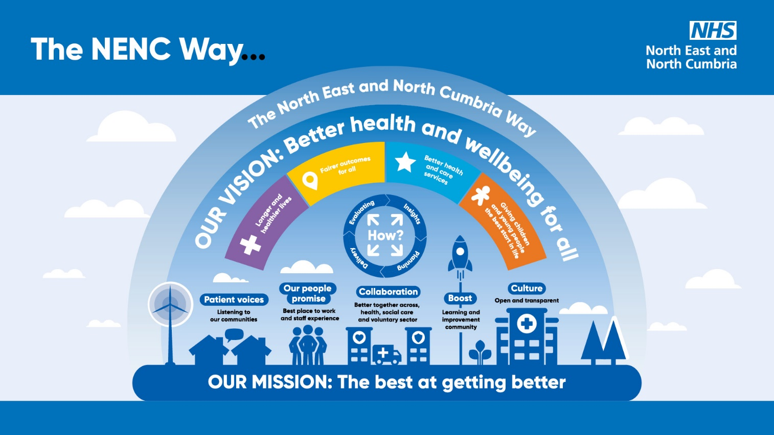

Figure 1: The NENC Way

## Legal duties

We have a legal duty to involve people in planning and decisions about NHS services. Duties include the need to:

* assess the need for public involvement
* plan and carry out involvement
* record how involvement has informed decisions
* have systems to assure that we meet the legal duty to involve
* report on how we meet the legal duty in our annual reports.

Our duties are in the [NHS England statutory guidance: working in partnership with people and communities](https://www.england.nhs.uk/long-read/working-in-partnership-with-people-and-communities-statutory-guidance/). The guidance gives us [ten principles](https://www.england.nhs.uk/long-read/working-in-partnership-with-people-and-communities-statutory-guidance/#ten-principles-for-working-with-people-and-communities) for working with people and communities. We commit to these principles.

|  |  |
| --- | --- |
|  | 1. Put the voices of people and communities at the centre of decision-making and governance, at every level of the ICS. |
|  | 1. Start engagement early when developing plans and feed back to people and communities how their engagement has influenced activities and decisions. |
|  | 1. Understand your community’s needs, experience and aspirations for health and care, using engagement to find out if change is having the desired effect. |
|  | 1. Build relationships with excluded groups, especially those affected by inequalities. |
|  | 1. Work with Healthwatch and the voluntary, community and social enterprise (VCSE) sector as key partners. |
|  | 1. Provide clear and accessible public information about vision, plans and progress, to build understanding and trust. |
|  | 1. Use community development approaches that empower people and communities, making connections to social action. |
|  | 1. Use co-production, insight and engagement to achieve accountable health and care services. |
|  | 1. Co-produce and redesign services and tackle system priorities in partnership with people and communities. |
|  | 1. Learn from what works and build on the assets of all ICS partners – networks, relationships, activity in local places. |

Involving people well can also help us to meet other legal duties, such as:

* equalities - the Equality Act 2010 and the Public Sector Equality Duty (PSED) (s.149 of the Equality Act)
* health inequalities - the National Health Service Act 2006
* social value - Public Services (Social Value) Act 2012.

# How we developed this strategy

In 2022, NHS involvement staff from across the region asked people and organisations for help to develop the [Communities and People Involvement and Engagement Framework](https://northeastnorthcumbria.nhs.uk/media/ht2nwzdt/nenc-involvement-strategy-2022-23-final.pdf).

In 2024, we asked Healthwatch to talk to people about the Framework. We used the feedback from Healthwatch to write a new involvement strategy. We then asked people what they thought of the new strategy. We listened to what people told us. We:

* changed our principles to:
  + meaningful involvement
  + removing barriers
  + listening to feedback
* made the document easier to read
* made the strategy shorter
* developed a workplan. The work plan includes how we will measure success.

We included these reports and workplan on our website. You can read them by going to: [Involvement strategy | North East and North Cumbria NHS](https://northeastnorthcumbria.nhs.uk/get-involved/our-approach-to-involvement/involvement-strategy/)

# How we will work - our principles

People tell us they want to be involved in a way that brings about change. This is important to improving services, improving health, and reducing health inequalities. This is what we commit to doing:

## 1. Involving people meaningfully

We will involve people and communities in a way that means they have an influence. We will:

* involve early when we are deciding what we need to do
* keep involving as we develop and improve services or do projects
* make sure there is a clear purpose for involvement
* have open conversations about the challenges and opportunities we face - this means we can find solutions together
* make sure people have enough time to get involved
* build leadership and staff understanding of, and commitment to, involvement
* make sure we hear people's voices in decision-making
* tell people the difference their involvement has made.

## 2. Removing barriers

When we think about inclusion, we think about:

**Equality -** Involving groups protected by the Equality Act. The protected groups are:

* age
* disability
* gender reassignment
* pregnancy and maternity
* race
* religion or belief
* sex
* sexual orientation.

**Health inequality -** Involving people who have worse access to services and worse health. This includes:

* homeless people
* refugees and asylum seekers
* carers
* people living in poverty.

It is important that we think about inclusion as part of our involvement plans. We will make it easier for different people to get involved. This includes:

* mapping different groups and people we want to involve
* working with organisations who know their communities well
* meeting people where they are and making it easy to get involved
* checking who is taking part and changing our approach if some groups are not involved
* offering different ways to get involved. People can get involved in a way that is best for them
* making information accessible. For example, in different formats and languages, with subtitles and British Sign Language
* thinking about ways to involve people who find it difficult to get online
* making meetings accessible
* asking experts by experience to help us make information, surveys, and meetings accessible
* making sure people are not out of pocket for working with us
* making it safe for people to get involved
* using equality impact assessments to understand:
* who uses a service,
* what views we have heard and
* which voices still need to be heard.

## 3. Listening to feedback

We will listen to, and act on what people tell us. We will:

* listen to people who are using our services, their families, and carers
* listen to people who don't use our services, to learn about the barriers
* listen to staff who work in services
* work closely with organisations to find out what people are telling them. This means we will not keep asking the same people similar things
* use different ways for people to give their views to the ICB
* resource and staff involvement equally across the region
* share insight from involvement across the region with leaders
* share insight between health providers, partner organisations, local areas and the ICB
* keep learning and improving what we do
* make sure patient and public voice shapes what we do in the future.

# How we will work – our methods

We will do different things to reach different people (Figure 2). The method we use depends on who we want to hear from, what we are talking about and, what stage the work is at.

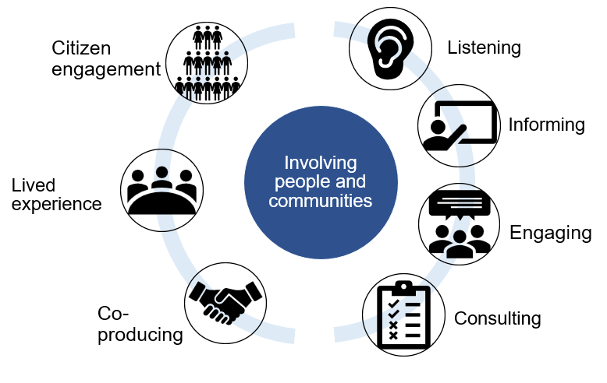

Figure 2: Different ways we involve people and communities.

When we start a piece of involvement work, we write a plan. Read about planning in our [Involvement Toolkit](https://northeastnorthcumbria.nhs.uk/get-involved/involvement-toolkit/). We will then:

## 1. Listen to what is important to people

We will find out what is important to people and communities. We will listen to people with lived experience of services and conditions. We will listen to feedback from people about different health services across the region. This includes hospitals, GPs, and dentists. We will make it easy for people to share their experiences in different ways.

We will meet people where they are. We will meet people in person and online. We know that some people struggle to have their say online. And we know other people can't travel to meetings. We will listen to people:

* in community forums
* in patient and carer groups. For example, in GP patient participation groups and through primary care networks
* through patient / public feedback
* with groups which focus on an issue or health problem
* through Healthwatch
* through partners, like the voluntary and community sector, schools, health services and councils
* on social media
* through [compliments and complaints](https://northeastnorthcumbria.nhs.uk/about-us/contact-us/compliments-and-complaints/)
* through emails sent to us
* through queries that come to us from Members of Parliament (MPs)
* as well as many other ways.

We will also support listening to patients across the ICB, by working with our:

* primary care networks, made up of GP practices
* network of Healthwatch organisations
* voluntary and community sector.

## 2. Inform people about what is happening

People need to know about possible changes to their services so they can:

* decide if they want to get involved
* know what the changes mean for them
* know how to get involved.

We will:

* keep people informed about any changes and what difference their voices have made
* work openly so people can know what they can get involved in
* communicate in many ways - both online and where people are
* communicate clearly and in accessible formats. For example, in easy read and in different languages, such as British Sign Language.

## 3. Engage people in conversations about changes

We will talk with people and the public about ideas for changes to services. We will listen to people to get to know the issues. This may involve:

* group conversations
* one to one conversations
* surveys
* face-to-face conversations
* online conversations, for example on social media.

We will also talk with staff. Staff can support change in their services. They also have useful views about what works and doesn't work. They often have good insight from patients and carers about their services. They are also patients and carers and members of different community groups themselves.

## 4. Consult people about big changes

We will not make big changes to health services without listening to people first. We will explain to people why changes need to happen. This may involve formal consultation. Organisations use the word consultation differently. In the NHS, "consultation" means a formal process with legal requirements.

If we are thinking of any big changes we must:

* tell the Secretary of State for Health and Social Care
* talk about changes with (joint) health overview and scrutiny committees.

Formal public consultations must follow the [Gunning Principles](https://www.consultationinstitute.org/the-gunning-principles-implications/). If we don't, the decision "to change the way a service is provided" can be referred to judicial review. We will follow the Gunning Principles for all involvement.

Consulting is asking for people’s opinions on one or more options. We work with people to decide what these options should be. This will be before planning any formal consultation.

## 5. Co-produce with people

People use the word co-production in different ways. To us it means staff and people with lived experience working together as equals. It needs us to involve people from the beginning of a project. And we need to be open about the problems we are facing.

In North Cumbria the NHS, Healthwatch and the community developed the [Working Together Toolkit](https://northeastnorthcumbria.nhs.uk/get-involved/involvement-toolkit/co-production-toolkit/).

## 6. Work with people with lived experience

Staff who plan and pay for services need to hear from people who use services. We support people to share their real-life experience, to help us improve services. This can be through:

* capturing people's lived experience to share with decision making committees and groups
* hearing people through lived experience boards and partnerships
* employing people with lived experience to work on our programmes. For example, in mental health, learning disability and autism transformation.

We value people who take time to share their experience with us. We will take care around the effect of people retelling their stories. We know that this can cause more trauma. We will tell people about the difference they make.

## 7. Citizen engagement

We want to do more proactive engagement. This will help the public and patients to influence healthcare from the bottom up. There are lots of ways we can do this.

**People's Hub -** We plan to create an online community. We will call it 'People's Hub'. The Hub is for people who want to take part. And, for people who want to learn more about involvement in the ICB.

We will send out online monthly newsletters to people who are part of the Hub. These newsletters will tell people what involvement events are happening. They will tell people how they can take part. The newsletters will give updates from past involvement projects. It will tell people what has happened after we have listened.

We will invite people through the Hub to take part in other things. Such as face-to-face conversations or online conversations.

**Big conversation** – The ICB wants to have honest conversations with patients and public. We want to learn more about the things that are important to people. We want to learn more about the things which are priorities for the ICB. We will do this by going out to our local communities. We will talk to people about one topic at a time. We will have lots of ways people can share their thoughts.

Big conversations include:

* The ['Always the right Door](C://Users/LISA~1.AND/AppData/Local/Temp/MicrosoftEdgeDownloads/8932b774-09ca-4ec3-b33d-030302fa57ba/Always-the-Right-Door-Post-Event-Report.pdf)' Children and young people's mental health summit (October 2023). Over 250 people attended from across the region. This included people who work in health and care, and young people. We worked in partnership with [Boost](https://boost.org.uk/).
* [Women's health](https://northeastnorthcumbria.nhs.uk/big-conversation/) (July to September 2024). We want better and fairer health for all women and girls. We heard from around 4,500 people. We worked in partnership with [Healthwatch](https://northeastnorthcumbria.nhs.uk/get-involved/our-work-with-people-and-communities/how-we-work-with-partners/).
* [LOC in the Lakes](https://healthinnovationnenc.org.uk/?s=LOC+in+the+Lakes) 2024 - Obesity (November 2024). Nearly a third of children under the age of 15 are overweight or obese. This affects physical, mental, and social health. It puts pressure on our services. At this event we will talk about tackling obesity. We will talk with people who work and volunteer in health and care services. We are working in partnership with Boost and Health Innovation North East and North Cumbria.

We are also looking at other ways to involve people. We are looking at:

* Citizens' panels – These are a database of people who want to take part in regular surveys. There would be about 1200 – 1600 people on a panel. We would send people 3 to 4 surveys a year. These surveys would ask about different things.
* Citizens' juries and assemblies – These are where people get together to talk about a topic. People meet up to have in-depth conversations about something the ICB is working on. People will have more than one conversation for each topic. People will first learn about the topic in more detail. They will then have a chance to talk about the topic with others. They will then reach a conclusion about what they think should happen. They make practical recommendations. Members will represent the thoughts of their community. Members will represent the wider population. Citizens' juries usually have fewer people in them than a citizens' assembly. Three groups of people are part of these conversations:
  + Members of the public
  + People who are experts about the topic
  + The people who organised the event.

## What we will do with what people tell us

We will get better at showing how involvement has made a difference to services. We will do this in different ways, including:

* publishing reports of findings. We are piloting an ‘insight bank’. We are piloting this in Sunderland, South Tyneside, and North Cumbria. An insight bank is somewhere past reports can be saved online. People will be able to search for what they are interested in
* meeting with patient, carer, and public involvement networks – ongoing conversations
* sharing information online. For example, on [our website](https://northeastnorthcumbria.nhs.uk/get-involved/)
* stakeholder updates.

When we start a new project, we look at what people have already told us. This will be from patient experience data and earlier involvement. This will stop us asking people the same thing and people getting tired.

We will share our learning widely. For example, with [Boost](https://boost.org.uk/), our learning and improvement community.

# Working with partners

Working with our partners is important in how we involve people. We will share feedback with different NHS and other organisations. This happens in local areas across North East and North Cumbria. We will keep developing how we work with people and partners. These are some of the partners we work with:

Healthwatch are an important partner and critical friend. We work with Healthwatch both in local areas and across the region. The NENC Healthwatch Network includes the fourteen Healthwatch organisations from each local authority area. Each Healthwatch is independent and local Boards set priorities based on feedback from residents. They are an independent health and care champion. They find out what people think about services. They share what they hear from the public with the NHS. They help the ICB to learn what are key emerging priorities. They also have strong connections with the community. This includes people who are seldom heard and disadvantaged. Working with Healthwatch helps us to prioritise areas of work. [Read more about how we work with Healthwatch on our website and find your local Healthwatch organisation](https://northeastnorthcumbria.nhs.uk/get-involved/our-work-with-people-and-communities/how-we-work-with-partners/)

The voluntary, community and social enterprise sector(VCSE) is vibrant and diverse in our region. VCSE organisations have valuable expertise, knowledge, and relationships with their service users. This is very important for people who have needs that are less well understood. Or for people whose voices are not often heard. We need to work with the VCSE to connect with diverse groups. We know that supporting us to involve people is extra work for the VCSE. It is important that we are careful with their time and resources. [Read more about how we work with the VCSE on our website](https://northeastnorthcumbria.nhs.uk/get-involved/our-work-with-people-and-communities/how-we-work-with-partners/).

NHS Foundation Trusts work closely with the people they serve. They have involvement staff and patient experience teams. They also have governors who link patients, the public and the Board of Directors. Governors meet with trust members and are important linking the trust with the public.

Local councils have strong local relationships and knowledge. Councils have publicly elected councillors who are well connected with communities. Councils also have staff who work closely with communities. Councils have an important role in health and wellbeing. They are responsible for:

* public health,
* [health and wellbeing boards](https://www.gov.uk/government/publications/health-and-wellbeing-boards-guidance/health-and-wellbeing-boards-guidance) and
* [health overview and scrutiny committees](https://www.gov.uk/government/publications/advice-to-local-authorities-on-scrutinising-health-services/local-authority-health-scrutiny).

We work closely with council staff and councillors when we know about changes. These are just some of the people we will work with.

# Staff and structures which support involvement

Involvement is an important part of what the ICB does. Lots of staff listen to people as part of their work. The ICB has local delivery teams working in local areas. These teams have good connections with people and organisations in their areas. They have detailed knowledge of lots of NHS services. This includes planning and paying for services through to delivering research and evaluation. There is also an Involvement Team. Each local delivery team is supported by an involvement team member. They advise, support, and help to plan local involvement work. The involvement team also support regional projects. Involvement work is overseen by the Chief Corporate Services Officer.

* Director of Policy, Involvement, and Stakeholder Affairs
* Strategic Head of Involvement and Engagement
* Involvement Manager
* Involvement Leads, who support: 1. Tees Valley; 2. North Cumbria; 3. Sunderland / South Tyneside; 4. County Durham; 5. Newcastle / Gateshead; 6. North Tyneside / Northumberland

You can contact the Involvement team by emailing [necsu.icb.involvement@nhs.net](mailto:necsu.icb.involvement@nhs.net)

## What the involvement team does

There are four main areas of work that the team does.

1. Build ways of working:

* support the wider ICB to involve people
* create processes, training, and toolkits. This helps other staff listen in a way that is meaningful.

1. Listen to people:

* get to know local people better
* listen to what organisations tell us. This includes Healthwatch, voluntary and community sector, local councils and hospitals.
* manage or attend local networks
* tell decision-makers about people's views.

1. Support service change:

* ask for views when we plan, review, change or buy services. This includes things like changes to a
  + GP practice,
  + hospital services, or
  + services to support different conditions.

1. Involve people in ICB work:
   * getting ideas for our plans
   * helping deliver our plans.

Some of these plans are across the region. Others are more local. We work closely with [Boost, our learning and improvement community](https://community.boost.org.uk/). This helps link involvement to the ICB's priority areas. Examples include:

* Quality strategy
* Healthy weight and treating obesity
* Women's health programme
* Plans to help people be healthier and have fairer outcomes.

Having an involvement team supports us to be consistent in:

* involving people early to shape service change and business case development
* using appropriate methods for the project and the people we are reaching
* involving diverse groups
* ensuring decision-makers hear the views of people and communities
* feeding back to our communities.

## Other staff who involve people

All ICB staff have a role to listen to local people and partners. We all take part in using what we learn to shape NHS services. Some of the teams that involve people include:

* Local Maternity & Neonatal System (Maternity and Neonatal Voice Partnerships)
* Northern Cancer Alliance
* Secure Data Environment
* Child Health and Wellbeing Network
* The Learning Disability Network

## Groups and committees

The ICB needs to hear what people are telling us. We report all our involvement work to the ICB's formal structures. We then use this to help shape NHS services. Leaders can then base their decisions on good quality involvement.

Reporting to ICB committees means leaders can check we are doing the right things. That we are accountable.

We report our involvement work at the Patient Voice Group. This meets every three months. The meeting is chaired by the Chief Corporate Services Officer. This provides a link to the Executive Director Team. This also links to the Executive Director Committee.

Patient Voice Group makes sure we:

* do what the law tells us
* involve diverse people
* have different ways for people to share their thoughts. Both face-to-face and online.
* listen to feedback from different sources. This includes MPs, complaints, media, Healthwatch, and our involvement work. This is to know what is important to local people
* share what we have heard
* use what we've heard in plans for NHS services.

It is important that the ICB shows that it:

* values patient voice,
* thinks about what matters to people and communities and
* uses what people tell us to make improvements.

The Patient Voice Group provides assurance to the Quality and Safety Committee (QSC). The QSC meets every two months. QSC is responsible for assuring the ICB Board that we are:

* meeting our duty to involve and
* we are doing what we say we will in this strategy.

We also hear people's voices in our committees:

* Healthwatch sits on the Board, QSC and Patient Voice.
* VCSE Partnership Programme sits on the Board and Patient Voice.

## Including listening in decision-making groups

The ICB includes patients and the public in decision-making groups. People are embedded into governance arrangements. People represent their communities. They share feedback on behalf of their communities. They make sure groups consider what other people think. They help us to deliver the right care.

Examples of where people are part of decision-making groups:

**Local maternity and neonatal system (LMNS)**

* + At LMNS Board meetings as a Service User Voice (SUV) Leads. This is the Board which oversees the work.
  + At MVPL as a Maternity Voices Partnerships Lead. MNVPs work with their local hospitals. There are 10 MNVPs who support the LMNS.
  + At LMNS subgroups as Patient and Public Voices Partners (PPV). Sub-groups focus on a topic to look at in more detail.

**Secure Data Environments (SDE)**

* A Public Member Group. This group helps shape the work of the SDE programme.
* A Patient Evaluation Group. This group helps evaluates applications to use data for research.

You can find out more information about these examples here: [Examples of the work we do | North East and North Cumbria NHS](https://northeastnorthcumbria.nhs.uk/get-involved/our-work-with-people-and-communities/examples-of-the-work-we-do/)

# Reviewing progress

We review our approach for each involvement project. We also review how we are performing as an organisation in terms of involvement. There is more information on how we review each project in our [Involvement Toolkit](https://northeastnorthcumbria.nhs.uk/get-involved/involvement-toolkit/). Reviewing projects includes thinking about:

* what we hear from people and communities
* what we hear from staff
* who we have heard from
* it can also include assurance from independent advisors.

Ongoing review helps us to:

* respond to changing situations
* change methods to better target different groups
* improve current and future projects
* make the most of the information we have
* share learning to improve future work
* help us use resources well.

People told us they want to see what we plan to do so they can check how well we are doing. We have made a workplan. It is based on what people told us. It includes:

* what our priority is
* how we will do it
* how we will know we have achieved it.

We will keep the work plan up to date. There will be a summary in our [annual engagement and involvement report](https://northeastnorthcumbria.nhs.uk/get-involved/our-approach-to-involvement/annual-involvement-and-engagement-report/). The report shows how we are meeting our duty to involve.

# Other strategies and ways of working

Other teams have their own ways of involving people. Some have their own involvement strategies. The different strategies mean each team speaks with the right people in the right way. We share many of the values and ideas.

[Healthwatch Strategy](https://www.healthwatch.co.uk/report/2021-05-13/our-strategy-2021-2026)   
Healthwatch listens to people's feedback to improve health and care services. Their work is guided by the people they serve. Its strategy aims to make sure health and care work for all.

[Child Health and Wellbeing Network](https://northeastnorthcumbria.nhs.uk/our-work/workstreams/optimising-services/child-health-and-wellbeing-network/)

The Child Health and Wellbeing Network is part of the ICB. The network brings together lots of partners to work with children, young people, and their families. Partners include:

* health,
* education,
* local authorities,
* and the voluntary and community sector.

[Secure Data Environment](https://northeastnorthcumbria.nhs.uk/our-work/workstreams/digital-care/secure-data-environment/)   
This work is about how we safely use people's health and care data for research. It is important to listen to people's concerns. Then work together to make sure people's data is used safely.

[ICB Research and Innovation Strategy](https://www.necsu.nhs.uk/what-we-offer/consulting-services/research-and-evidence/)   
For good healthcare we need to know what works. We do this through research. We also need to keep trying different things to see if they work better. It is important that we involve people in testing new ideas. And in research. We are working on a new strategy with our partners.

Boost – Boost is our learning and improvement community, bringing people together with a passion for change in health and care. Boost provides a hub for innovation, idea-sharing, networking, and supporting improvement efforts across our region. Boost is hosted by the North East and North Cumbria Integrated Care Board. Our community is open to anyone with an interest in driving forward change.

[Northern Cancer Alliance](https://www.northerncanceralliance.nhs.uk/wp-content/uploads/2021/05/V2.0-Northern-Cancer-Alliance-Public-Involvement-Strategy-October-2020.pdf) - The Northern Cancer Alliance is one of 20 Cancer Alliances in England. It includes lots of organisation's who work together. This includes:

* providers,
* commissioners,
* third sector organisations
* Patients and the public

People work together to improve cancer survival across the North East and North Cumbria. Involving people in health services needs to be meaningful. It can improve:

* Patient safety
* patient experience
* health results

[Health Innovation North East and North Cumbria](https://healthinnovationnenc.org.uk/) (HINENC) – HINENC is the Academic health science network for the NENC. We work with lots of health organisations. We want to

Improve health outcomes for the population. We want to make sure patients are safe. We want to improve processes.