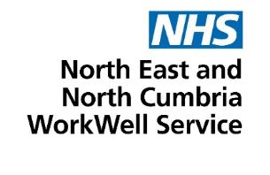
Version 1
25 August 2026

WorkWell Gateshead

Information pack for GP practices in Gateshead to support communications with patients
As you may be aware, people in Gateshead who are struggling to stay in work because of their health can now access NHS WorkWell services and WorkWell Advisers to support them to stay well and working. The following provides some information to support you in your communications with patients. Information for patients is also available on the ICB website. Services in Gateshead are led by WorkWell Advisers at Gateshead Futures.
We are asking practices in Gateshead to refer eligible patients to the WorkWell service by contacting workinggateshead@gateshead.gov.uk.
The WorkWell Coordinator for Gateshead is Michelle Robson who can be contacted on michelle.robson@connectedvoice.org.uk.

What's in this toolkit?
Item | Where to access it
Suggested script for staff in practices to help answer questions from patients and provide information when referring patients to the service. | See below.
Suggested content to go on GP practice websites. | See below.
Advert you can use on digital screens in a GP practice.  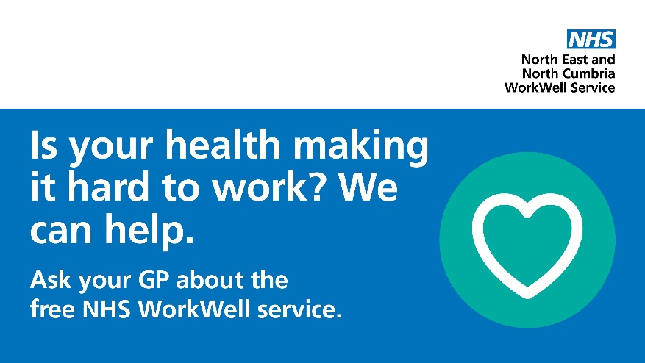 | This can be downloaded from our toolkit using the link below.  https://www.northeastnorthcumbria.nhs.uk/toolkits/workwell-gateshead/
Leaflet for GP practice waiting areas.  Printed versions are being supplied to practices.  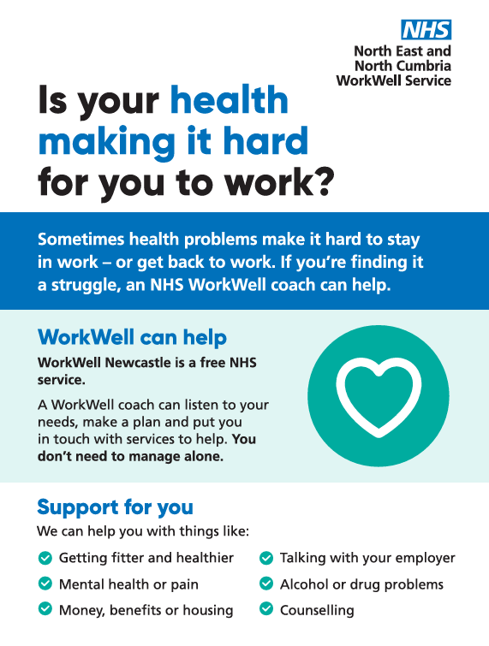 | This can be downloaded from our toolkit using the link below.  https://www.northeastnorthcumbria.nhs.uk/toolkits/workwell-gateshead/
Digital copy of A4 information sheet - GPs/practice staff can hand to a patient they have referred to the service.  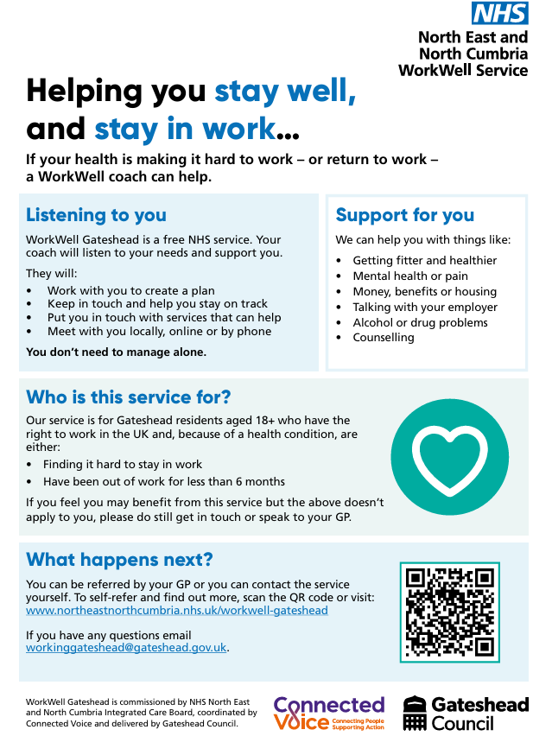 | This can be downloaded from our toolkit using the link below.  https://www.northeastnorthcumbria.nhs.uk/toolkits/workwell-gateshead/
Animation about WorkWell Advisers which can be added to websites and shared on digital screens in practices. | This can be downloaded from our toolkit using the link below.  https://www.northeastnorthcumbria.nhs.uk/toolkits/workwell-gateshead/  Or accessed on YouTube.  https://youtu.be/Ztgi03IGBso

Suggested content for practice websites

Is your health making it hard for you to work?

Sometimes health problems like stress, back pain or long-term conditions make it hard to stay in work or return to work.

If you’re finding it a struggle, a WorkWell Adviser can help. It’s a free NHS service and we can arrange for you to meet an adviser to see how they can help you.

Our advisers will listen to you, help you to make a plan, and put you in touch with services that can help.

This could include:
• Support from other health services, like pain or mental health teams
• Advice on benefits, money or housing
• Help with talking to your employer or making changes at work
• Links to local groups and activities

You don't have to manage alone.

Just ask your GP about WorkWell. You can also find out more by watching this animation (https://youtu.be/Ztgi03IGBso) and visiting this website: https://northeastnorthcumbria.nhs.uk/workwell

Suggested script for staff
Hi, I'm NAME from PRACTICE
I am calling on behalf of your GP/nurse who has suggested you may find it helpful to get some extra support for your health
problems.
There's a new service called WorkWell which can help if health problems or difficult circumstances are making it hard for you to
work.
It's a free NHS service and we can arrange for you to meet a WorkWell Adviser to see how they can help you. They can
listen to your needs, help you make a plan and help you stay on track with it.
They can help with all sorts of things, like:
• Money worries
• Mental health or health issues
• Housing problems
• Helping you talk with your employer about making adjustments
…whatever will help you.

It's completely up to you, but we think you might find it helpful.
We know that people who have used this service or similar services have found it helpful and supportive.
Would you consider talking with a WorkWell Adviser?
[Pause for questions – please use FAQs below to answer questions if appropriate]
Follow-up conversation (where appropriate):
- Offer to email a leaflet or give a web address
- Web address is https://northeastnorthcumbria.nhs.uk/workwell
- Reassure this is an NHS service, but is provided by Working Gateshead at Gateshead Council
- NHS WorkWell services for our area can be contacted on workinggateshead@gateshead.gov.uk

Answers to frequently asked questions
Do I have to take part? No. It is your choice. You do not have to take part if you do not want to. Many people find the help on offer useful.
Will it affect me if I say no? No. It will not affect you. You can change your mind later. You can ask your GP or another health worker to refer you again.
Will this affect my benefits? No. The service is separate from Jobcentre Plus and the DWP. Taking part will not affect your benefits. What you say will not be used to make decisions about your benefits.
What happens to my information?
If you agree to take part:
- A short form is filled in with your details
- This is sent safely to a WorkWell Adviser.
- They will call you for a chat first.
Your information is:
- Kept safe
- Only shared if you agree
Sometimes information is used to help improve the service, but
- Your name is not used
- It will not affect you or your benefits
Who can see my medical notes?
Only NHS staff who are allowed to see them.
When will a WorkWell Adviser contact me?
They will contact you as soon as they can. Usually within 5 days, often sooner.
Can I use this service, if I’m working?
Yes. You can use it if you:
- Are working and struggling
- Are off sick
- Are not working (out of work in last 6 months)
Is it only for certain health problems?
No. It is for many different needs. For example, help with:
- Getting fitter and healthier
- Looking after your mental health
- Women’s health, such as menopause, pelvic pain, or heavy periods
- Family or caring worries
- Things like dyslexia or ADHD
- Money or housing
- Talking to your employer

Your WorkWell Adviser will talk with you and make a plan that suits you.
These are just examples. Your WorkWell Adviser will talk to you and come up with a personalised plan that suits you best.
How long can I get support for?
As long as you need. There is no set end date.

