Human Resources | HR44 Volunteers Policy
Version Number |  | Date Issued | Review Date
1.0 |  | July 2022 | July 2025

Prepared By: | Kirstin Brundle
Consultation Process: | North of England Commissioning Support (NECS) in partnership with CCG management and Trade Union organisations via the HR Policy Working Group and the CCG Partnership Forum.
Formally Approved: | July 2022
Approved By: | ICB Board

EQUALITY IMPACT ASSESSMENT

Date | Issues
 | To be completed, as outlined in the agreed 2022/23 HR EIA review schedule.

POLICY VALIDITY STATEMENT
Policy users should ensure that they are consulting the currently valid version of the documentation. The policy will remain valid, including during its period of review. However, the policy must be reviewed at least once in every 3-year period.

ACCESSIBLE INFORMATION STANDARDS
If you require this document in an alternative format, such as easy read, large text, braille or an alternative language please contact necsu.icbhr@nhs.net

Version Control

Version | Release Date | Author | Update comments
1.0 | July 2022 | NECS HR | First Issue

Approval

Role | Name | Date
1.0 | July 2022 | NECS HR

Contents

1. Policy Statement 3
2. Principles 3
3. Responsibilities 4
4. Volunteer Placements 5
5. Recruitment 5
6. Commencement 7
7. Training of Volunteers 7
8. Volunteer Performance 7
9. Resolving problems 7
10. Liability and Insurance 8
11. Health & Safety 8
12. Reimbursement of Travel Expenses 8
13. Volunteering & Benefit Claims 9
14. Termination of Arrangement 9
15. Equality Statement 9
16. Data Protection 9
17. Monitoring and Review 10
18. Associated Documentation 10

Appendix 1 – Managing Volunteer Complaints 11
Appendix 2 – Managing Complaints Against Volunteers 12
Appendix 3 Equality Impact Assessment 13

1. Policy Statement

1.1 The North East and North Cumbria Integrated Care Board (the Organisation)recognises the important role which voluntary activity plays in complementing the work of the organisation and therefore supports and encourages the efforts of the voluntary sector.

1.2 The Organisation recognises that volunteers add immense value to the services it provides and support the work of employees. The policy sets out how the Organisation will recruit and support volunteers to ensure it is a useful opportunity for both parties.

1.3 The Department of Health’s definition of a volunteer is:
“Someone who commits time and energy for the benefit of others, who does so freely, through personal choice and without expectation of financial reward, except for payment of out of pocket expenses”.

1.4 Volunteering in the Organisation may be undertaken for a wide variety of reasons involving holistic personal development, reflective learning and skills development and to influence the work of the Organisation. A range of volunteering opportunities is available and although this is not an exhaustive list, these include:

- Active involvement in specific projects
- Helping the Organisation enhance community involvement

1.5 This policy adopts four principles fundamental to volunteering as identified by the Government Code of Practice (1998) which are choice, diversity, reciprocity and recognition.

1.6 This policy is supported by a number of Organisational policies and procedures as well as a Safeguarding Training Strategy which demonstrates the organisation’s commitment to improving safeguarding competencies at all levels within agencies commissioned by the Organisation. All staff working within the Organisation's health economy that commission or provide services for children and adults at risk must make safeguarding and promoting the welfare of children and adults at risk an integral part of the care they offer.

1.6 This policy sets out the arrangements to be followed for the recruitment, management and support of volunteers and covers all volunteers in the Organisation including those recruited through third party volunteer organisations.

2. Principles

2.1 The Organisation supports and encourages the work of individual volunteers and voluntary organisations for the benefit of patients, users of services and their relatives. However, volunteers are not intended to be used to substitute the work of paid staff. Instead they can improve and enhance the level of service provided by the Organisation by offering their time, skills and expertise.

2.2 In response to the Saville Inquiry, Kate Lampard QC produced two reports following investigations into the abuse of individuals on NHS premises. The second report makes 14 recommendations, a number of which refer directly to volunteers and safeguards to be considered by NHS organisations. The Organisation will take these reports into account.

2.3 Volunteers do not have employee or worker status as defined by employment legislation. However, whilst the Organisation has no employment responsibility towards volunteers it is recognised that they need and deserve support via health and safety policies and procedures that safeguard their welfare. They also require feedback and a clear guide to their role.

2.4 Volunteers will be recruited in accordance with HR policies and procedures to ensure a fair and equitable approach. All volunteers will be required to meet employment checks as set out within the NHS Employment Check Standards to ensure normal safeguards are met.

3. Responsibilities

3.1 Corporate

It is the responsibility of the Organisation to co-ordinate a process which includes the following;
- Take general responsibility for volunteer placements within their work areas ensuring that this policy and procedure is adhered to
- Decide whether the volunteer requires any clearances to undertake their placement and if so ensure this takes place
- Undertake a risk assessment for any volunteer placements identified within their department
- Be accountable for the volunteer and ensure that they are supported within the team/by staff. This will include clear management and reporting arrangements for the volunteer which are made known to both the volunteer and line manager
- Ensure that the volunteer is made aware of health and safety policies and Organisation procedures and that whilst there is no employment relationship with the volunteer, that their health, safety and welfare at work are dealt with in the same way as for employees
- Ensure that volunteers receive the appropriate training for their role including the completion of the induction checklist – see Appendix 2.

3.2 Other Employees

It is the responsibility of other employees to:
- Understand the role of the volunteer within their work area/team and recognise the benefits of their involvement
- Support the volunteer in their role and explain any areas where the volunteer may be unsure
- Introduce the volunteer to other staff in the Organisation
- Give general awareness of first aid and other safety procedures within the area

3.3 Volunteers

It is the responsibility of volunteers to:
- Follow the instructions or guidance given to them by the manager of the work area/team or other manager to whom they report.
- Follow Organisation policies and procedures, as appropriate, for their role.
- Ensure that they consider the health, safety and welfare of themselves and others as they undertake their role.
- Undertake any training deemed necessary to their role by their manager.

4. Volunteer Placements

4.1 Managers must consider the content of placements when considering opportunities for volunteers in the Organisation, including training and supervision requirements and the management of risk. Managers are encouraged to seek advice from HR, Health and Safety or any other professional that may be relevant to the placement being considered.
4.2 A ‘volunteer supervisor’ will be identified for the Organisation who will be responsible for the recruitment of volunteer(s) to a placement and supporting the volunteer(s).
4.3 A role description for each voluntary role will be drawn up by the Organisation. The description will outline the purpose of the role and associated tasks and the necessary skills/attributes required.
4.4 The role description must be risk assessed to identify and where necessary take action to minimise potential risks.

5. Recruitment

5.1 Advertising for volunteers will be undertaken through a variety of methods as appropriate. The recruitment process will be open, fair and transparent.
5.2 All volunteers are required to complete a Volunteer Application Form and all pre-employment checks in accordance with NHS Employment Check Standards.

5.3 Verification of Identity

5.3.1 Acceptable original documents must be provided as set out in the NHS Employment Check Standards to establish the individual’s identity is genuine and relates to them.
5.3.2 The volunteer supervisor must ensure copies of the original documents are taken and these are signed, dated and certified by the person who has had sight of the originals. The copies must be stored on the volunteer’s personal file held in the Organisation.
5.4 Right to Work
5.4.1 Although volunteers are not employed by the Organisation, they are undertaking voluntary work on the Organisation s behalf and as such checks do need to be carried out to ensure that they are permitted to work / volunteer within the UK.

5.4.2 As with Right to Work checks for employees, this check should be carried out on all volunteers who are engaged with the Organisation.
5.4.3 The volunteer supervisor must ensure copies of the original documents are taken and these are signed, dated and certified by the person who has had sight of the originals. The copies must be stored on the volunteer’s personal file held in the Organisation.

5.5 References

5.5.1 The volunteer supervisor must ensure references for a volunteer are requested after a placement has been offered.
5.5.2 References are required from individuals who have known the volunteer for at least three years. References may be accepted from employers, but if the volunteer has not recently been employed character references can be provided from other sources, i.e. teacher/tutor, religious/cultural leader, case worker, community or social worker or family doctor. References from friends/relatives are not acceptable.
5.5.3 References must cover a minimum period of three years, ideally 2 references should be sought, however a minimum of one reference is required.

5.6 Health Assessment

5.6.1 Volunteers are required to undergo a health assessment to ensure that they will not be put at risk by the role they are about to undertake.
5.6.2 After a placement has been offered the volunteer must complete a health assessment form.
5.6.3 Occupational health input must be sought where the volunteer has a health condition or disability that might affect their role. The purpose of this is to explore the type of reasonable adjustments or restrictions that may be necessary and support that may be required.

5.7 Criminal Records

5.7.1 If applicable, the Organisation will use the criminal records checking service provided by the Disclosure & Barring Service to assess volunteers’ suitability for positions of trust. The organisation complies fully with the DBS Code of Practice and undertakes to treat all volunteers fairly in this respect.
5.7.2 The Organisation also undertakes not to discriminate unfairly against any subject of a Disclosure on the basis of conviction or other information received and the Recruiting Ex-Offenders Policy (HR25)

6. Commencement

6.1 The volunteer will be permitted to commence their placement with the Organisation once all satisfactory clearances have been obtained.
6.2 Before commencing any volunteer work the volunteer will be asked to sign and comply with:
- A confidentiality statement
- A volunteer agreement

7. Training of Volunteers

7.1 The volunteer supervisor will arrange all appropriate training for volunteers.

7.2 This training will include:
- Organisation induction and familiarisation of the area in which they are working
- Information governance/confidentiality
- Fire awareness training
- Manual handling (where appropriate)
- Health and safety, including security
- Further training specific to tasks being undertaken will be arranged for each individual according to need

8. Volunteer Performance

8.1 If there are concerns about the behavior or performance of a volunteer, their volunteer supervisor should investigate. This should include talking with the volunteer concerned.
8.2 If concerns are not resolved, the volunteer should be informed that they will be offered guidance and support for a period of time as an opportunity to encourage improvement.
8.3 The Organisation reserves the right to end a volunteer placement at any time.

9. Resolving problems

9.1 All problems concerning volunteers should be dealt with in line with NHS Employers guidance on volunteer management, specifically around resolving disputes with volunteers. An overview of the processes are provided at Appendix 1 and Appendix 2.

9.2 The final decision as to the suitability of a volunteer in any particular area shall be that of the Chief Executive Officer or equivalent.

10. Liability and Insurance

10.1 Insurance for Volunteering Activities

10.1.1 The Organisation will ensure that it has appropriate cover under its insurance policies which includes volunteers undertaking activities on behalf of the Organisation. This may be either under the Organisation s employer’s liability insurance or the Organisation s public liability insurance.

10.2 Motor Vehicle Insurance

10.2.1 Volunteers who are required to use their car as part of their role must ensure that their car insurance covers them for driving as part of a volunteer scheme.

10.2.2 Insurance companies do not normally make additional charges for their cover. The Organisation, as with paid employees, will not pay if a charge is made.

10.2.3 Prior to using their car, the volunteer will be expected to provide:
- A valid driving licence and insurance document (any changes to either of the aforementioned should be immediately notified to the manager)
- Confirmation from the insurance company that the car can be used for volunteer activities

11. Health & Safety

11.1 The Organisation has a duty to look after the safety and wellbeing of volunteers. The volunteer supervisor must identify any significant risks to the role and make sure appropriate precautions are put in place to control and manage any risks, including having supervision, training and information about any relevant health and safety policies and procedures.
11.2 Volunteers must take reasonable care and responsibility for their own health and safety and the health and safety of others who may be affected by what they do, or omit to do, while volunteering. Volunteers must also cooperate with the Organisation in carrying out any duty or complying with any requirement imposed by relevant health and safety legislation.

11.3 All employees, workers and volunteers have a responsibility for safeguarding and protecting adults and children from abuse, regardless of the setting in which the care takes place. All employees, workers and volunteers must remain mindful of safeguarding and use the expertise of Designated professionals. All employees, workers and volunteers need to be aware of relevant organisational policies in relation to safeguarding and must take part in training as identified within the Organisation's Safeguarding Training Strategy, in line with the requirements of the intercollegiate documents for child and adult safeguarding

12. Reimbursement of Travel Expenses

12.1 The Organisation will reimburse volunteers for reasonable out-of-pocket travel expenses on completion of a claim form and submission of any receipts, providing they are agreed in advance.

12.2 Mileage will be reimbursed at the Agenda for Change reserve rate (Agenda for Change, Section 17). Public transport costs will be reimbursed at standard fares only. Taxi fares will only be reimbursed where this is the only appropriate method of transport and is agreed in advance by the Organisation.

12.3 These expenses include;
- Travel from home to the place of Organisation activity
- Travel while on agreed Organisation business

12.4 These expenses do not include;
- Individuals attending meetings or other activities without specific authorisation or request from the Organisation
- Representatives of voluntary organisations and community groups whose expenses are paid by that organisation or group
- Any activity where expenses are funded from another source
- Costs that are incurred as a result of an individual’s choice or action, and not as a direct result of undertaking a Organisation activity

12.5 To make a claim, volunteers should speak to their supervisor who will be able to provide them with a copy of the volunteer expenses claim form.

12.6 Claim forms must be completed by the volunteer and authorised by the Organisation in order to be paid.

13. Volunteering & Benefit Claims

13.1 The Department of Work and Pensions (DWP) states that volunteers can volunteer for as many hours as they wish, as long as they still meet the conditions to get their benefit or tax credit. It is the volunteers own responsibility to check the latest information either with their benefits advisor or at www.dwp.gov.uk.

13.2 Benefits claimants are required to notify their benefits adviser of their intention to start volunteering.

14. Termination of Arrangement

14.1 Volunteers who wish to terminate their involvement with the Organisation should give their line manager as much notice as possible so that alternative arrangements can be made.

14.2 The Organisation reserves the right to end a volunteer placement at any time and will be open about the reasons for such a decision.

15. Equality Statement

15.1 In applying this policy, the organisation will have due regard for the need to eliminate unlawful discrimination, promote equality of opportunity, and provide for good relations between people of diverse groups, in particular on the grounds of the following characteristics protected by the Equality Act (2010); age, disability, gender, gender reassignment, marriage and civil partnership, pregnancy and maternity, race, religion or belief, and sexual orientation, in addition to offending background, trade union membership, or any other personal characteristic.
16. Data Protection

16.1 In applying this policy, the Organisation will have due regard for the UK General Data Protection Regulation (UK GDPR) tailored by the Data Protection Act 2018 and the requirement to process personal data fairly and lawfully and in accordance with the data protection principles. Data Subject Rights and freedoms will be respected, and measures will be in place to enable employees to exercise those rights. Appropriate technical and organisational measures will be designed and implemented to ensure an appropriate level of security is applied to the processing of personal information. Employees will have access to a Data Protection Officer for advice in relation to the processing of their personal information and data protection issues.

17. Monitoring and Review

17.1 The policy and procedure will be reviewed periodically by Human Resources in conjunction with operational managers and Trade Union representatives. Where review is necessary due to legislative change, this will happen immediately.

18. Associated Documentation

18.1 Policies
HR27 Recruitment and Selection Policy
HR25 Recruiting Ex-Offenders Policy
HR40 Managing allegations against Staff Policy
Health & Safety Policy

18.2 Online Resources

The Savile Inquiry – Lessons Learned
Jimmy Savile NHS investigations: lessons learned - GOV.UK (www.gov.uk)
Jimmy Savile NHS investigations: Update on the themes and lessons learnt from NHS investigations into matters relating to Jimmy Savile (publishing.service.gov.uk)

NHS Employers – Volunteer Management
Recruiting and managing volunteers in the NHS: a practical guide (england.nhs.uk)
NHS Employment check standards
https://www.nhsemployers.org/topics-networks/employment-standards-and-regulation

NHS Employers – Volunteering Overview
NHS England » Volunteering
https://www.england.nhs.uk/get-involved/get-involved/volunteering/

Volunteering
https://www.gov.uk/government/get-involved/take-part/volunteer

Appendix 1 – Managing Volunteer Complaints

To be read in conjunction with HR40 Managing allegations against staff.

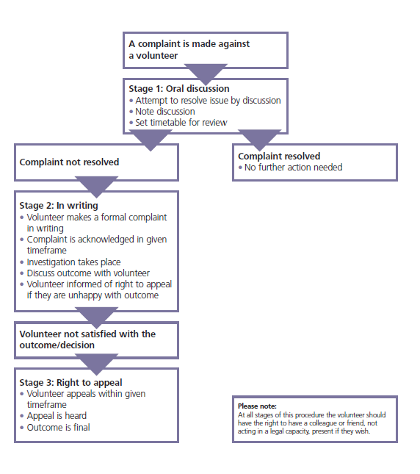

Appendix 2 – Managing Complaints Against Volunteers

To be read in conjunction with HRX40 Managing allegations against staff.

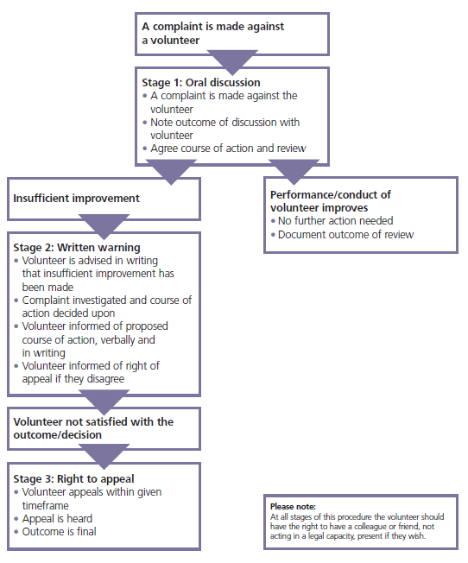

Appendix 3 Equality Impact Assessment

Equality Impact Assessments will be updated to include statistical data. Equality Impact Assessments will be updated and included in each Human Resource policy, as per the agreed 2022/23 HR EIA review schedule

