Communications toolkit
Here to help winter campaign
(V4. 09/12/24)

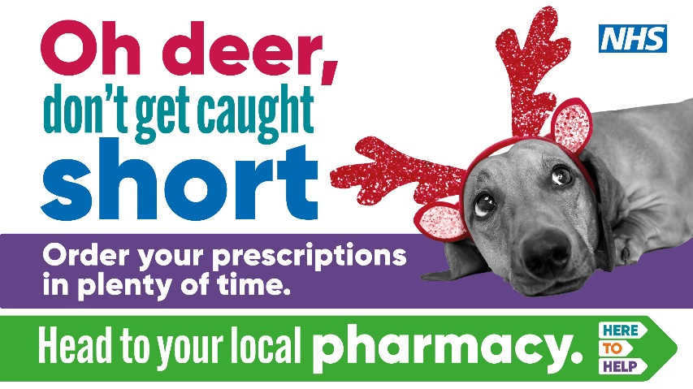
About this toolkit

This toolkit is for all NHS, local authority and VCSE sector communication leads, GP practices and local community pharmacies.

Working together across the region, we have created some key messages and visuals to support our communications with the public this winter, such as supporting them to stay well and safe this winter, and access the right NHS service for their needs.

This toolkit and all resources will be adapted and updated with alerts issued when new assets become available.

The full here to help winter toolkit can be accessed here.

This toolkit builds on the region's here to help campaign which signposts people to the most appropriate NHS service for their needs, and is backed by a regional wide media buy. This includes asking people to think pharmacy, 111 and GP first, as well as keeping A&E and 999 free for life threatening emergencies only. As well as specific campaigns to raise awareness of the importance of getting vaccinated and the conditions people can seek advice and treatment from their pharmacist, urgent treatment centres and much more.

Our website

A public facing 'here to help' campaign webpage is available on the ICB website here, with help and advice for the public about staying well, choosing the right NHS service, looking after your mental health, keeping a well-stocked medicine cabinet, signining up to the priority services register and getting your winter vaccines. Some of our social media and digital advertising directs people to these pages or nhs.uk where appropriate.

Pharmacy opening times
The website also includes bank holiday pharmacy opening times which are available here – please note these are opening times for Christmas and NYE bank holidays ONLY, the public should visit Find a Pharmacy for all other opening hours.

Social media plans

Enclosed in this toolkit are social media plans which include posts you can adapt, and instructions on how to access the relevant visuals.

The full social media toolkit and assets can be found here.

How you can help us

You can help us by:

- Posting and sharing content on your communication channels to help further promote the campaign across the region
- Getting in touch if you need any assets developed to meet your local needs.

Your support in sharing these messages is very much appreciated.

Please keep checking the toolkit as new content will be added regulary.

For further help or advice please contact either: Lee Hansom, lee.hansom@nhs.net, Abbie Mulgrew, abbie.mulgrew@nhs.net or NECSU.comms@nhs.net.

Here to help winter campaign

The campaign and messages cover:

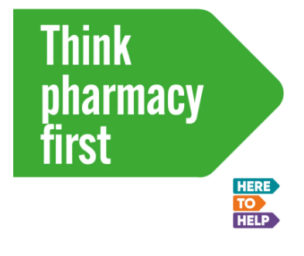 | Raising awareness of the services provided by local community pharmacists to help direct people to the right place for their needs and to help reduce pressure on GP and emergency health care services.  - Ordering repeat prescriptions in plenty of time  - What to do if you have forgotten to order your repeat prescription  - Keeping a well stocked medicine cabinet  - Think pharmacy first and services on offer  - Advice and treatment which is now available for urinary tract infections at your local pharmacy – Bye Bye UTI  - Minor ailments you can go to a pharamcy for – Got an itch? Gut feeling? Little problems?

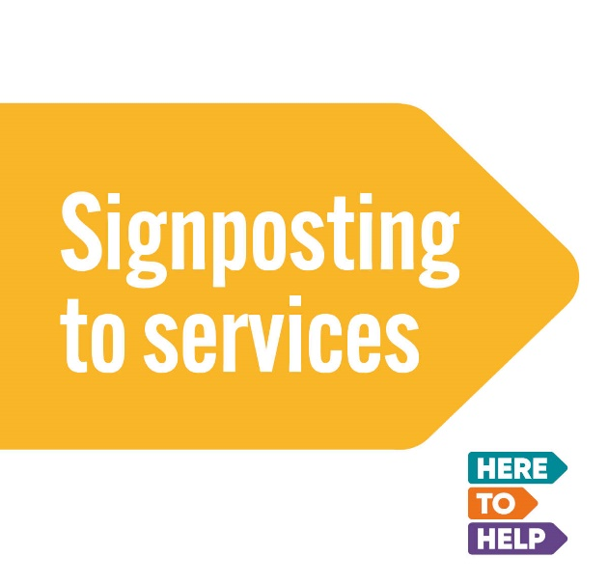 | Focusing on keeping people well by signposting them to the right service for their needs.  - NHS111 online and by phone  - GP  - Urgent treatment centres  - Mental health support and services  - A&E and 999 – when to call 999 or go to A&E

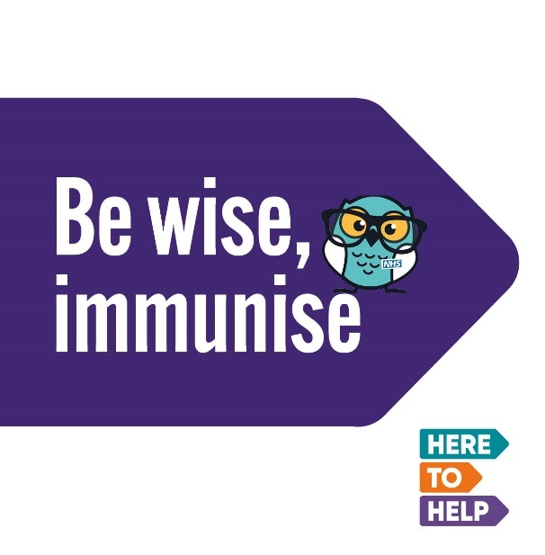 | Encouraging those eligible for a free flu and COVID-19 vaccintion including those aged over 65, pregnant women, people in a clinical at-risk group, carers, frontline health and social care worker, people with a learning disability. Those who live with someone who is immunosuppressed, 2-3 year olds and school age children from reception to year 11, to get protected this winter (flu only).  - Flu and COVID-19 vaccinations

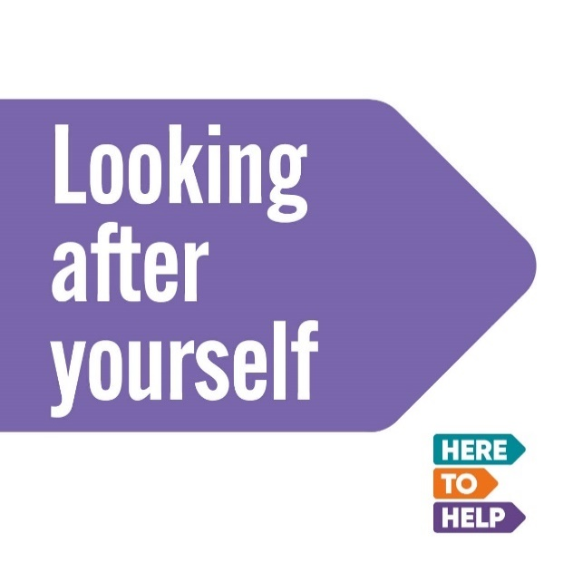 | Signposting people to online healthcare advice such as the healthier together website for parents of under 5s and young people, getting support to quit smoking and signing up to your energy suppliers priority services register and staying warm.  - Self care  - Support to quit smoking  - Sign up to the priority services register – stay switched on

Social media plan

Here to help winter messaging Christmas/bank holidays 2024/25

This social media plan provides content you can include in your social media posts. Animations and images can be downloaded from our toolkit here.

Please tag us in your social media posts:
Handles: Facebook – NorthEastandNorthCumbriaNHS, X – @NENC_NHS, Instagram – nenc_nhs

Hastags: #heretohelp

Repeat prescriptions
1. Ordering repeat prescriptions in time  Schedule from:  11 Dec to 20 Dec  &  27 Dec |  | Enough repeat medication to last you over the festive bank holiday?  Don’t get caught short this Christmas and New Year!  REMEMBER to order your repeat prescriptions in plenty of time.  Use the NHS App or visit your local pharmacy or GP surgery online ordering system.  Find pharmacy bank holiday opening hours in the North East and North Cumbria here.  #HereToHelp
2. Forgot your repeat prescription?  Schedule from:  21 Dec to 24 Dec  &  28 Dec to 31 Dec |  | What to do if YOU forget urgent repeat medication over the festive bank holidays!  If your local pharmacy is closed, you can get your medicine from an extended hours community pharmacy.  Click here to find available pharmacies and their opening hours over the festive bank holidays.  Or get ONLINE help at NHS111.  #NHS #HereToHelp | 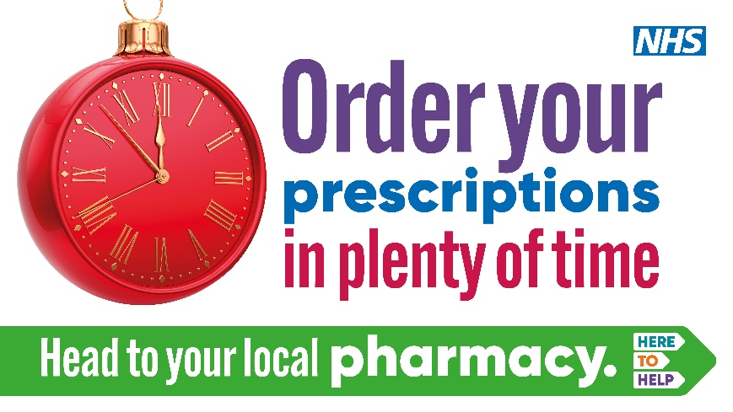

Well stocked medicine cabinet
3. Stock up on healthcare essentials  Schedule from:  11 Dec to 1 Jan |  | Be prepared over the festive holidays by keeping a well-stocked medicine cabinet at home.  Paracetamol, plasters, indigestion remedy, allergy relief and anti-diarrhoeal medicine are a good place to start!  Your local pharmacist can give you more advice.  Find pharmacy bank holiday opening hours in the North East and North Cumbria here.  #NHS #HereToHelp | 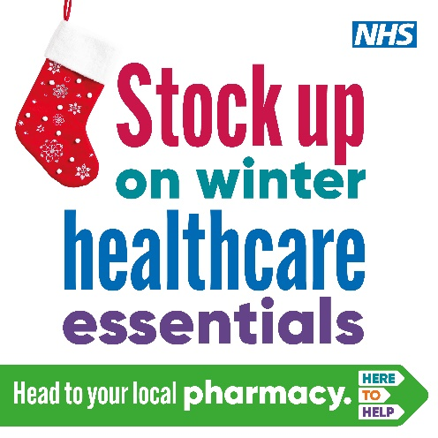  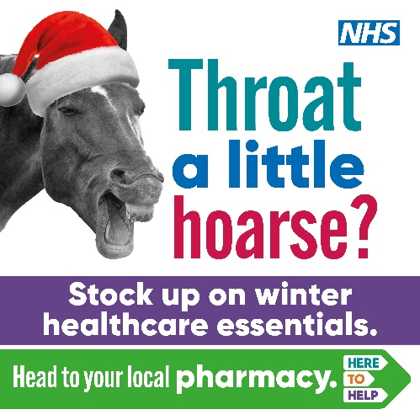 | Or you can use the video available in our online toolkit.
4. Think pharmacy first  Schedule from:  11 Dec to 1 Jan |  | Feeling ill this winter?  There are a number of NHS services available to you to provide the best health care for your needs.  Choosing the right NHS service will help get you the best advice, and often more quickly too.  - Think pharmacy first  - GP  - NHS 111 online for medical help and advice  - Keep A&E free for EMERGENCIES ONLY  Help reduce pressure on A&E and other services - so they can help those who need it most.  Click here to find available pharmacies and opening hours over the festive holidays. | 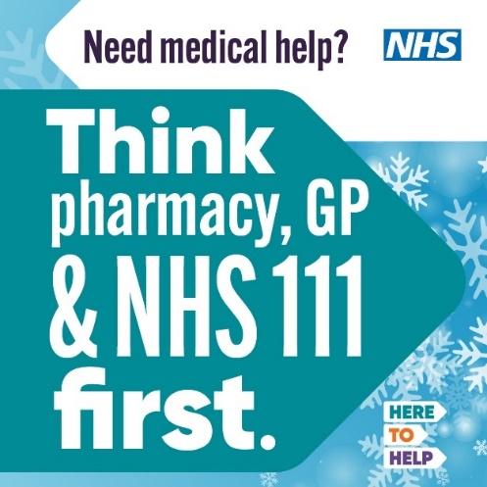 | Or you can use the animation available in our online toolkit.
5. Think pharmacy first  Schedule from:  21 Dec to 24 Dec  &  28 Dec to 31 Dec |  | If you have a health concern over the festive period, but your GP practice is closed, please think pharmacy first!  Your local pharmacy teams are experts in healthcare and can help with advice and treatment for a range of common conditions like coughs, colds, sore throats, upset stomachs and general aches and pains – no appointment needed.  Click here to find available pharmacies and opening hours over the holidays.  If in doubt, contact NHS111 online 24 hours a day, 7 days a week for advice. | 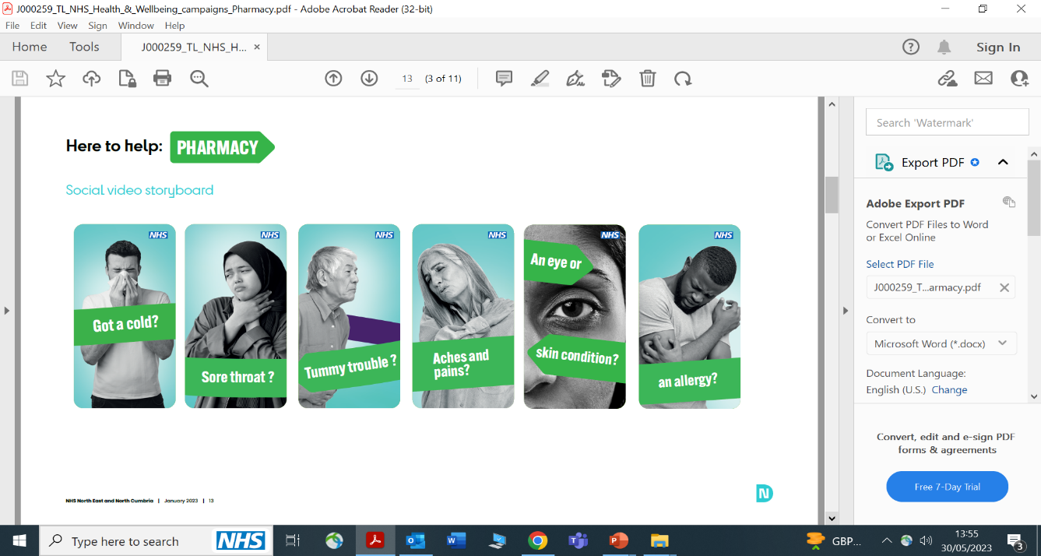  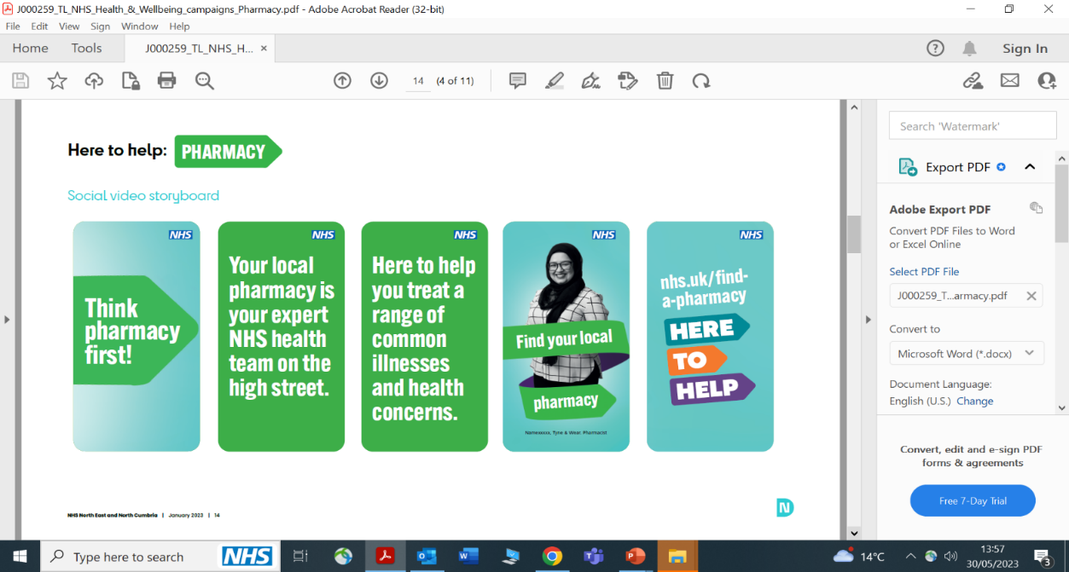  Or you can use the animation available in our online toolkit.

Pharmacy general
6. General message  Schedue from:  11 Dec Nov to 31 Mar  Target more from:  20 Dec to 24 Dec  &  27 Dec to 31 Dec | More than just a place to pick up a prescription!  Your local pharmacy teams are NHS experts in healthcare and can help you with advice and treatment for a range of common concerns including:  - hayfever/allergies  - tummy troubles  - itchy eyes or skin  - coughs  - colds  - sore throat  - aches and pains and many more…….  Find your nearest NHS community pharmacy at: https://www.nhs.uk/service-search/pharmacy/find-a-pharmacy  #NHS #HeretoHelp

UTI
7. UTI message  Schedule from:  11 Dec to 31 Mar  Target more from:  20 Dec to 24 Dec  &  27 Dec to 31 Dec | OUCH!  Burning or stinging sensation when you wee?  Need to wee frequently or urgently?  Now't much coming out?  You may have a Urinary Tract Infection.  Did you know across the North East & North Cumbria community pharmacies can provide immediate advice & treatment for UTIs for women aged 16-64.  No appointment needed.  Ask your local pharmacist today and say #Bye-ByeUTI  #HeretoHelp  Available at participating pharmacies only: https://www.thinkpharmacyfirst.health/ |  | 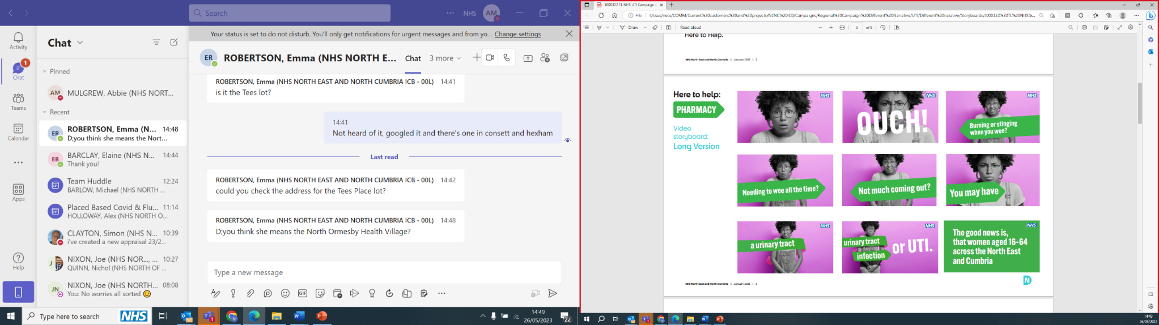 | Or you can use the animation available in our online toolkit.
8. UTI message  Schedule from:  11 Dec to 31 Mar  Target more from:  20 Dec to 24 Dec  &  27 Dec to 31 Dec | OUCH!  Do you have a burning sensation when weeing, need to wee frequently or urgently or have cloudy wee?  You may have a Urinary Tract Infection!  Pharmacists in the North East & North Cumbria can provide immediate advice and appropriate treatment for UTIs for women aged 16-64 with no appointment needed!  Ask your local pharmacist today and say #ByeByeUTI  #HeretoHelp  Available at participating pharmacies only: https://www.thinkpharmacyfirst.health/ |  | 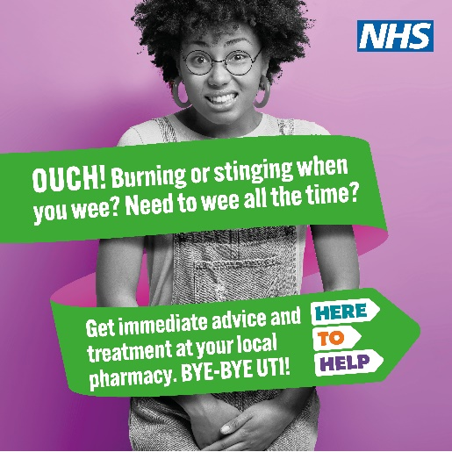

Minor ailments
9. Got an itch? message  Schedule from:  11 Dec to 31 Mar  Target more from:  20 Dec to 24 Dec  &  27 Dec to 31 Dec | Got an Itch?  Dry skin, eczema, thrush, fungal skin infections  Head straight to your local pharmacy…  Pharmacists are qualified experts in healthcare and medicines and can give you advice and treatment for a range of common health concerns.  Find out more here.  #HeretoHelp  #NotJustAPlaceToPickUpAPrescription |  | 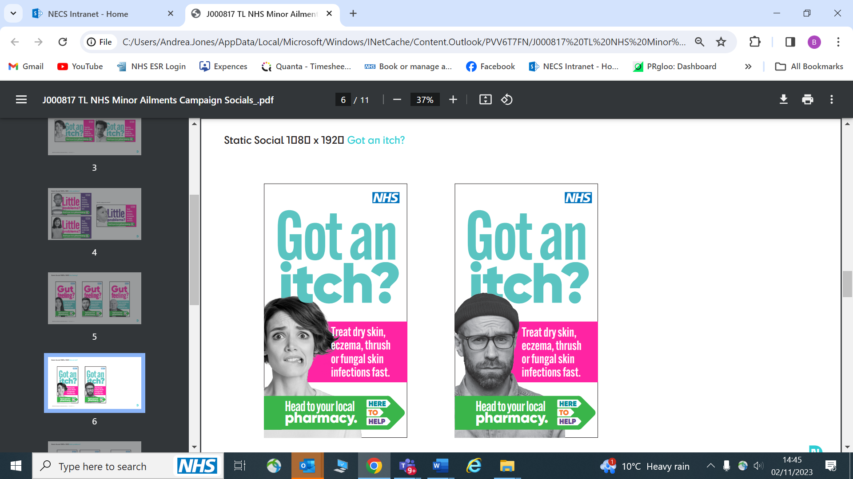  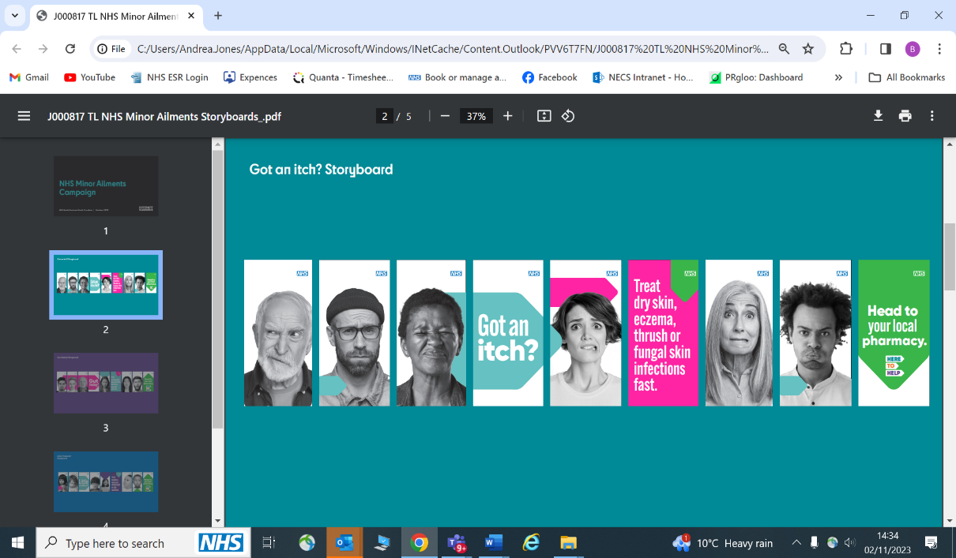  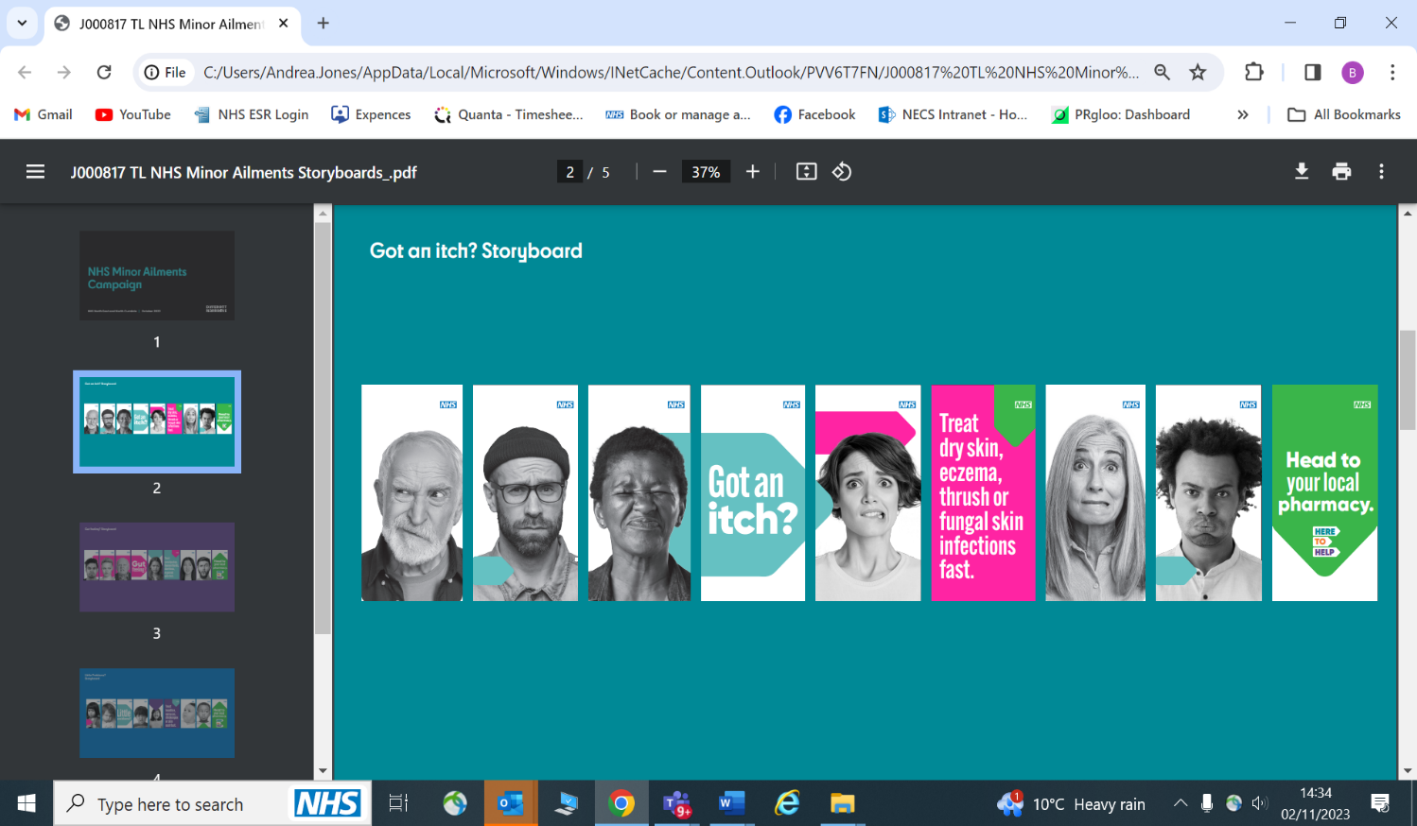  Or you can use the animation available in our online toolkit.
10. Gut feeling? message  Schedule from:  11 Dec to 31 Mar  Target more from:  20 Dec to 24 Dec  &  27 Dec to 31 Dec | Gut feeling?  Constipation, diarrhoea, haemorrhoids, period pain  Head straight to your local pharmacy…  Pharmacists are qualified experts in healthcare and medicines and can give you advice and treatment for a range of common health concerns.  Find your nearest NHS community pharmacy here  #HeretoHelp  #NotJustAPlaceToPickUpAPrescription |  | 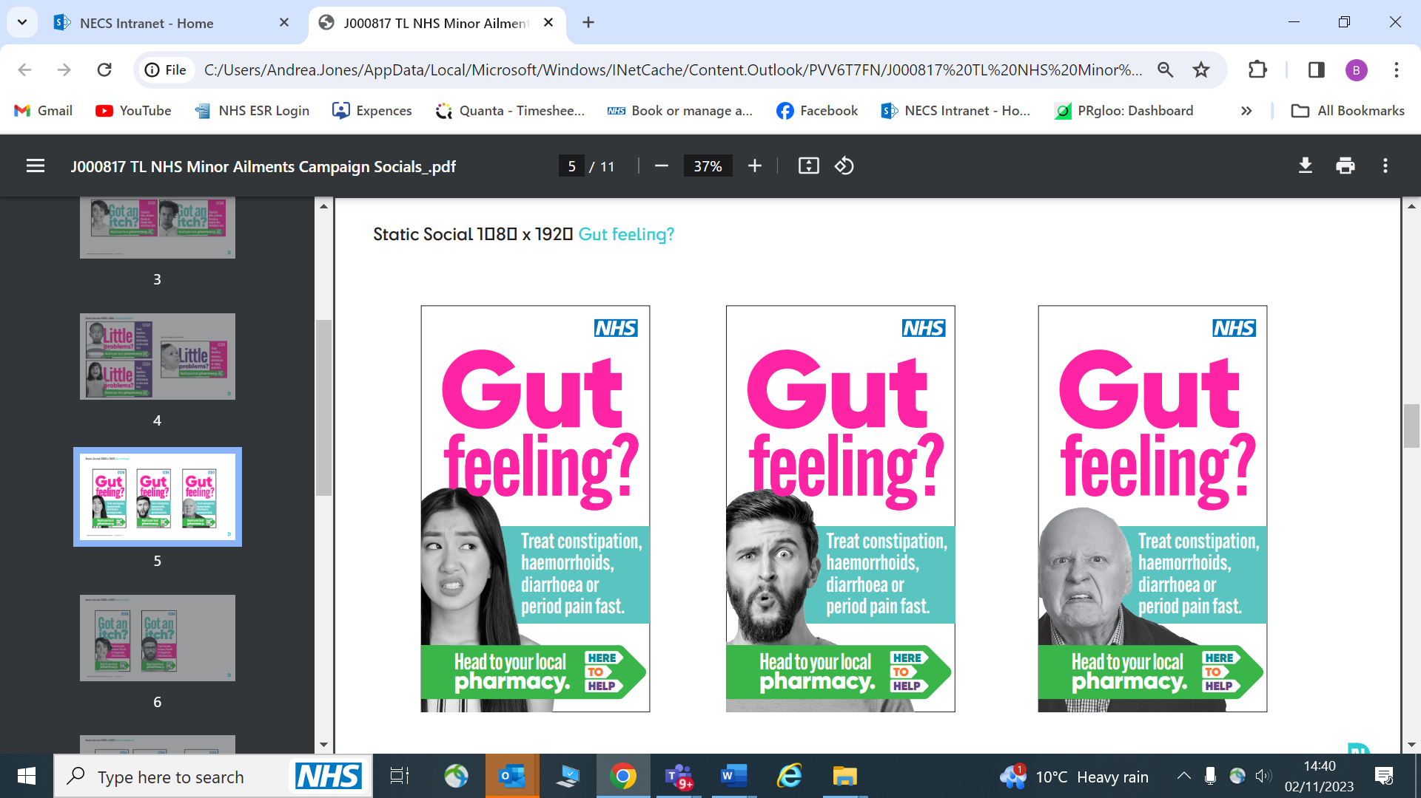  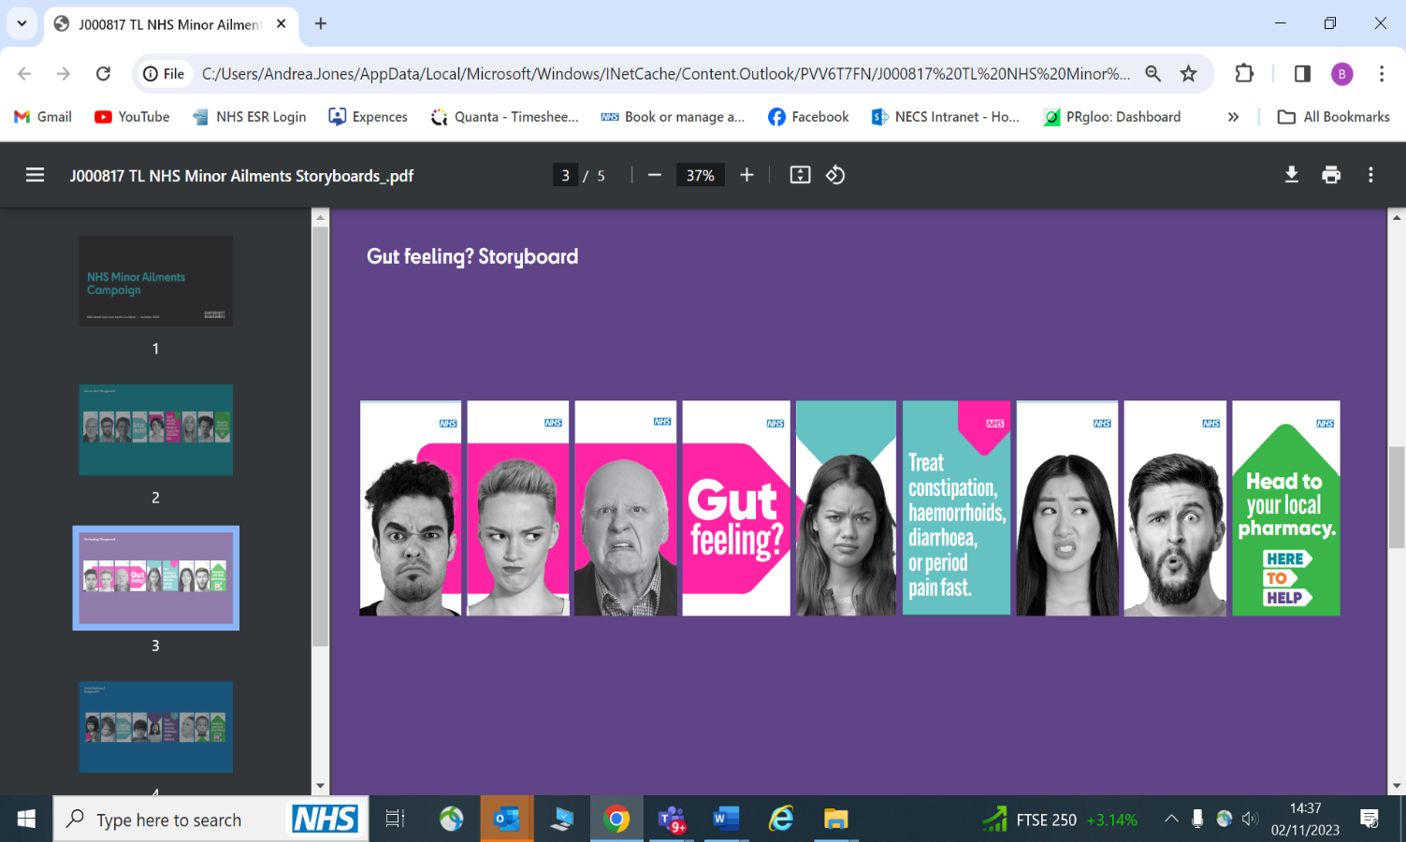  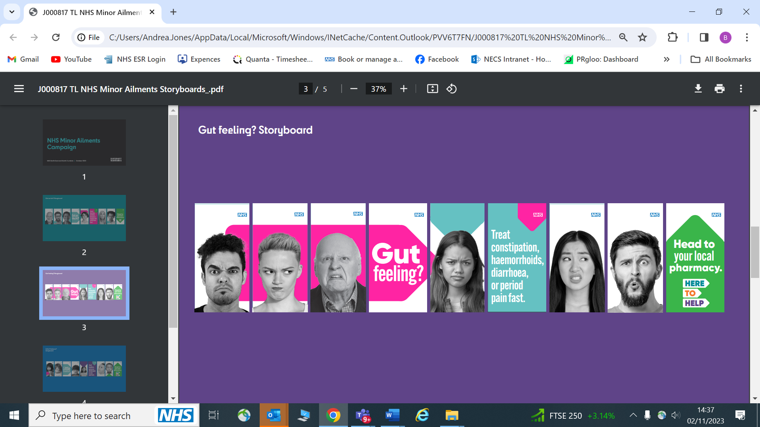 | Or you can use the animation available in our online toolkit.
11. Little one not well? message  Schedule from:  11 Dec to 31 Mar  Target more from:  20 Dec to 24 Dec  &  27 Dec to 31 Dec | Little one not well?  Headlice, verruca, chicken pox, nappy rash  Head straight to your local pharmacy…  Pharmacists are qualified experts in healthcare and medicines and can give you advice and treatment for a range of common health concerns for your little ones.  Find your nearest NHS community pharmacy here  #HeretoHelp  #NotJustAPlaceToPickUpAPrescription |  | 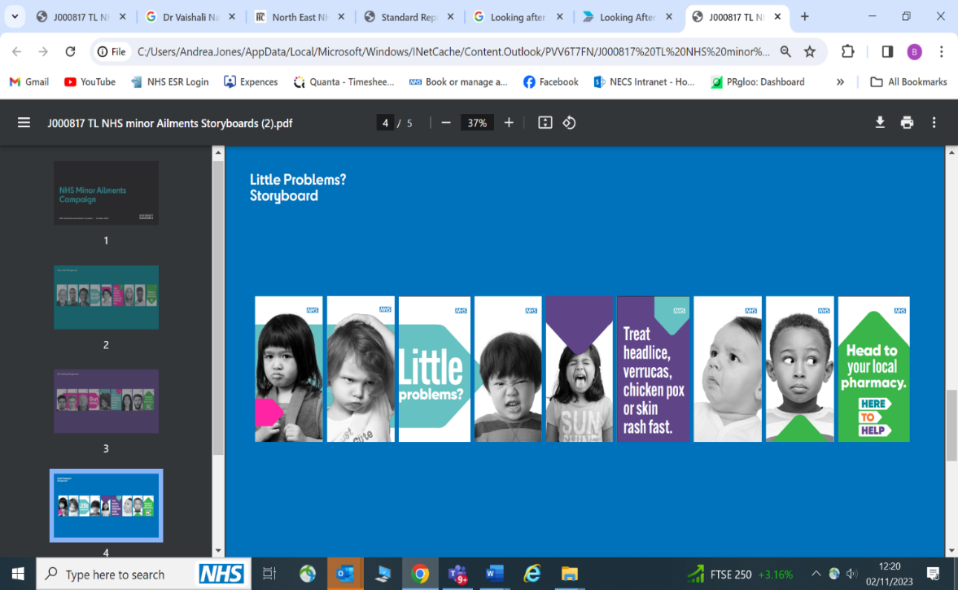  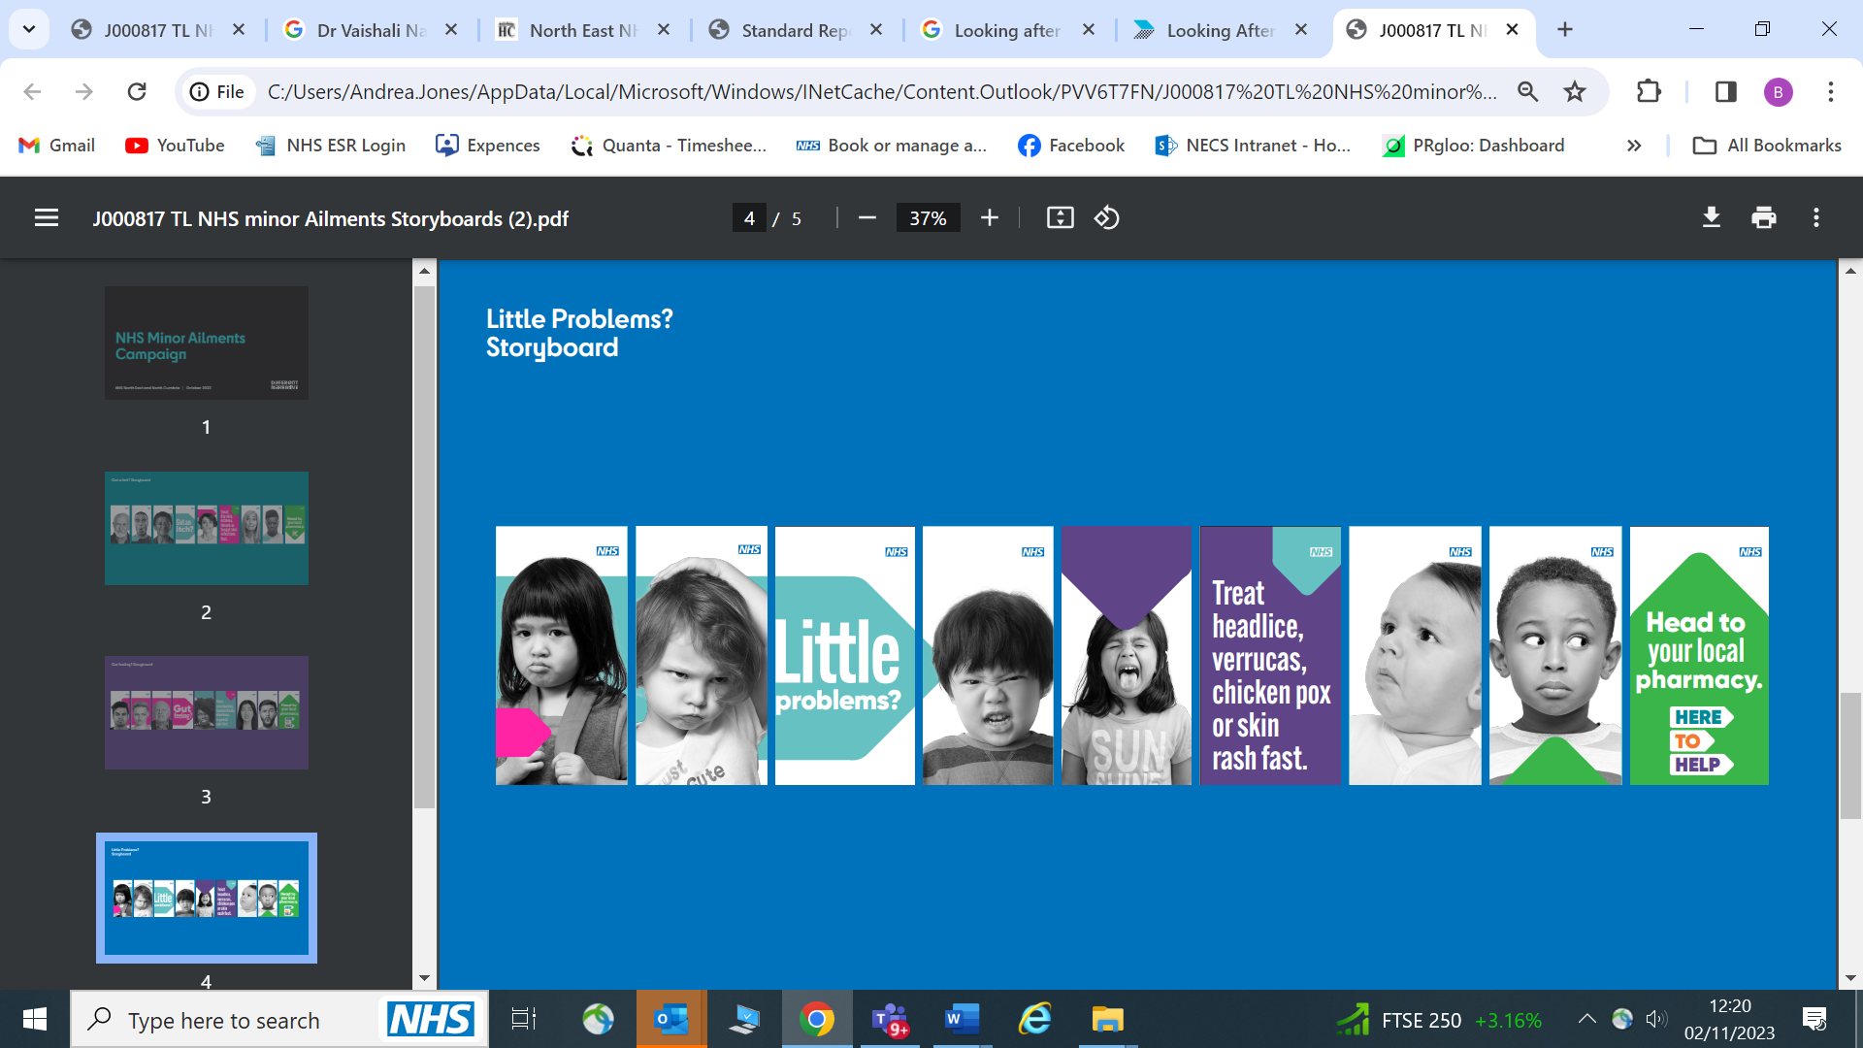  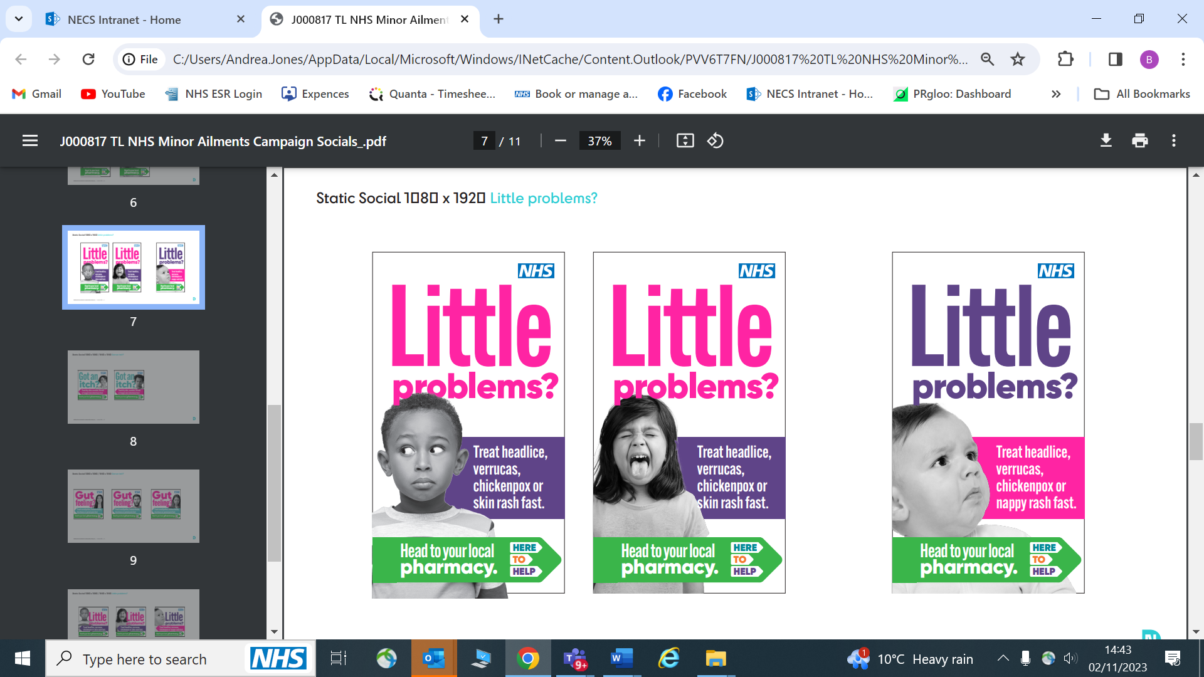 | Or you can use the animation available in our online toolkit.

Flu vaccinations
12. Flu vaccinations  Schedule from:  11 Dec to 28 Mar |  | Be wise – immunise!  It's still not too late to get your flu vaccination to keep you and those around you safe during the festive season.  If you're over 65, pregnant, in a clinical at-risk group, a carer, a health and social care worker, have a learning disability or live with someone who is immunosuppressed, flu vaccinations are available at your GP or local pharmacy. | 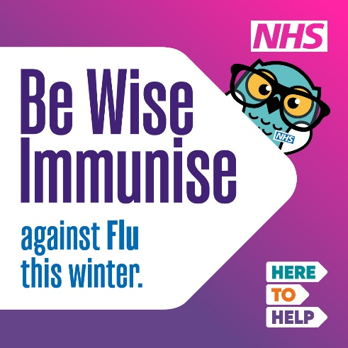

NHS111
13. NHS111  Schedule from:  11 Dec to 31 Jan |  | Get to the help you need ….. when you need it!  When it’s not life threatening but still urgent  or  - You think you might need to go to a hospital or urgent treatment centre but you're not sure  - You need urgent advice and your GP surgery is closed.  NHS111 is here is to help 24 hours a day,7 days a week online or by phone.  #HeretoHelp | 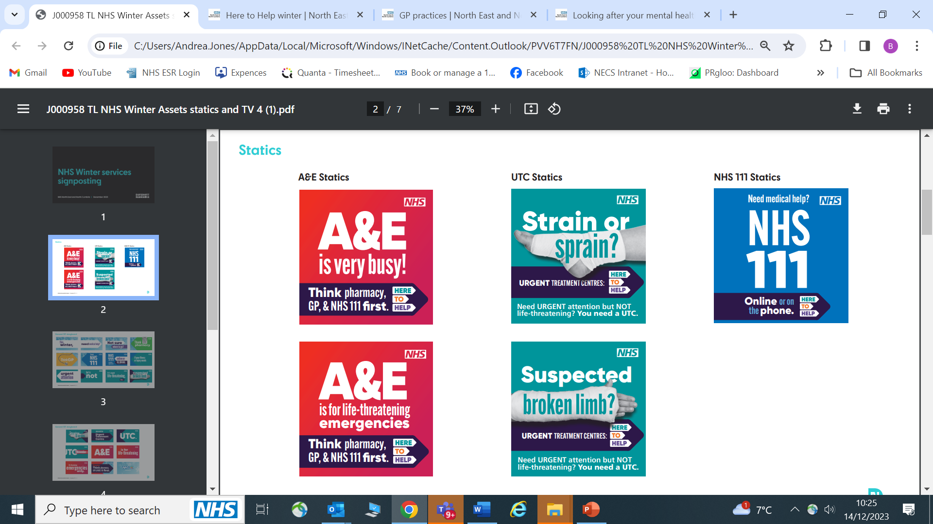

UTC
14. Urgent Treatment Centre  11 Dec to 31 Jan |  | If you have a minor injury or illness that needs medical attention – but is not life threatening - you can get help at your nearest urgent treatment centre!  Urgent treatment centres can treat many conditions including:  - sprains and strains  - cuts and grazes  - suspected broken limbs  - coughs and cold  - ear and throat infections  If you're still not sure where to go or what to do, contact NHS111 online - or by phone - 24 hours a day, 7 days a week - they can help assess and direct you to the right place to go.  NHS, we're #HeretoHelp |  | Or you can use the animation available in our online toolkit.

Mental Health
15. NHS 111 mental health option  Schedule from:  11 Dec to 31 Jan |  | If someone’s mental or emotional state gets worse quickly, this can be referred to as a mental health crisis or a mental health emergency.  If you, or someone you know experiences this, you should get help as soon as possible.  24/7 support is available by calling NHS 111 and selecting the mental health option.  A mental health professional will listen to you and help you find the right support for you.  Find out more - https://northeastnorthcumbria.nhs.uk/here-to-help-winter/looking-after-your-mental-health/ | 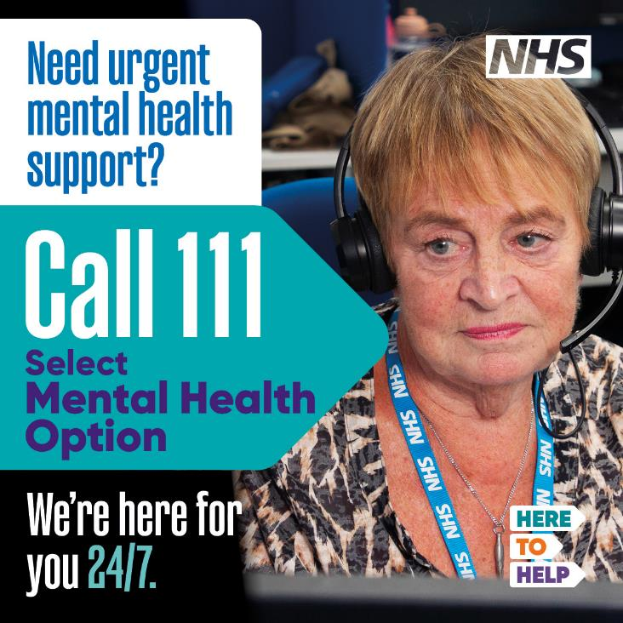
16. NHS 111 mental health option  Schedule from:  11 Dec to 31 Jan |  | If you, or someone you know, is struggling with their mental health, there is a range of support available:  - Self help  - Mental health support from your GP practice  - Talking Therapies  - Urgent crisis support  In a mental health crisis, you may feel unable to cope with day-to-day life or work, you might think about harming yourself, or you might experience hallucinations and hear voices.  If this happens, it’s important to get help quickly.  You can call NHS 111 and select the mental health option for 24/7 support from mental health professionals.  Find out more - https://northeastnorthcumbria.nhs.uk/here-to-help-winter/looking-after-your-mental-health/ | 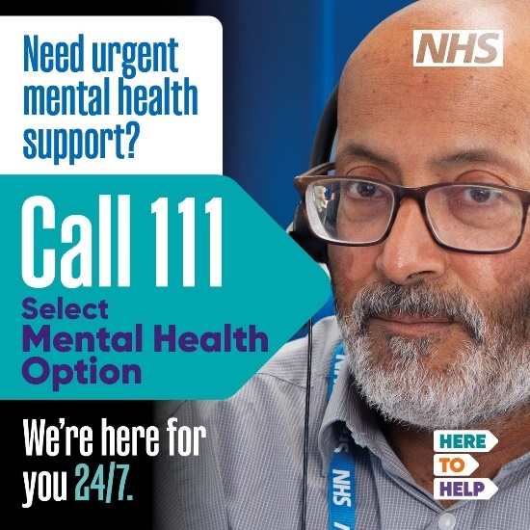
17. NHS 111 mental health option  Schedule from:  11 Dec to 31 Jan |  | If you, or someone you know, is experiencing a mental health crisis, call NHS 111 and select the mental health option. NHS 111 is available 24/7.  Call if you are worried about:  - thoughts about your life not being worth living or about harming yourself  - feeling out of control or unable to cope  - feeling anxious about leaving the house  - hearing voices or seeing things that others can’t  To help you get the support you need, you will speak to a mental health advisor who will ask you some questions and listen to you.  If you or someone else have physically harmed themselves, or if their life is at risk, then you should still call 999 or go to A&E.  If you are deaf or have hearing loss please use NHS 111 – SignVideo or use the 18001 111 Relay UK app. | 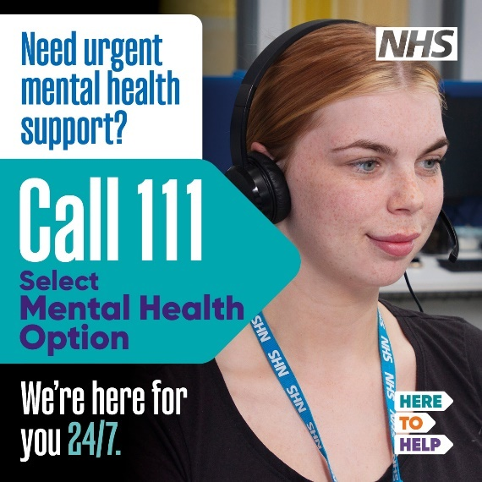
18. NHS 111 mental health option  Schedule from:  11 Dec to 31 Jan |  | If you experience mental health problems, it can be frightening, and you may feel alone.  A mental health crisis can mean different things to different people, but often means that you no longer feel able to cope or in control of your situation.  If you, or someone you know experiences this, it is important to get help quickly.  - Call NHS 111 and select the mental health option.  Available 24/7, you will speak to a mental health professional who can listen to you and help you find the right support.  Find out more - https://northeastnorthcumbria.nhs.uk/here-to-help-winter/looking-after-your-mental-health/ | 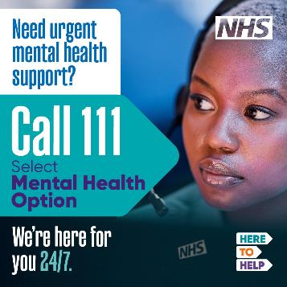
19. Self care  Schedule from:  11 Dec to 31 Jan |  | There are some tried-and-tested ways to understand how you’re feeling and feel better.  Clinical experts, and people who’ve faced these problems themselves, have written our self-help guides. The guides give advice and walk you through some practical exercises. They’re based on techniques proven to help people feel better.  The guides cover topics like  - alcohol  - anxiety  - bereavement / grief  - depression  - childhood and domestic abuse  - eating disorder  - hearing voice  - managing anger  - obsessions and compulsions  - panic attacks  - post-traumatic stress  - postnatal depression  - self-harm  - sleeping problems  - stress  - and more  These self-help guides are available for free online. You can get versions in large print, Easy Read, audio and BSL.  Online mindfulness and relaxation exercises might help you to feel better. And you can try free, online ‘Recovery College’ courses.  Explore self-help information at https://northeastnorthcumbria.nhs.uk/here-to-help-winter/looking-after-your-mental-health/ | 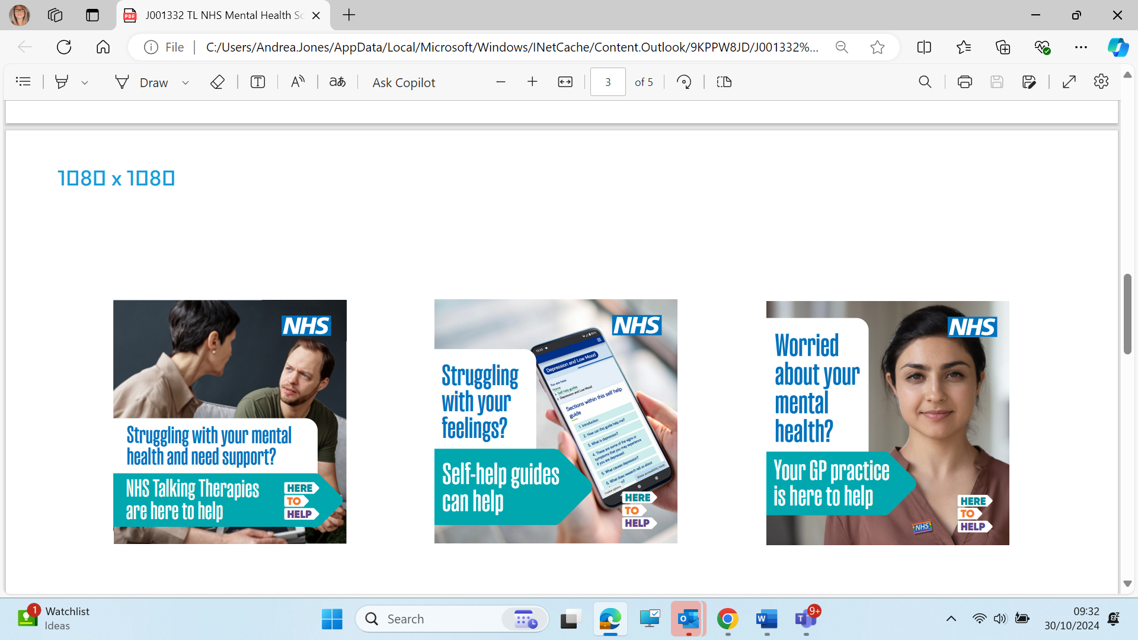
20. GP  Schedule from:  11 Dec to 31 Jan |  | It's not always easy to start a conversation about your personal feelings with your GP, especially when you're not feeling well. But it's usually the first step towards working out what kind of treatment and support might help you.  Lots of GPs in the North East and Cumbria have mental health nurses and practitioners working in their surgeries. So, you may be able to get specialist support and treatment at your usual GP practice. | 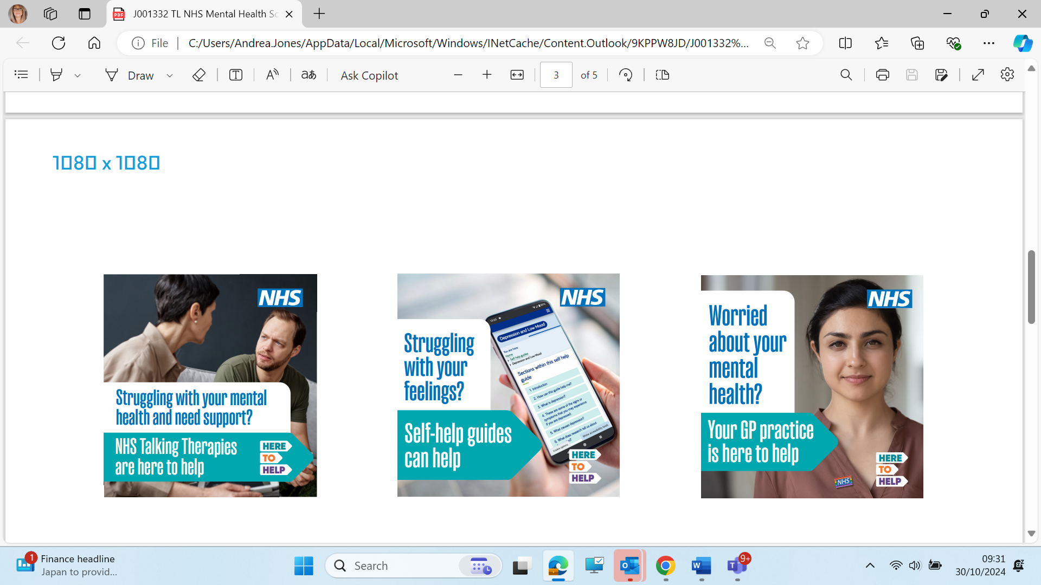
21. Talking Therapies  Schedule from:  11 Dec to 31 Jan |  | Struggling with feeling depressed, worrying a lot, social anxiety, post-traumatic stress, or obsessions and compulsions? NHS Talking Therapies are here to help.  You don’t need a diagnosis to get support. The sooner you reach out, the sooner we can help you feel better.  Talking Therapies are free, and confidential. You’ll be treated by trained clinicians, online, on the phone, or in person.  Your GP can refer you, or you can refer yourself at nhs.uk/talk |  | Or you can use one of the videos in our online toolkit.
GP practices
22. Talking Therapies  Schedule from:  11 Dec to 31 Jan |  | GP phone lines can be very busy, especially in the mornings.  Save yourself a wait by calling later in the day, if possible, for non-urgent appointments or test results.  Alternatively, if available, you can use your practice's online booking services, available on their website, or use the NHS app.  You may also be able to email your practice for medication requests and other general queries.  Need help using the app?  Visit www.nhs.uk/helpmeapp  Or visit your practice website for more information.  #HeretoHelp | 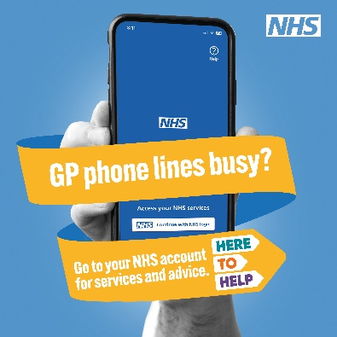 | Or you can use the animation available in our online toolkit.

A&E and 999 – only use these assets in times of high pressure!
22. A&E  Only for use in times of high pressure |  | This festive season - Please remember ONLY call 999 or go to A&E if you or someone else has a life -threatening emergency, such as:  • signs of a heart attack  chest pain, pressure, heaviness, tightness or squeezing across the chest  • signs of a stroke  face dropping on one side, cannot hold both arms up, difficulty speaking  • sudden confusion  cannot be sure of own name or age  • suicide attempt  by taking something or self -harming  • severe difficulty breathing  not being able to get words out, choking or gasping  • choking  on liquids or solids right now  • heavy bleeding  spraying, pouring or enough to make a puddle  • severe injuries  after a serious accident or assault 9  • seizure (fit)  shaking or jerking because of a fit, or unconscious (cannot be woken up)  • sudden, rapid swelling  of the lips, mouth, throat or tongue  If you need EMERGENCY care, call 999, or go to your nearest A&E.  British Sign Language (BSL) speakers can make a BSL video call to 999.  Deaf people can use 18000 to contact 999 using text relay.  If in doubt, contact NHS111, online or by phone, to get assessed and directed to the right place for you - including emergency care.  #HereToHelp
23. A&E is very busy  Only for use in times of high pressure |  | A&E departments are extremely busy  Think pharmacy, GP or NHS111 first!  Too many people who come to A&E don't need to be there. Their illnesses and injuries can be dealt with quicker by an alternative service freeing up emergency services for those who really need them.  If in doubt, contact NHS111 online or by phone, to get assessed and directed to the right place for you - including emergency care.  If you go to A&E and your condition isn't life threatening, you may experience a very long wait.  #HereToHelp
24. A&E and 999 are busy  Only for use in times of high pressure |  | A&E and 999 are extremely busy  Think pharmacy, GP or NHS 111 first!  Too many people who come to A&E don't need to be there. Their illnesses and injuries can be dealt with quicker by an alternative service freeing up emergency services for those who really need them.  If in doubt, contact NHS111 online or by phone, to get assessed and directed to the right place for you - including emergency care.  If you go to A&E and your condition isn't life threatening, you may experience a very long wait.  #HereToHelp | 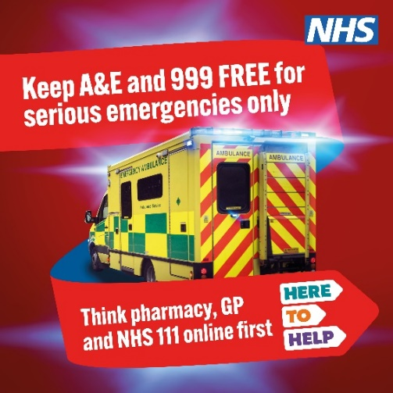

Self-care
25. Little orange book  Schedule from:  11 Dec to 31 Jan |  | Poorly baby or child this winter?  Download the LITTLE ORANGE BOOK!  It contains online advice for parents of under 5s on a wide range of illnesses in children from common minor concerns to more serious conditions.  Find out more here: www.nenc-healthiertogether.nhs.uk  #NHS #HereToHelp | 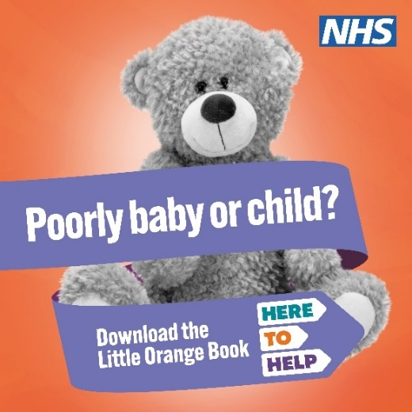
21. Healthier together  Schedule from:  11 Dec to 31 Jan |  | Little one not well?  Visit the Healthier Together website  www.nenc-healthiertogether.nhs.uk  For online advice to help manage and improve the health and wellbeing of babies, children and young people.  #NHS #HereToHelp | 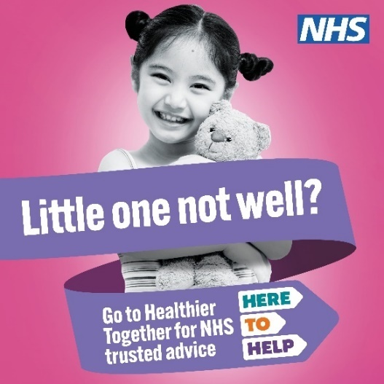 | Or you can use the animation available in our online toolkit.

Smoking
22. Quit smoking  Schedule from:  11 Dec to 31 Feb |  | If you smoke, quitting is an important part of looking after your health this winter.  Quitting reduces the risks from flu, pneumonia and COVID-19, as well as COPD, heart attack and stroke!  We’re here to help this winter.  Visit www.freshquit.co.uk for support to quit | To download campaign material go to:  https://www.fresh-balance.co.uk/campaigns/smoking-survivors/

Priority register – stay switched on
23. Sign up to the priority register  Schedule from:  11 Dec to 31 Feb |  | As winter bites it's good to have all bases covered!  Every energy supplier has a priority services register.  Signing up lets them know you may need extra free support like advance notice of power cuts, priority support in an emergency or sending bills to a family member or carer and much more.  Check if you're eligible at www.ofgem.gov.uk/get-help-your-supplier-priority-services-register  @ofgem | 