North East and North Cumbria
Staff Wellbeing Hub – Communications toolkit v.2

Contents:
What is the Staff Wellbeing Hub?
Key messages
Newsletter template copy – long
Newsletter template copy – short
Website article template copy
Posters and leaflets
Social media copy and images
Signature banner

What is the Staff Wellbeing Hub?
The Staff Wellbeing Hub has been set up by the North East and North Cumbria Integrated Care System. It will support our region’s health and care staff to access what they need to stay mentally well throughout the COVID-19 pandemic.
The Hub isn’t replacing other services. Instead, the Hub brings together the many pieces of exemplary work organisations across our region are already doing to help staff stay well. Where there are gaps in the support on offer to staff, organisations across the Integrated Care System and beyond are working together through the Hub, extending their offers of help or resources to plug those gaps.
Our team of expert Link Workers are reaching out to those staff who may be most at risk of suffering, offering them direct support.
We will also help staff navigate what’s available, so they can quickly and confidentially get the help that’s right for them when they need it.
Some of the things that the Hub offers are:
- A helpline offering information, advice, and guidance to help staff navigate the support available for their needs. It can also arrange call-backs from experienced NHS psychological therapists if required.
- An online Wellbeing Diary, to help people track their mood and understand what helps them stay well.
- A wellbeing toolkit, with short and practical self-help exercises.
- A range of support offers, including coaching for managers to help them look after their team, group support such as Balint Groups for clinicians and teams, and other ways to regulate and manage stress.
- One-to-one sessions with experienced NHS therapists and clinicians, on a one-time or ongoing basis.
- Free webinars to help staff understand and adapt to what we are going through.
More information about the Hub can be found at:
http://www.northeastandnorthcumbriaics.nhs.uk/staff-wellbeing-hub

Key messages:
- It’s normal to feel anxious, sad, or overwhelmed in response to the pressures of the COVID-19 pandemic, but these feelings can be difficult to manage sometimes.
- Looking after ourselves as well as our patients/service users has never been so important.
- There are some simple steps you can take to help prevent things from getting worse.
- There might be specialist support that can help you with reactions to these pressures too.
- We know it can be hard for staff who are tired and under pressure to navigate all the different offers of help that are out there; that’s where the Staff Wellbeing Hub comes in.
- By caring for each other, we make the whole health and care system stronger. There is strength in asking for help.
- When you’re under pressure and at risk of feeling overwhelmed, you can turn to the Hub.

Newsletter template copy - long:
There’s strength in asking for support – turn to the Staff Wellbeing Hub
The pressures of the COVID-19 pandemic have affected every one of us, both at home and at work. It’s normal to feel anxious, sad, or overwhelmed in response to such stressful circumstances, but these feelings can be difficult to manage sometimes.
There are some simple steps you can take to help prevent things from getting worse. There might be specialist support that can help with certain reactions to these pressures too.
But it can be hard to navigate all the different offers of help that are out there. That’s where the Staff Wellbeing Hub comes in.
The Staff Wellbeing Hub has been set up by the North East and North Cumbria Integrated Care System. It is supporting our region’s health and care staff to access what they need to stay mentally well throughout the COVID-19 pandemic.
The Hub offers:
- A helpline providing a listening ear as well as information, advice, and guidance, to help you find the support you need. It can also arrange call-backs from experienced NHS psychological therapists if you need to talk to someone about what you are going through.
- A range of support offers, including coaching for managers to help you look after your team, group support such as Balint Groups for clinicians and teams, and other ways to regulate the stress in your body or mind.
- An online Wellbeing Diary, to help you track your mood and understand what helps you stay well.
- A wellbeing toolkit, with short and practical self-help exercises.
- Free webinars to help staff understand and adapt to what we are going through.
You can call the Hub’s confidential helpline on 0191 223 2030 to get support.
The helpline is available seven days a week, inc. Bank Holidays, from 7am-9pm.
Therapists are available between 12-6pm Monday to Friday; if you call outside these hours and need to speak to a therapist, helpline staff will arrange for a therapist to call you back at the soonest suitable time.
The Hub isn’t replacing other services. Instead, the Hub brings together the many pieces of exemplary work organisations across our region are already doing to help staff stay well.
To find out more about the Staff Wellbeing Hub, visit the ICS website.
If you have any queries, please email HubsTheWord@cntw.nhs.uk.

Newsletter template copy - short:
New Regional Staff Wellbeing Hub
The Staff Wellbeing Hub has been set up by the North East and North Cumbria Integrated Care System. It is supporting our region’s health and care staff to access what they need to stay mentally well throughout the COVID-19 pandemic.
The Hub is providing a range of support, including: a confidential helpline; coaching for managers, group support (such as Balint Groups) for clinicians and teams; an online Wellbeing Diary; a wellbeing toolkit with short and practical self-help exercises; free webinars; and other ways to regulate the stress in your body or mind.
To get support, you can call the Hub on 0191 223 2030, seven days a week, inc. Bank Holidays, from 7am-9pm. Therapists are available between 12-6pm Monday to Friday; if you call outside these hours and need to speak to a therapist, helpline staff will arrange for a therapist to call you back at the soonest suitable time.
To find out more about the Staff Wellbeing Hub, visit the ICS website.
If you have any queries, please email HubsTheWord@cntw.nhs.uk

Website article template copy:
The Hub launch press release on the ICS website can be used as a template for news articles.

Posters and leaflets:
Printed A4 posters and A5 leaflets can be requested by emailing HubsTheWord@cntw.nhs.uk
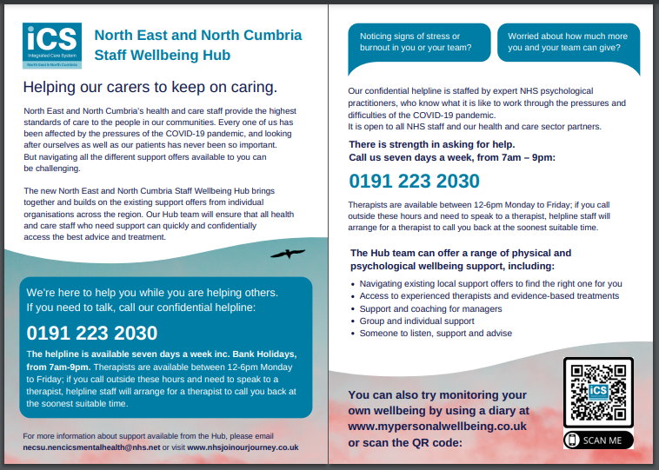
PDF copies can be downloaded by clicking the images below:
A5 leaflet:

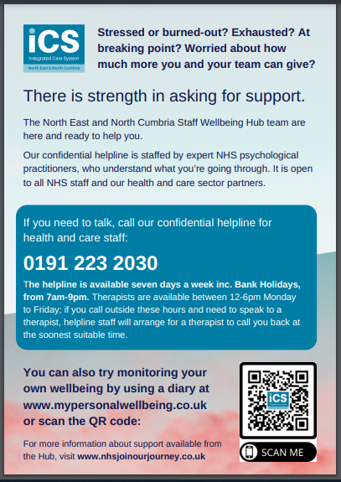
A4 poster:

Social media copy and images:
Across social media, we are encouraging people to tweet about the Staff Wellbeing Hub using the hashtag #HubsTheWord - emphasising that when staff are under pressure and feeling overwhelmed, it’s simply ‘Hub’s the word’ they need to remember to find support.
Below are a variety of template posts to use across social media platforms, along with suggested images (available to download below).
You are welcome to adapt these as required for different platforms/audiences.
Do you work in health or care in the North East or North Cumbria?  Are you feeling anxious, sad or overwhelmed, and finding it hard to manage?  It’s normal to feel this way during this pandemic - but there is support out there to help you before things get worse.  The NENC ICS Staff Wellbeing Hub is a one-stop place where health and care staff can access whatever they need to stay mentally well throughout the COVID-19 pandemic. #HubsTheWord  Go to http://www.northeastandnorthcumbriaics.nhs.uk/staff-wellbeing-hub/ | 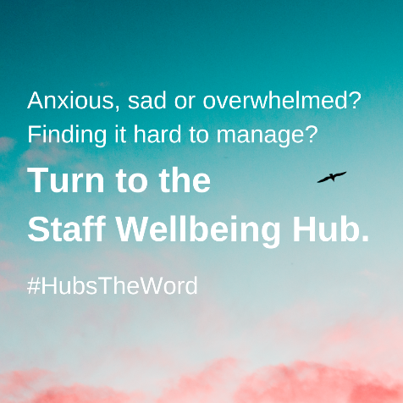
Our region’s health and care staff continue to provide amazing care to our communities in the face of the pressures of COVID-19.  But if you work in health or care, it’s important that you’re supported to stay well too.  That’s where our Staff Wellbeing Hub comes in. Don’t know where to turn for support? #HubsTheWord. Our expert team have gathered simple resources to help you stay well, and will help you get more support if you need it.  Go to http://www.northeastandnorthcumbriaics.nhs.uk/staff-wellbeing-hub/ | 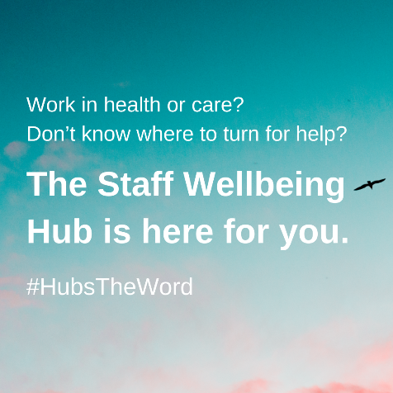
If you’re working in health or care during this pandemic, it’s normal to feel anxious, sad or overwhelmed in such stressful circumstances. But we know these feelings can be difficult to manage sometimes - and it can be overwhelming to know where to get more support.  That’s where our Staff Wellbeing Hub comes in. Want to quickly find what you need to stay well? #HubsTheWord. Our expert team have gathered simple resources to look after your wellbeing, and can help you get more support if you need it.  Go to http://www.northeastandnorthcumbriaics.nhs.uk/staff-wellbeing-hub/ | 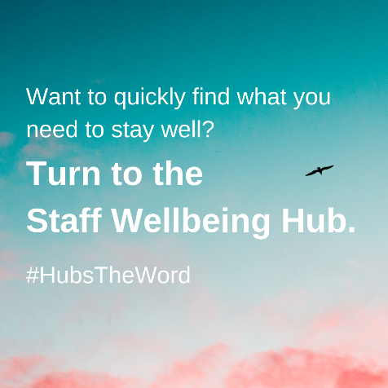
The pressures of the COVID-19 pandemic have affected every one of us working in health and care, both at home and at work. But there are some simple things you can do to look after your wellbeing. There might be specialist support that can help with certain issues too.
That’s where our Staff Wellbeing Hub comes in. Need to quickly find support and resources to stay well? #HubsTheWord. Our expert team have gathered simple resources to look after your wellbeing, and can help you access specialist support if you need it.
Go to http://www.northeastandnorthcumbriaics.nhs.uk/staff-wellbeing-hub/

You’re working in health or care. You’re – understandably! – feeling stressed, worried or even quite overwhelmed, in the face of this pandemic. You know there’s lots of support out there…but when you’re busy and tired, it can be hard to figure out what’s the best option for YOU.  That’s where our Staff Wellbeing Hub comes in. Our expert team will help you navigate what’s available, so you can quickly and confidentially get the help that’s just right for you, when you need it.  #HubsTheWord. Go to http://www.northeastandnorthcumbriaics.nhs.uk/staff-wellbeing-hub/ | 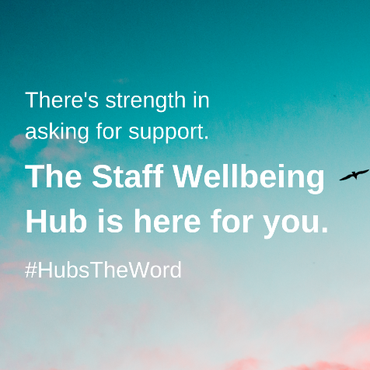
If you work in health or care in the North East or North Cumbria, and you don’t know where to start with getting support to stay well during the COVID-19 pandemic, you can turn to the Staff Wellbeing Hub.
The Hub team are supporting our region’s health and care staff to get help quickly and confidentially.
#HubsTheWord. Go to http://www.northeastandnorthcumbriaics.nhs.uk/staff-wellbeing-hub/

Do you work in health or care? Feeling stressed or at risk of ‘burning out’? Worried about how much more you and your team can give?
There is strength in asking for support – but we know it can be hard to navigate everything that’s out there.
That’s where our Staff Wellbeing Hub comes in. Our expert team are here and ready to help you. The Hub is a one-stop place where health and care staff can access whatever help they need to stay mentally well throughout the COVID-19 pandemic.
#HubsTheWord. Go to http://www.northeastandnorthcumbriaics.nhs.uk/staff-wellbeing-hub/

Working in health and care during the Covid-19 pandemic is putting us under stress like we’ve never experienced before.
If you’re struggling to cope and don’t know where to turn, the North East and North Cumbria Staff Wellbeing Hub team are here for you.
Call our confidential staff helpline, to speak to staff who understand how you feel and can help you to find the support you need.
Call 0191 223 2030 7 days a week 7am-9pm. #HubsTheWord
More info: http://www.northeastandnorthcumbriaics.nhs.uk/staff-wellbeing-hub/

If you’re working in health or care during this pandemic, you could be feeling stressed, anxious and struggling to cope.  The North East and North Cumbria Staff Wellbeing Hub can offer a listening ear and support with our confidential staff helpline, open to all health and care staff in our region.  If you need to talk, call 0191 223 2030 7 days a week 7am-9pm.. #HubsTheWord  More info: http://www.northeastandnorthcumbriaics.nhs.uk/staff-wellbeing-hub/staff-helpline/ | 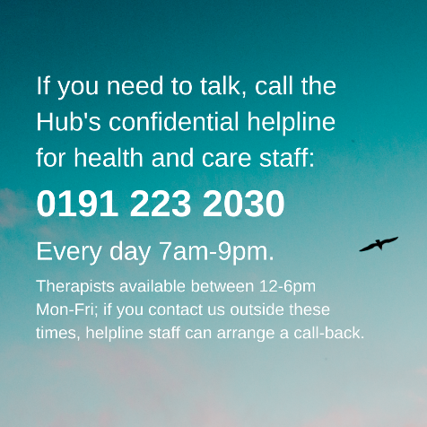
Want help making sense of how you’re feeling? Need a way of identifying what helps you stay well?  Try monitoring your mood by using the new online wellbeing diary by @NorthumbriaUni and @NENC_ICS Staff Wellbeing Hub at www.mypersonalwellbeing.co.uk. | 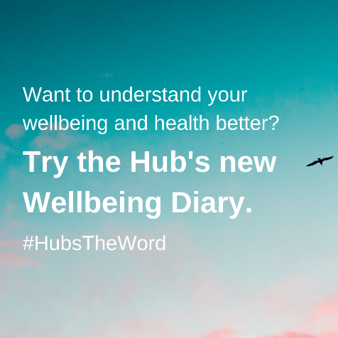

Signature banner:

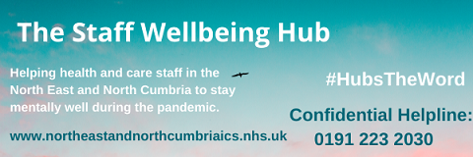
(Hyperlink to http://www.northeastandnorthcumbriaics.nhs.uk/staff-wellbeing-hub/ )

If you have any queries about communicating about the Staff Wellbeing Hub or to be added to our Hub Newsletter mailing list, please contact dawn.bailey@cntw.nhs.uk

