Find Your Place toolkit
Welcome new trainees to our region

Introduction

In July, August and September we will be welcoming new medical trainees to our region.

This is an opportunity for us all to ensure our new trainees receive a warm welcome and to raise the profile of the Find Your Place campaign – asking people to join our movement and encourage others to choose our region for their medical training. Whether that's through induction events at trusts or across communication channels such as websites, intranets, bulletins and social media.

A range of content has been developed for trusts to use and this guide provides some top tips on how to access this content, as well as sample social media messages.

All assets are available to download here https://northeastnorthcumbria.nhs.uk/find-your-place-toolkit/ and can be adapted within your own organisations.

We also have a dedicated welcome page on the Find Your Place website www.nhsfindyourplace.co.uk/welcome

Remember to tag us in and follow us!

For reference, our social media accounts can be found using the following handles and links:

Facebook - https://www.facebook.com/nhsfindyourplace
Twitter - @NHSFYP
Instagram - @nhsfyp
YouTube - @nhsfindyourplace6185
TikTok - @find.your.place.NENC
We ask that all trusts use our Twitter, TikTok and Instagram handles to tag us in all welcome posts to new medical trainees where possible.

The toolkit
Includes the following:

- Find Your place welcome presentation

These can be used at induction events or welcome presentations. They provide information about the find your place campaign and encourage people to join our movement

- Presentation (PowerPoint)
- Presentation (PDF)

- Induction films

These can be used at events and on social media channels

- Generic general welcome message
- Postgraduate dean Dawn Ashley
- Dr Catherine Monaghan, Integrated Care Board medical director
- Welcome message – Animation
- Know your clinician This animation can be used at events and on social media. It is a guide to what type of doctor each colour lanyard represents. All our doctors and dentists in training are offered lanyards as it helps other staff identify them. Lanyard film
- Information about Lead Employer Trust (LET) The animation is an introduction to the function of the Lead Employer Trust to junior doctors in the North East and North Cumbria. LET animation (introduction to the Lead Employer Trust)
- Hidden gems – a short preview of what the North East and North Cumbria offers outside of the training environment from cities, beaches and national parks. Hidden gems in our region – showcasing the North East and North Cumbria

- Found your place app

The app is a careers management tool for foundation doctors in the Northern Foundation School and suitable for all trainees in the North East and North Cumbria region. Please promote on your internal and external channels – as well as any induction events.

- Careers sessions and app promotion – a short film promoting the Found Your Place app and it's functions and an overview of the careers session available to all new medical trainees
- FYP app promotion - a short film promoting the Found Your Place app and it's functions

Help us build our movement

Support by creating your own content

Help us build our movement and raise awareness of the North East and North Cumbria region as a great place to train and live. Please feel free to create your own content and share it on your own channels. For example, this could be photos or videos from induction events or with your own trainees or short films with people within your organisations sharing their #toptipsfornewdocs.

Some questions you might want to ask?

- Why did you choose the North East and North Cumbria for your training?
- What advice would you give to new medical trainees who are about to start their training in our region?
- What's your top tip for places to visit and see when you get downtime?

Remember to tag us in and follow us!

For reference, our social media accounts can be found using the following handles and links:

Facebook - https://www.facebook.com/nhsfindyourplace
Twitter - @NHSFYP
Instagram - @nhsfyp
YouTube - @nhsfindyourplace6185
TikTok - @find.your.place.NENC
We ask that all trusts use our Twitter, TikTok and Instagram handles to tag us in all welcome posts to new medical trainees where possible.

Hashtags for the campaign - #foundmyplace #foundyourplace #northeastnorthcumbria #TopTips

Please feel free to like and share from our channels across Twitter, Instagram and Facebook or schedule from your own social media accounts.

All our social media will drive people to the dedicated welcome page on the Find Your Place website www.nhsfindyourplace.co.uk/welcome

For inductions, we ask that all trainees are directed to the Find Your Place welcome page: www.nhsfindyourplace.co.uk/welcome

For any queries please contact:
alastair.railton2@nhs.net 07388014980 or sarah.mckellar3@nhs.net

Content *please edit to fit (twitter handles are included) | Image reference | Content description and possible tags
🎉 Welcome to the North East and North Cumbria! Ready to start your medical journey? See what is in store for you as you live and train in our region #FindYourPlace  www.nhsfindyourplace.co.uk/welcome/ | 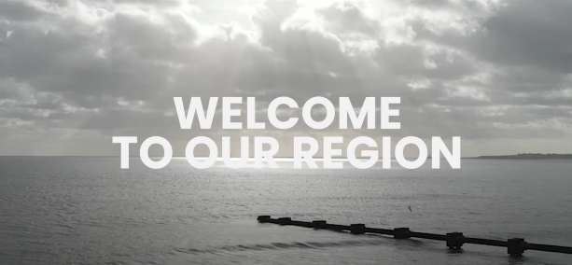  Download from our toolkit | Generic welcome film  @NHSFYP  @nenc_nhs  @madeinheene
🏥 Dawn Ashley, postgraduate dean, welcomes all new medical trainees to the North East and North Cumbria. This marks the start of your medical career in a region known for strong training and supportive teams.  👉 Learn more about what to expect and how to get started: www.nhsfindyourplace.co.uk/welcome  #FindYourPlace | 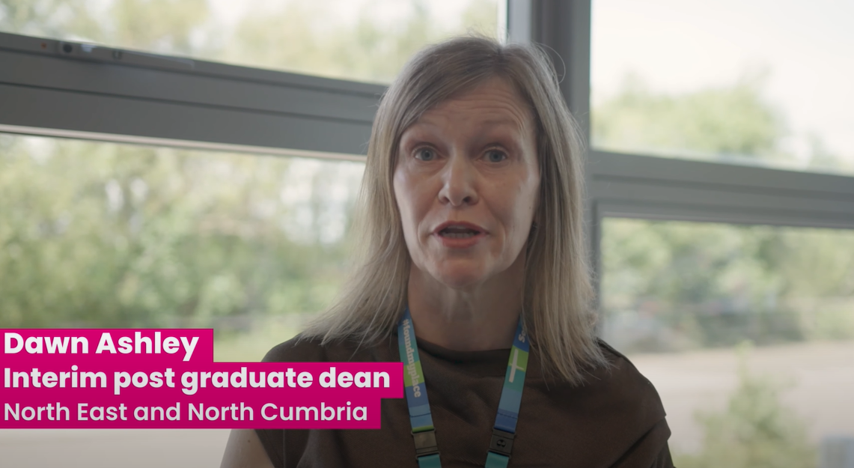  Download from our toolkit | Welcome film from– postgraduate Dean Dawn Ashley  @nenc_nhs  @madeinheene
🤝 Dr Catherine Monaghan, medical director for the North East and North Cumbria Integrated Care Board, shares her experience as a resident doctor and welcomes new trainees to the region. She highlights the value of good training and professional support from the start.  👉 Watch her message and find out more: www.nhsfindyourplace.co.uk/welcome  #FindYourPlace | 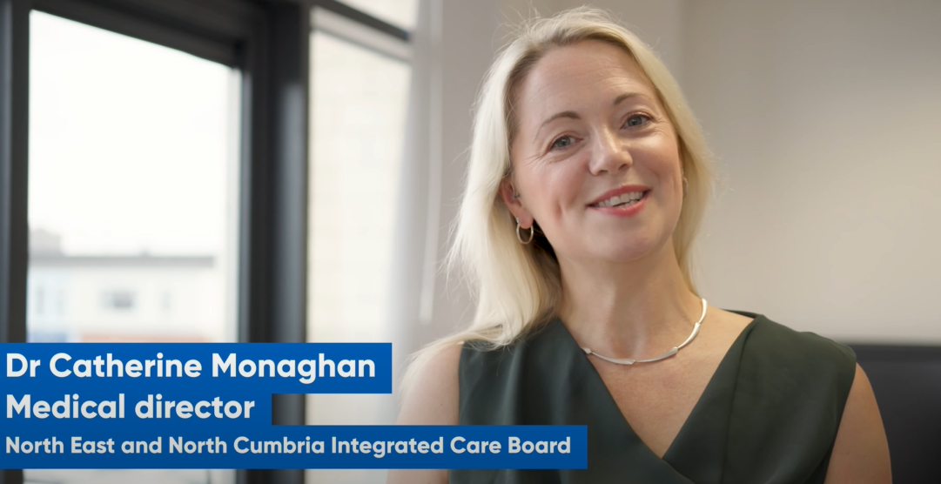  Download from our toolkit | Welcome film from Dr Catherine Monaghan – ICB medical director  @NHSFYP  @nenc_nhs  @madeinheene
👋 Welcome to all our new medical trainees, we hope you #FindYourPlace in our fabulous region 🌟 Follow us @NHSFYP on Twitter and Instagram🩺💙  www.nhsfindyourplace.co.uk/welcome/ | 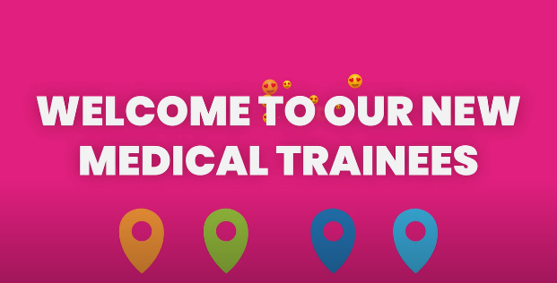  Download from our toolkit | Welcome animation 1  @NHSFYP  @nenc_nhs  @madeinheene
👋 Welcome to all our new medical trainees! 🩺 Have you got your new lanyard? Wearing them helps people identify you. Find out more about the meaning behind the colours. Watch our video #northeastnorthcumbria. 🌈✨ #foundmyplace  🎥👉 www.nhsfindyourplace.co.uk/welcome/ | 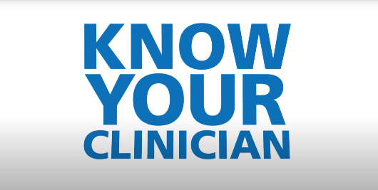  Download from our toolkit | Lanyard information film – know your clinician  @NHSFYP  @nenc_nhs  @madeinheene
👋 Welcome to our new medical trainees! 🩺 Want to know more about the Lead Employer Trust? Watch our video and discover how the team will support you #northeastnorthcumbria. 🤝✨ #foundmyplace  🎥👉  https://www.nenc-leademployertrust.nhs.uk/ | 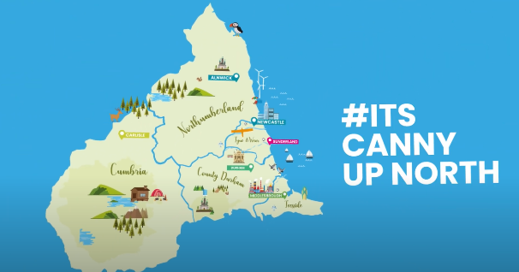  Download from our toolkit | Lead employer trust – animation film  @NHSFYP  @nenc_nhs  @madeinheene
Calling all new medical trainees! 🔍 Download the #foundyourplaceapp to get all the essential information you need on key recruitment dates, career events and mental health resources all tailored for you. #FindYourPlace  https://www.nhsfindyourplace.co.uk/welcome/ | 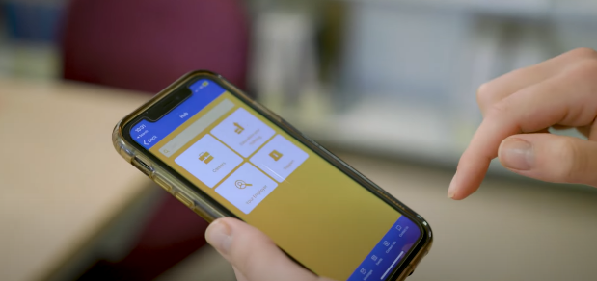  Download from our toolkit | Found your place app promotional video  @NHSFYP  @nenc_nhs  @madeinheene
🌟 Calling all new medical trainees in the #northeastnorthcumbria! 🩺 Watch @GemmaSinclair17 to discover the career support on offer and why you need to download the #foundyourplaceapp. 📱✨ #foundmyplace  www.nhsfindyourplace.co.uk/welcome/ | 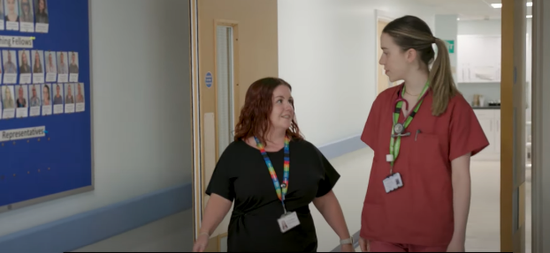  Download from our toolkit | Found your place app and careers sessions  @NHSFYP  @nenc_nhs  @madeinheene  @GemmaSinclair17

