Communications toolkit - Cardiovascular (CVD) campaign!
Phase 1: 'Know your numbers week' – 2 – 8 September 2024
(Final. 30/08/24)

About this toolkit

The 'Know your numbers' campaign toolkit is for GPs, pharmacists, NHS foundation trusts and partners across the North East and North Cumbria.
The campaign aims to encourage adults who haven’t visited their GP in over a year to have a blood pressure check by visiting their local pharmacy and / or contacting their GP surgery.
This toolkit includes information and resources to use across your own channels to help raise awareness with patients. The online resources can be found here.
Your support in helping us to share these messages is very much appreciated.
For further help or advice on using this toolkit, or if you need support to tailor assets, please contact Anisah.sharmeen@nhs.net.
Overview
The following sets out our plans to communicate and raise awareness of hypertension (blood pressure) and to encourage people who haven’t visited a GP practice in over a year to book an appointment and have their blood pressure checked.
Phase 1 of the "Keep Your Heart Healthy - Every Beat Counts" campaign will launch during Know Your Numbers Week in September. The campaign will use multiple channels to reach the target audience, focusing on education, accessibility, and engagement.
Background
CVD is the leading cause of death worldwide, accounting for 17.9 million deaths each year and 31% of all global deaths.
The NHS Long Term Plan identifies CVD as a clinical priority and the single biggest condition where lives can be saved by the NHS over the next 10 years. The Plan sets the ambition for the NHS to help prevent over 150,000 heart attacks, strokes, and dementia cases over the next 10 years.

Campaign objectives
- Raise awareness of importance of regular blood pressure checks
- Educate public understanding of blood pressure numbers and the health risks associated.
- Encourage patients to book an appointment with their GP or visit their local pharmacy
- Encourage proactive heart health management
- Highlight ICB blood pressure kiosk projects and encourage engagement

Target Audience
- Patients at higher risk of CVD
- Patients who typically don’t engage with health services
- People living in most deprived areas of the region, ethnic minorities (practically black groups), males, age ranges typically between 40-79

Timeline
Pre-Campaign (August):
  - Develop and finalise social media assets, video content, and case study.
Campaign Launch (September - Know Your Numbers Week, 2 – 8 September):
  - Daily social media content, including sharing of finalised social media assets.
  - Share clinical lead videos and case study mid-week.
  - Send out press release to media at the start of the week to align with the campaign launch.
Post-Campaign (Late September):
  - Share campaign results and insights on social media.
  - Planning for phase 2 of the campaign will begin w/c 19 August.

Key messages
- Keep your heart healthy, #EveryBeatCounts –
- Every Beat Counts - know your numbers and get your blood pressure checked.
- Cardiovascular disease is a leading cause of death, but early detection through blood pressure checks can save lives.
- A quick blood pressure check could prevent life-threatening conditions like heart attacks and strokes.
- You have the power: know your blood pressure numbers and keep your heart healthy.

Press release – Quick blood pressure checks can save lives – #EveryBeatCounts (02/09/2024)
News release
30 September
Quick blood pressure checks can save lives – #EveryBeatCounts
Doctors are urging people in the North East and North Cumbria to take control of their heart health by having a simple blood pressure check. Monitoring blood pressure through regular checks could prevent life-threatening conditions such as heart attacks and strokes.
The NHS in the North East and North Cumbria is supporting "Know Your Numbers" Week, a national campaign focused on raising awareness about the importance of blood pressure checks by launching a new pilot scheme in areas known to have low take up of blood pressure checks.
The new initiative will see blood pressure kiosks installed in six community centres across the region, providing an easy and convenient way for people to monitor their blood pressure and get vital help if needed.
Blood pressure kiosks in Hartlepool, Middlesborough and North Tyneside are funded by the NHS North East and North Cumbria Integrated Care Board (ICB), with North Tyneside Council funding one of the North Tyneside kiosks.
Kiosks can be found at:
- Hartlepool: Community Hub Central and Community Hub South
- Middlesbrough: Newport Community Hub and NUR Fitness
- North Tyneside: Wallsend Customer First Centre and North Shields Customer First Centre
Community Champions have also been trained at each centre to assist with using the kiosks, providing lifestyle advice, and guiding individuals on next steps if their readings are high. Free, returnable home blood pressure monitoring kits are also available for those needing further monitoring.

Dr Saira Malik, GP in Sunderland and clinical lead for Cardiovascular Disease, North East and North Cumbria (ICB), said: "High blood pressure, often called the 'silent killer,' can go unnoticed because it has no obvious symptoms. This new pilot is all about making it easier for people in our communities to take that crucial step towards better heart health.
We're focusing on areas with a higher risk of undiagnosed high blood pressure, as we know if high blood pressure is diagnosed early by a simple check, it can help save lives."
Along with the new kiosks, many local pharmacies also offer free blood pressure checks or people can contact their GP surgery.
High blood pressure, also known as hypertension, is the world's leading cause of death and disability and cardiovascular disease. However, with the right support and care, it is both preventable and treatable.
Managing high blood pressure often involves simple lifestyle changes such as reducing salt and high-fat food intake, maintaining a healthy BMI, exercising, smoking cessation, and limiting alcohol use to 14 units weekly for both men and women. Medications can also effectively control blood pressure, but if left untreated, it can lead to heart attacks, heart failure, strokes, and less commonly known, kidney damage, visual loss, and memory problems.
High blood pressure is considered to be from 140/90mmHg (or an average of 135/85mmHg at home) – or 150/90mmHg (or an average of 145/85mmHg at home) if you're over the age of 80.
Around 5.5 million people in England have undiagnosed hypertension and don’t know they are at risk. The only way to check is by having your blood pressure measured.
The NHS recommends that adults over 40 have their blood pressure checked at least once every five years - and ideally every year if your blood pressure is borderline or you have any lifestyle risk factors.
Further information about high blood pressure is available on the NHS website.
ENDS
Toolkit contents (TBA)
This toolkit contains useful resources including social media graphics along with accompanying messages, visuals for GP waiting room and pharmacies, display screens and posters.
- social media graphics and messaging
- digital GP screen displays
- clinical lead talking heads
- Pharmacist lead video
- News release

You can access all assets at: https://northeastnorthcumbria.nhs.uk/here-to-help/know-your-numbers-week/
How can you support?
Please use this toolkit to:
• Support conversations with patients around encouraging blood pressure check.
• Share the resources within your practice/community pharmacy.
• Encourage patients to visit their local pharmacy or GP surgery to arrange a blood pressure check – especially if they are in an at risk group.
• If you have social media accounts, please help us by sharing the resources within this toolkit by posting on your social media channels and sharing assets with your groups and networks.

Social media messaging – download: https://northeastnorthcumbria.nhs.uk/here-to-help/know-your-numbers-week/
Know your numbers messaging
1. | Don’t wait until it’s too late!  High blood pressure can be a silent killer. Know your numbers and protect your heart.  Visit your local pharmacy or contact your GP surgery for a quick blood pressure check.  https://www.nhs.uk/conditions/high-blood-pressure/  #KnowYourNumbers #EveryBeatCounts | 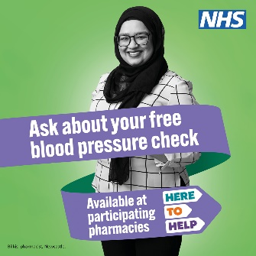
2. | You have the power! ❤️  A simple blood pressure check can make a big difference. Whether at your GP or local pharmacy, take that first step to keep your heart strong.  Don’t wait—know your numbers today!  https://www.nhs.uk/health-assessment-tools/check-your-blood-pressure-reading  #HeartHealth #KnowYourNumbers | 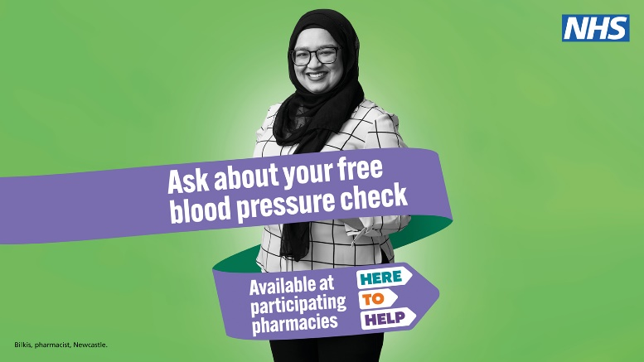
3. | Blood pressure check due? Don’t wait until it’s too late!  People over 40 should get their blood pressure tested at least once every 5 years.  Get tested at:  • Your GP surgery  • Your local pharmacy  • At home  • At an NHS Health Check appointment  Find out more at: https://www.nhs.uk/conditions/blood-pressure-test/  #KnowYourNumbers #EveryBeatCounts | David Webb Blood Pressure Video
4. | Every beat counts – protect your heart by knowing your numbers.  Cardiovascular disease is a leading cause of death, but early detection through blood pressure checks can save lives.  Many local pharmacies offer free blood pressure checks or you can contact your GP surgery.  Find out more at: https://www.nhs.uk/nhs-services/pharmacies/find-a-pharmacy-that-offers-free-blood-pressure-checks/  #EveryBeatCounts #HeartHealth | Dr Raj Bethapudi blood pressure videos
5. | 🩺 Keep Your Heart Healthy – Every Beat Counts! ❤️  This #KnowYourNumbersWeek, visit your local pharmacy for a free blood pressure check. It's quick, easy, and no appointment is needed!  The NHS is committed to delivering 2.5 million blood pressure checks in community pharmacies by Spring 2025, potentially preventing over 1,350 heart attacks and strokes in the first year alone.  Pharmacies are open 7 days a week, late into the evening, and even on bank holidays. Just walk in and have a confidential chat.  👉 Find your nearest pharmacy: https://www.nhs.uk/nhs-services/pharmacies/find-a-pharmacy-that-offers-free-blood-pressure-checks/  Remember, Every Beat Counts – take a few minutes today to protect your heart. | Ewan Maule Blood Pressure Video
 | 🔍 Could You Have High Blood Pressure? 🔍  Around 5.5 million people in England have undiagnosed hypertension and don’t know they are at risk. The only way to find out is to get checked. Visit your local pharmacy or contact your GP surgery to measure your blood pressure—it could save your life! #KnowYourNumbers  https://www.nhs.uk/nhs-services/pharmacies/find-a-pharmacy-that-offers-free-blood-pressure-checks/ | Dr Raj Bethapudi blood pressure videos

