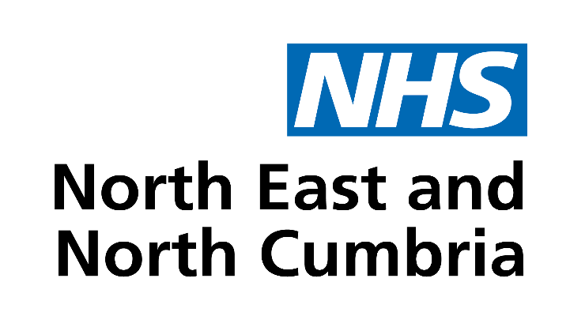
Zero alcohol in pregnancy - super babies communications toolkit
Campaign overview
NHS North East and North Cumbria Integrated Care Board is launching a campaign to encourage zero alcohol during pregnancy. This digital campaign will run across paid-for and organic social media channels for 2.5 months from early November 2022. The ‘Super Babies’ campaign urges pregnant women to abstain from alcohol for the duration of their pregnancies, to give their babies mental and physical benefits that will last their entire lives.

Presenting pregnant women with a positive incentive not to drink, the campaign offers a fresh take on established messaging around avoiding alcohol completely while pregnant. We're inviting our partners to support the campaign by sharing our social media posts, and by posting their own ‘Super Babies’ content, using the assets we've created.

You can follow NHS North East and North Cumbria Integrated Care Board via these channels:

Coverage in Partner bulletins and newsletters
The copy below can be used for bulletins, newsletters, news, and blogs pages, to let your stakeholders know about the importance of zero alcohol in pregnancy and the campaign assets available to help promote this message.
Brief copy
Be your baby's hero - keep alcohol at zero!
By abstaining from alcohol before and during pregnancy, you can give your baby the best possible start. In the North East, around one baby each day is born with some form of Foetal Alcohol Spectrum Disorders (FASD), which are caused by the consumption of alcohol during pregnancy.
Drinking alcohol during pregnancy can lead to learning difficulties, heart problems, and permanent damage to a developing baby's brain. There is no safe amount. The benefits of not drinking during pregnancy cover both physical and mental development and include sight, brain development, growth, and motor skills.
NHS North East and North Cumbria Integrated Care Board is spreading this message via its Super Babies campaign, which highlights the benefits for babies when they're not exposed to alcohol.
Jayne Mackey is a North Tees and Hartlepool NHS Foundation Trust midwife who works hard to help women stay alcohol-free during pregnancy. She said: "Abstaining from alcohol needs to be part of planning a pregnancy, to give a baby the best start in life. We know some pregnancies are unplanned, happy miracles, but from conception or from the first knowledge of pregnancy, a mother can help her baby by saying no to alcohol."
For more advice talk to your midwife or GP. Be your baby’s hero, keep alcohol at zero.

Longer copy
Be your baby's hero - keep alcohol at zero!
By abstaining from alcohol before and during pregnancy, you can give your baby the best possible start. In the North East, around one baby each day is born with some form of Foetal Alcohol Spectrum Disorders (FASD), which are caused by the consumption of alcohol during pregnancy.
Drinking alcohol during pregnancy can lead to learning difficulties, heart problems, and permanent damage to a developing baby's brain. There is no safe amount. The benefits of not drinking during pregnancy cover both physical and mental development and include sight, brain development, growth, and motor skills.
NHS North East and North Cumbria Integrated Care Board (ICB) is spreading this message via its Super Babies campaign, highlighting the benefits for babies when they're not exposed to alcohol.
Jayne Mackey is a North Tees and Hartlepool NHS Foundation Trust midwife who works hard to help women stay alcohol-free during pregnancy. She said: "Abstaining from alcohol needs to be part of planning a pregnancy, to give a baby the best start in life. We know some pregnancies are unplanned, happy miracles, but from conception or from the first knowledge of pregnancy, a mother can help her baby by saying no to alcohol."

Sarah Hulse, alcohol strategic manager at NHS North East and North Cumbria ICB said: "We're reminding people of the benefits to babies when mums abstain from alcohol during pregnancy.
"Babies whose mums don't drink during pregnancy are at an advantage in terms of their learning and behaviour, their organ development, emotional and social outlook, and communication. The impact is wide-reaching and long-lasting.
"Additionally, not drinking can help avoid miscarriage and low birth weights. It’s really important women are aware of the dangers of drinking when pregnant and are supported to take a zero alcohol during their pregnancy.”
For more advice talk to your midwife or GP. Be your baby’s hero, keep alcohol at zero.

Social media assets
Videos to share via Facebook, Instagram and Snapchat, or to post on websites, can be downloaded here:
https://northeastnorthcumbria.nhs.uk/superbabies-toolkit/
Social media posts
Below are suggested social media posts and corresponding assets for you to use on your social media. Only one of these posts is time sensitive, dated to the day of the campaign's launch, Friday 4th November.
FACEBOOK
Date/Time | Wording | Asset
Friday 4th November 2022 | Today, we’re supporting mums to go zero alcohol in pregnancy across the North East and North Cumbria.  Give your baby super powers by going alcohol-free if possible before and during pregnancy. For more advice please talk to your midwife or GP. 👩‍⚕️  Be your baby’s hero, keep alcohol at zero. 🦸 | 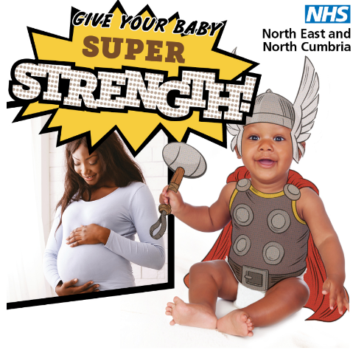
 | Give your baby the gift of super brains!🧠🎁  By going alcohol-free during pregnancy, you are protecting your baby’s development. 🧸  For more advice talk to your midwife or GP. Be your baby’s hero, keep alcohol at zero.🙌 | 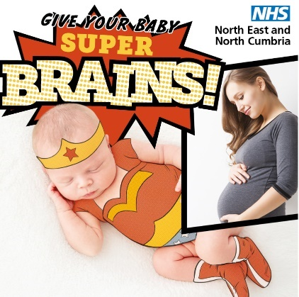
 | 🎁Give your baby the gift of super strength! 💪  By going alcohol-free during pregnancy, you are protecting your baby’s physical development. 🧠  For more advice talk to your midwife or GP. Be your baby’s hero, keep alcohol at zero. 🦸 | 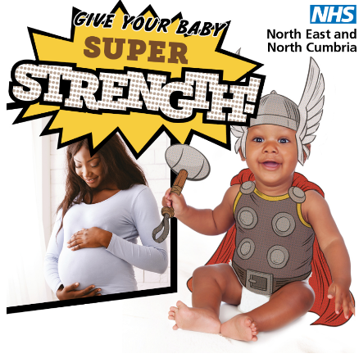
 | Pass on the power of coordination to your baby! 🏃  By going alcohol-free during pregnancy, you are protecting your baby’s physical development. 🧠  For more advice talk to a midwife or GP. Be your baby’s hero, keep alcohol at zero. 🦸 | 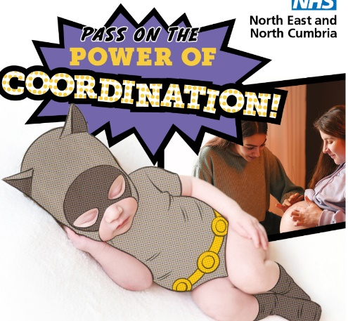
 | 🎁Give your baby the gift of super agility! 🏃  By going alcohol-free during pregnancy, you are protecting your baby’s physical development. 💪  For more advice talk to your midwife or GP. Be your baby’s hero, keep alcohol at zero. | 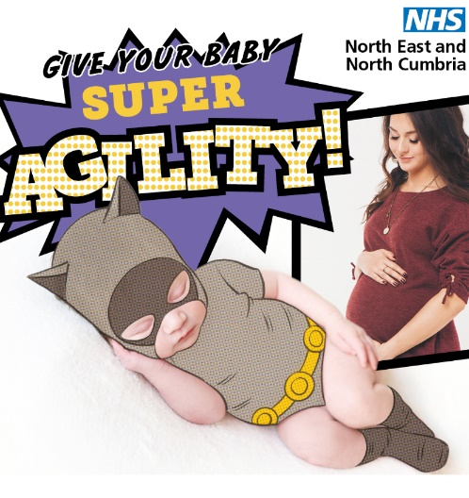
 | Ever wondered how to give your baby super strength? 💪  By going alcohol-free during pregnancy, you are protecting your baby's physical development.  For more advice talk to your midwife or GP. Be your baby’s hero, keep alcohol at zero. | Super Strength Video  https://northeastnorthcumbria.nhs.uk/superbabies-toolkit/  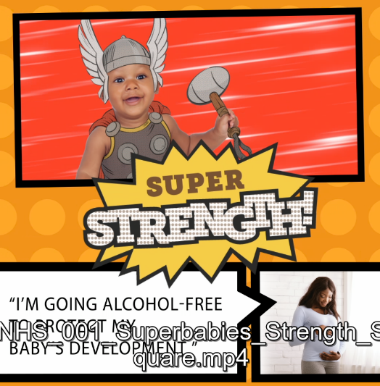
 | Friends – help pass on the power of coordination! 🏃  Support your pregnant friend and help them to go alcohol free to protect her baby’s development. 🙌  For more advice talk to your midwife or GP. Be your baby’s hero, keep alcohol at zero. | Power of Coordination Video  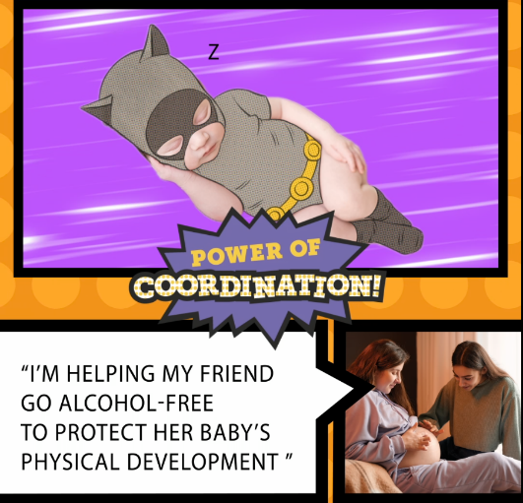  https://northeastnorthcumbria.nhs.uk/superbabies-toolkit/
 | 🎁Give your baby the gift of super agility! 🏃  By going alcohol-free during pregnancy, you are protecting your baby’s physical development. 💪  For more advice talk to your midwife or GP. Be your baby’s hero, keep alcohol at zero. | Super Agility Video  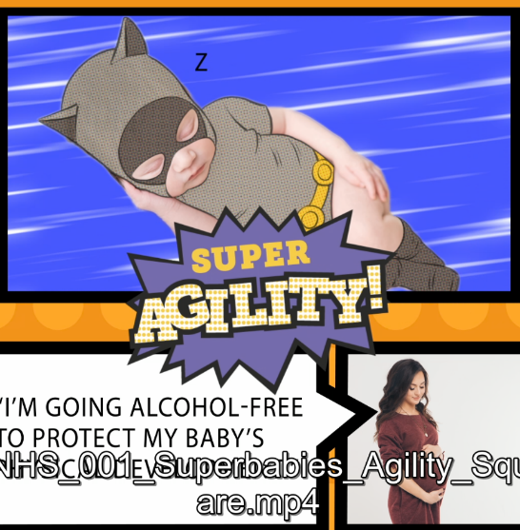  https://northeastnorthcumbria.nhs.uk/superbabies-toolkit/

Twitter
Date/Time | Wording | Asset
 | 🦸 Help support friends and family who are pregnant to go alcohol free during their pregnancy. There are lots of benefits to an un-born baby who isn’t exposed to alcohol. ‬‬‬👀  ‬‬‬‬‬‬‬  Get them to talk to their midwife or GP. Be your baby’s hero, keep alcohol at zero. | 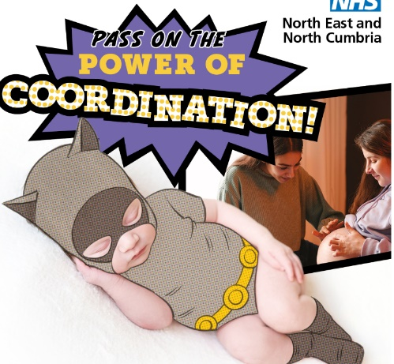
 | Give your baby the gift of super brains!🧠🎁  By going alcohol-free during pregnancy, you are protecting your baby’s development. 🧸  For more advice talk to your midwife or GP. Be your baby’s hero, keep alcohol at zero. 🙌 | 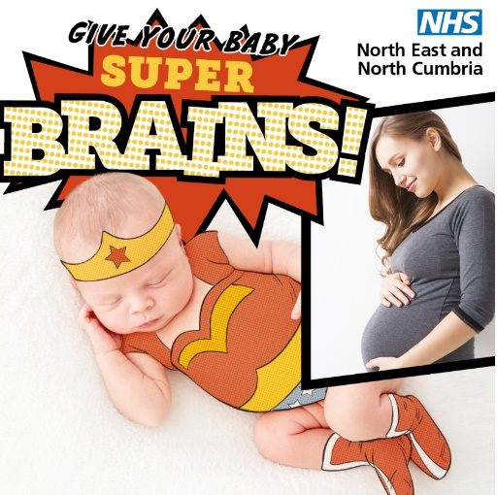
 | Friends – help pass on the power of coordination! 🏃  Support your pregnant friend and help them to go alcohol free to protect her baby’s development. 🙌  For more advice talk to your midwife or GP. Be your baby’s hero, keep alcohol at zero. 🙌 | Power of Coordination Video
 | 🎁Give your baby the gift of super strength! 💪  By going alcohol-free during pregnancy, you are protecting your baby’s physical development. 🧠  For more advice talk to your midwife or GP. Be your baby’s hero, keep alcohol at zero. 🦸  For more advice talk to your midwife or GP. Be your baby’s hero, keep alcohol at zero. 🙌 | Super Strength Video  https://northeastnorthcumbria.nhs.uk/superbabies-toolkit/
 | 🎁Give your baby the gift of super agility! 🏃  By going alcohol-free during pregnancy, you are protecting your baby’s physical development. 💪  For more advice talk to your midwife or GP. Be your baby’s hero, keep alcohol at zero. 🙌 | Super Agility Video  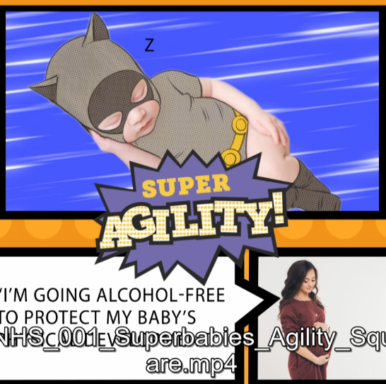  https://northeastnorthcumbria.nhs.uk/superbabies-toolkit/

If you have any questions about the Super Babies campaign, please email chloe.corkhill1@nhs.net

