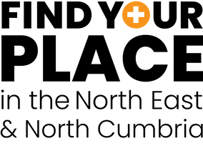
Find Your Place toolkit
Welcome new trainees to our region

Introduction
In July and August we will be welcoming new medical trainees to our region.

This is an opportunity for us all to ensure our new trainees receive a warm welcome and to raise the profile of the Find Your Place campaign – asking people to join our movement and encourage others to choose our region for their medical training. Whether that's through induction events at trusts or across communication channels such as websites, intranets, bulletins and social media.

A range of content has been developed for trusts to use and this guide provides some top tips on how to access this content, as well as sample social media messages.

From Monday 24 July, all assets are available to download here https://northeastnorthcumbria.nhs.uk/find-your-place-toolkit/ and can be adapted within your own organisations.

We also have a dedicated welcome page on the Find Your Place website www.nhsfindyourplace.co.uk/welcome

The toolkit
Includes the following:

- Find Your place welcome presentation

These can be used at induction events or welcome presentations. They provide information about the find your place campaign and encourage people to join our movement

- Presentation (PowerPoint)
- Presentation (PDF)

- Welcome films

These can be used at events and one social media channels

- Generic general welcome message
- Postgraduate dean Namita Kumar
- Dr Neil O'Brien, Integrated Care Board executive medical director

- Social media animations

- Welcome message – Animation 1
- Welcome message – Animation 2

- Know your clinician

This animation can be used at events an on social media. It is a guide to what type of doctor each colour lanyard represents. All our doctors and dentists in training are offered a lanyards as it helps other staff identify them.

- Lanyard film

- LET films

The LET animation is an introduction to the function of the Lead Employer Trust to junior doctors in the North East and North Cumbria)

- LET animation (introduction to the Lead Employer Trust)

- Top tips films

Tips from current and previous medical trainees in the NENC region – can be used at induction events and on social media

- FY2 Dr Adam Gatherer (1 long and 2x short)
- ST6 Laura Clifton (1 long and 2x short)
- Anaesthetics trainee Ben Evans
- Specialty trainee Sabrina Kupar

- Junior Doctor challenge

We have so many great things to do and places to see and explore in our region – encourage your new trainees to discover our region their downtime and take on our challenge. A full list of challenges can be found here: https://www.nhsfindyourplace.co.uk/junior-doctor-challenge/

- Animation 1
- Animation 2
- Static graphic

- Found your place app

The app is a careers management tool for foundation doctors in the Northern Foundation School and suitable for all trainees in the North East and North Cumbria region.

- Careers sessions and app promotion
- FYP app promotion
- FYP app animation

Build our movement
Help us build our movement and raise awareness of region as a great place to train and live. Please feel free to create your own content and share it on your own channels. For example, this could be photos or videos from induction events or with your own trainees or short films with people within your own organisations sharing their #toptipsfornewdocs. Find your place film book ends are available in the toolkit.

Some questions you might want to ask?

- Why did you choose the North East and North Cumbria for your training
- What advice would you give to new medical trainees who are about to start their training in our region?
- What's your top tip for places to visit and see when you get downtime?

Remember to tag us in and follow us!
For reference, our social media accounts can be found using the following handles and links:

Facebook - https://www.facebook.com/nhsfindyourplace
Twitter - @NHSFYP
Instagram - @nhsfyp
We ask that all trusts use our Twitter and Instagram handles to tag us in all welcome posts to new medical trainees where possible.

Hashtags for the campaign - #foundmyplace #foundyourplace #medtrainees #northeastnorthcumbria #TopTipsForNewDocs

Please feel free to like and share from @NHSFYP across Twitter, Instagram and Facebook or schedule from your own social media accounts.

All our social media will drive people to dedicated welcome page on the Find Your Place website www.nhsfindyourplace.co.uk/welcome

For the purpose of induction we ask that all trainees are directed to the Find Your Place welcome page: www.nhsfindyourplace.co.uk/welcome

For any queries please contact:
alastair.railton2@nhs.net 07388014980 or sarah.mckellar3@nhs.net

Content *please edit to fit (twitter handles are included) | Image reference | Content description and possible tags
🌟 Welcome medical trainees! Discover the beauty of North East & North Cumbria. 🏥🌄 Watch our video to see what awaits you: www.nhsfindyourplace.co.uk/welcome/  #foundmyplace #northeastnorthcumbria | 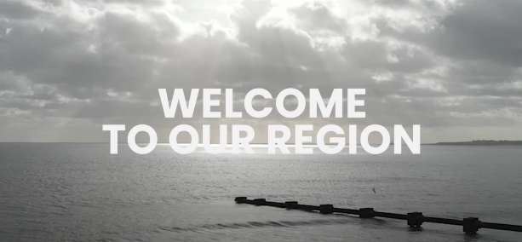 | Generic welcome film  @NHSFYP  @nenc_nhs  @madeinheene
Our postgraduate dean @namita_1 shares her #TipsForNewDocs as she welcomes our new doctors in training to the #northeastnorthcumbria  https://www.nhsfindyourplace.co.uk/welcome/ | 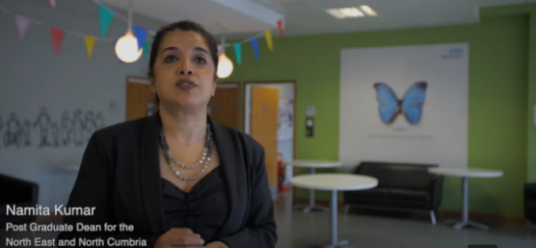 | Welcome film from Namita Kumar – Postgraduate Dean NENC  @nenc_nhs  @madeinheene  @namita_1
Dr. Neil O'Brien, local GP and executive medical director for the @NENC_NHS, welcomes our new medical trainees to the #northeastnorthcumbria  www.nhsfindyourplace.co.uk/welcome/ #foundmyplace | 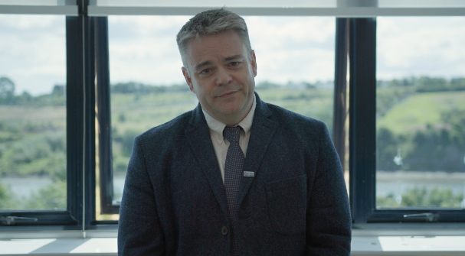 | Welcome film from Neil O'Brien – ICB chief executive  @NHSFYP  @nenc_nhs  @madeinheene
👋 Welcome medical trainees to the #northeastnorthcumbria! 🌟 Join our vibrant community @NHSFYP on Twitter and Instagram 🩺💙 | 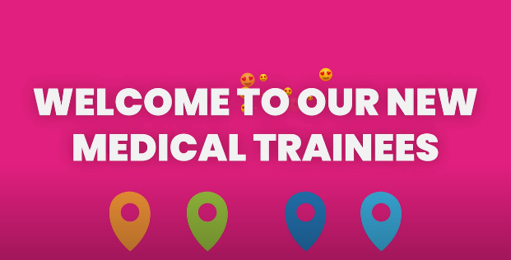 | Welcome animation 1  @NHSFYP  @nenc_nhs  @madeinheene
🌟 Welcome medical trainees! 🩺 Explore the endless opportunities in #northeastnorthcumbria. Visit www.nhsfindyourplace.co.uk/welcome/ to learn about our region and receive #toptips! | 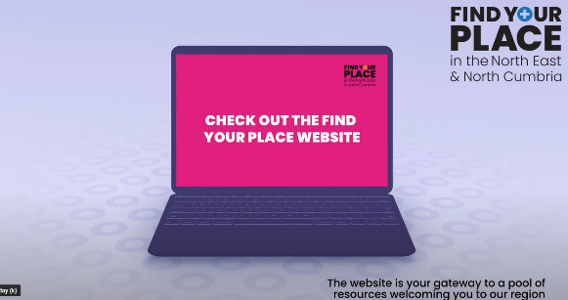 | Welcome animation 2  @NHSFYP  @nenc_nhs  @madeinheene
👋 Welcome medical trainees! 🩺 Curious about the meaning behind coloured lanyards? Watch our video to uncover their significance in #northeastnorthcumbria. 🌈✨ #foundmyplace  🎥👉 www.nhsfindyourplace.co.uk/welcome/ | 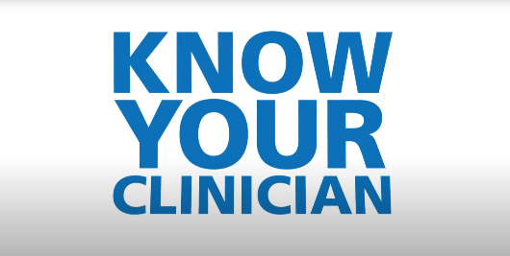 | Lanyard information film – know your clinician  @NHSFYP  @nenc_nhs  @madeinheene
👋 Welcome medical trainees! 🩺 Want to know more about the Lead Employer Trust? Watch our video and discover how it supports your journey in #northeastnorthcumbria. 🤝✨ #foundmyplace  🎥👉 | 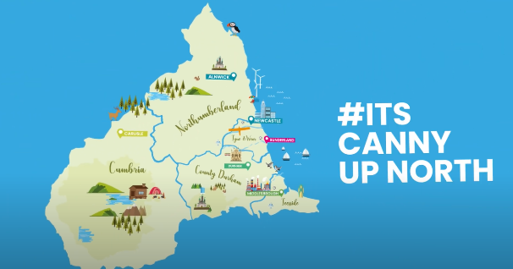 | Lead employer trust – animation film  @NHSFYP  @nenc_nhs  @madeinheene
👋 Welcome medical trainees! 🩺 Don't miss out on #toptipsfornewdocs from foundation trainee, Adam Gatherer. Watch his insightful video and embark on your #northeastnorthcumbria journey with confidence! 🌟✨ #foundmyplace  🎥👉 www.nhsfindyourplace.co.uk/welcome/ | 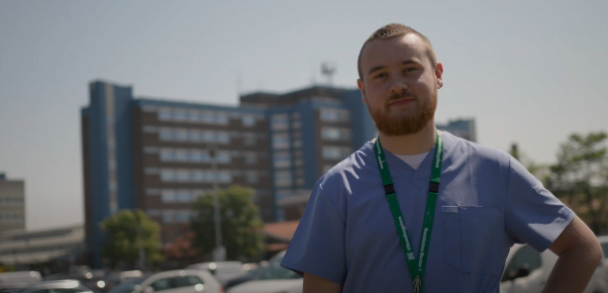 | Top tips film – Adam Gatherer  @NHSFYP  @nenc_nhs  @madeinheene  @NTeesHpoolNHSFT
👋 Welcome medical trainees! 🩺 Watch Laura Clifton, trainee in trauma & orthopaedics, sharing her invaluable #toptipsfornewdocs. Gain insights and thrive in #northeastnorthcumbria! 🌟✨ #foundmyplace  🎥👉 www.nhsfindyourplace.co.uk/welcome/ | 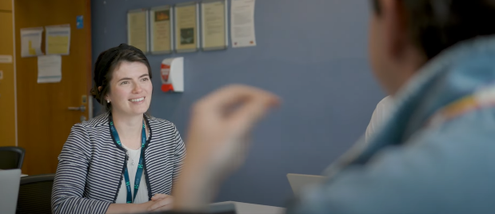 | Top tips film – Laura Clifton  @NHSFYP  @nenc_nhs  @madeinheene
Anaesthetics trainee Ben Evans shares why he loves training in the #northeastnorthcumbria  Sharing his experience of training and giving his #TipsForNewDocs https://www.nhsfindyourplace.co.uk/welcome/ | 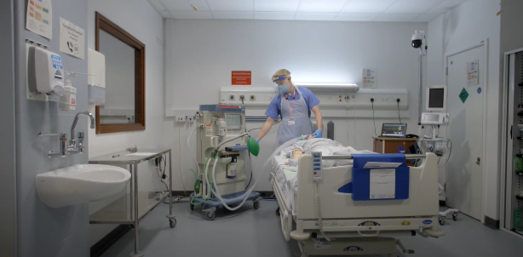 | Top tips film – Ben Evans  @NHSFYP  @nenc_nhs  @madeinheene
👋 Welcome, medical trainees! 🩺 Don't miss specialty trainee Sabrina Kapur's #toptipsfornewdocs in this video. Get inspired and embark on your #northeastnorthcumbria journey with confidence! 🌟✨ #foundmyplace  🎥👉 www.nhsfindyourplace.co.uk/welcome/ | 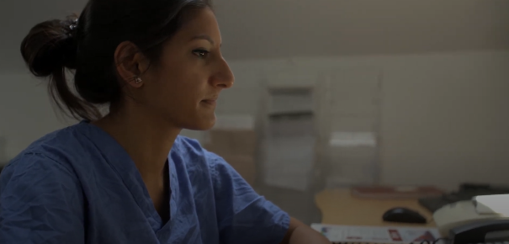 | Top tips film – Sabrina Kapur  @NHSFYP  @nenc_nhs  @madeinheene
🌟 Calling all new medical trainees in #northeastnorthcumbria. Take on our challenge and explore 50 incredible landmarks and experiences. Embrace the adventure! 🏞️✨ #foundmyplace #juniordocchallenge #findtherightbalance  🔗 Learn more: https://www.nhsfindyourplace.co.uk/junior-doctor-challenge/ | 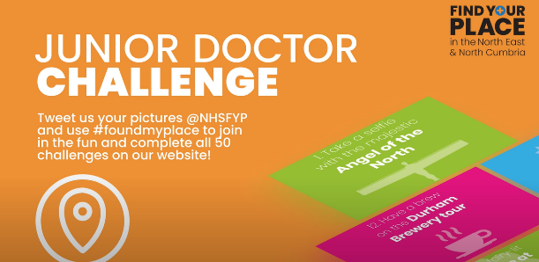 | Junior doctor challenge animation  @NHSFYP  @nenc_nhs  @madeinheene
🌟 From breath taking beaches, stunning countryside to vibrant nightlife, towns and cities – we have got it all in our region 🩺 Join the #juniordoctorchallenge & explore. Are you up for the adventure? 🗺️✨ #foundmyplace #gettherightbalance  👉 Join the challenge at https://www.nhsfindyourplace.co.uk/junior-doctor-challenge/ | 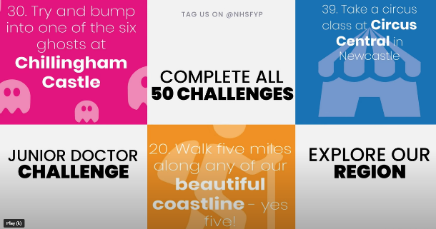 | Junior doctor challenge animation 2  @NHSFYP  @nenc_nhs  @madeinheene
Calling all foundation doctors manage your career by downloading the #foundyourplaceapp, a one stop careers information hub for foundation doctors and trainees in the #northeastnorthcumbria #foundyourplace  https://www.nhsfindyourplace.co.uk/welcome/ | 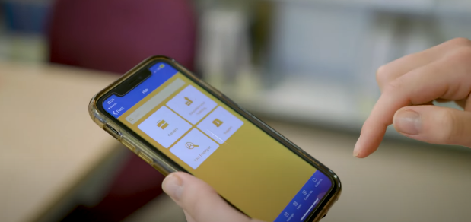 | Found your place app promotional video  @NHSFYP  @nenc_nhs  @madeinheene
🌟 Calling all new medical trainees in the #northeastnorthcumbria! 🩺 Watch @GemmaSinclair17 to discover the career support on offer and why you need to download the #foundyourplaceapp . Your journey awaits! 📱✨ #foundmyplace | 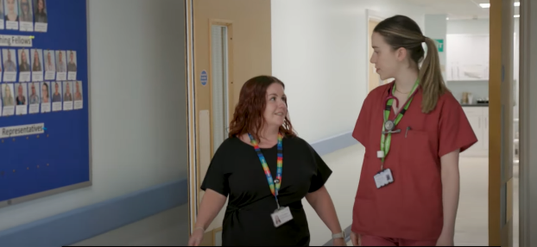 | Found your place app and careers sessions  @NHSFYP  @nenc_nhs  @madeinheene  @GemmaSinclair17

