Social media plan
Urgent social media messaging for Norovirus and flu.
This social media plan provides urgent content to use in your social media posts.
Images can be downloaded from our toolkit here.
Please tag us in your social media posts:
Handles: Facebook – NorthEastandNorthCumbriaNHS, X – @NENC_NHS, Instagram – nenc_nhs

Norovirus
Norovirus | #Norovirus cases are on the rise!  Symptoms to look out for include:  - Diarrhoea  - Nausea  - Vomiting  If you, or someone you are close to, has experienced these symptoms in the last 48 hours PLEASE do not visit loved-ones in hospitals.  For medical help and advice contact NHS111 24 hours a day,7 days a week, online or by phone.  Find out more: www.nhs.uk/conditions/norovirus/ | 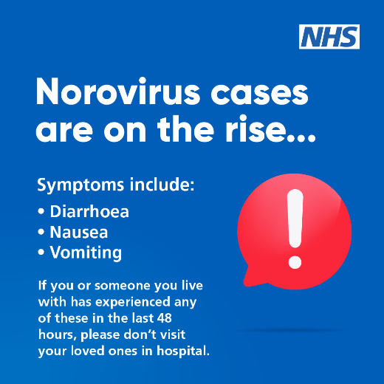
Norovirus | #Norovirus cases are on the rise!  Think before you visit!  If you or someone you live with has had symptoms of diarrhoea, nausea or vomiting in the last 48 hours please keep away from hospitals to protect patients and staff!  Find out more: www.nhs.uk/conditions/norovirus/ | 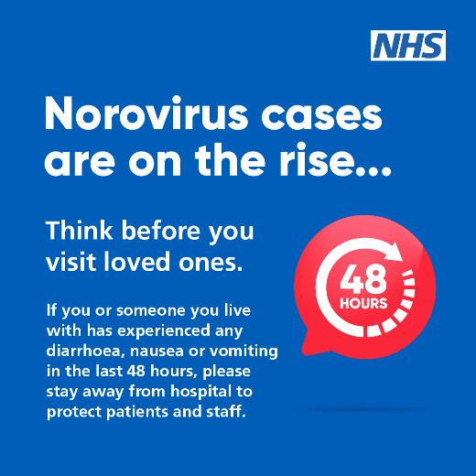
Norovirus | #Norovirus cases are rising!  Norovirus, or the 'winter vomiting bug', is spreading.  Here is what you can do to stop and avoid the spread this winter.  Do  - Stay home for 48 hours after your symptoms clear  - Wash clothes and bedding at 60 degrees!  - Wash hands with soap, clean surfaces with bleach-based disinfectants.  Don’t  - Go to work, school, or visit hospitals.  - Prepare food for others.  Find out more: www.nhs.uk/conditions/norovirus/ | 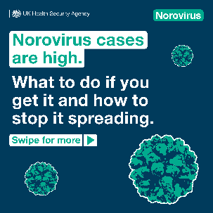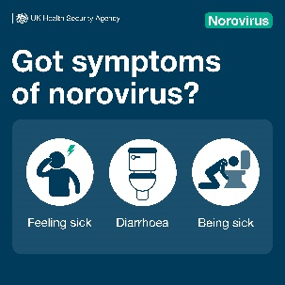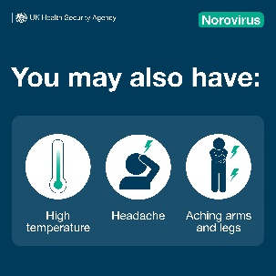  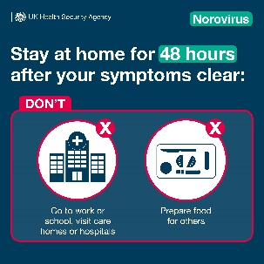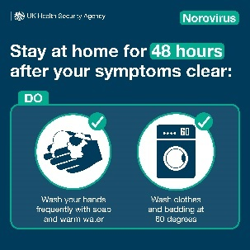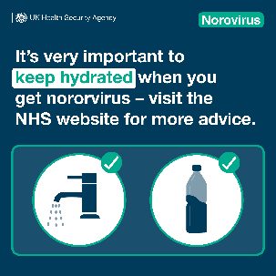  norovirus social media assets
Flu
Flu | Simple steps you can take to stop the spread of flu!  - Use a tissue to cover your mouth and nose when you cough or sneeze.  - Dispose of the tissue in a bin – catch it, bin it, kill it!  - Wash your hands regularly!  - Clean and disinfect surfaces after use.  - Use soap and water and wash for at least 20 seconds.  Remember you may be eligible for a free flu vaccine book now | 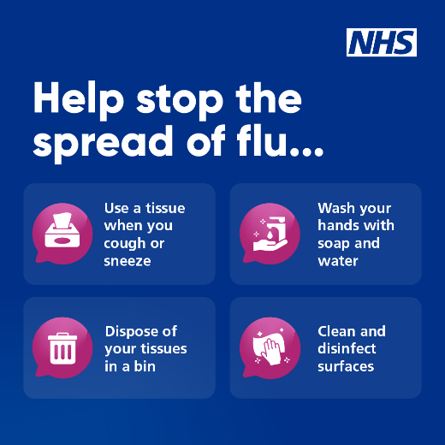
Pharmacy
Feeling ill | This winter choose the right NHS service!  To help you get the best advice, and often more quickly too.  - Think pharmacy first  - GP  - NHS 111 online for medical help and advice  - Keep A&E free for EMERGENCIES ONLY  Help reduce pressure on A&E and other services - so they can help those who need it most.  Click NHS find a pharmacy to find available pharmacies and opening hours.  #HeretoHelp | 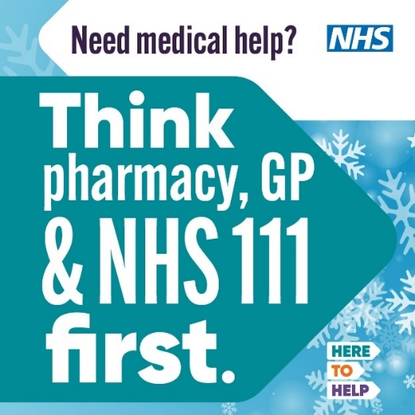
NHS 111
NHS 111 | Get to the help you need ….. when you need it!  When it’s not life threatening but still urgent  or  - You think you might need to go to a hospital or urgent treatment centre but you're not sure  - You need urgent advice and your GP surgery is closed.  NHS111 is here is to help 24 hours a day,7 days a week online or by phone.  #HeretoHelp | 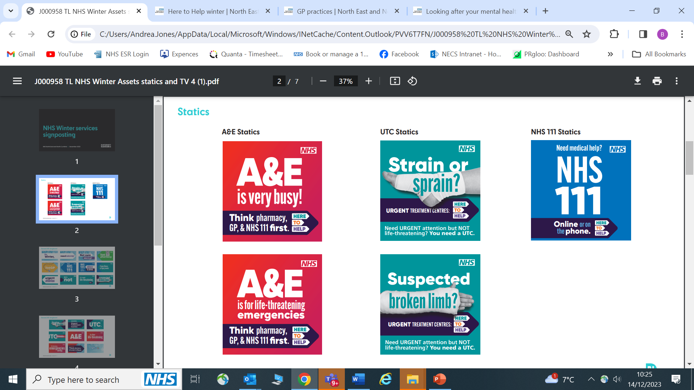

A&E
A&E departments are extremely busy!

Unless your condition is life threatening, PLEASE do not go to A&E.

Think pharmacy, GP or NHS111 first!

Too many people who come to A&E don't need to be there. Their illnesses and injuries can be dealt with quicker by an alternative service freeing up emergency services for those who really need them.

If in doubt, contact NHS111 online or by phone, to get assessed and directed to the right place for you - including emergency care.

If you go to A&E and your condition isn't life threatening, you may experience a very long wait.

