Communications toolkit - Cardiovascular (CVD) campaign!
Phase 2: Cholesterol awareness month – October 2024
(FINAL. 11/10/24)

About this toolkit

This CVD phase 2 toolkit is for GPs, pharmacists, NHS foundation trusts and partners across the North East and North Cumbria.
The campaign aims to encourage adults who are aged 40 or over and have not had a cholesterol check before or in the past 5 years to get a check by contacting their GP surgery.
This toolkit includes information and resources to use across your own channels to help raise awareness with patients. The online resources can be found here.
Your support in helping us to share these messages is very much appreciated.
For further help or advice on using this toolkit, or if you need support to tailor assets, please contact Anisah.sharmeen@nhs.net.
Overview
The following sets out our plans to communicate and raise awareness of cholesterol numbers and to encourage people to get their cholesterol levels checked. The campaign will focus on knowing the role of cholesterol numbers, the risks of higher cholesterol and encouraging people to get checked by contacting their GP surgery, or by having the NHS health check if over the age of 40.
Phase 2 of the "Keep Your Heart Healthy " campaign will launch during Cholesterol month in October. The campaign will use social media channels to reach the target audience, focusing on education, accessibility, and engagement.
Background
CVD is the leading cause of death worldwide, accounting for 17.9 million deaths each year and 31% of all global deaths.
The NHS Long Term Plan identifies CVD as a clinical priority and the single biggest condition where lives can be saved by the NHS over the next 10 years. The Plan sets the ambition for the NHS to help prevent over 150,000 heart attacks, strokes, and dementia cases over the next 10 years. Cardiovascular health is also one of the 12 clinical priorities set out in our Clinical Conditions Strategic Plan.

Campaign objectives
- Raise awareness of importance of regular cholesterol checks.
- Educate public understanding of cholesterol levels and the health risks associated.
- Encourage patients to book an appointment with their GP surgery.
- Promote lifestyle changes such as healthy eating, regular physical activity, and smoking cessation to manage cholesterol levels.
- Myth busting against statins and negativity around medication management.

Target Audience
- Patients at higher risk of CVD.
- Patients who typically don’t engage with health services.
- People living in most deprived areas of the region, ethnic minorities, age ranges typically 40+ and or also have a family history of high cholesterol.

Key messages
- Keep your heart healthy, know your cholesterol numbers and get your cholesterol checked.
- High cholesterol doesn't usually have any signs or symptoms, and it can be caused by your genes.
- High cholesterol can lead to heart attacks and strokes and is often called a silent killer.
- Positive lifestyle changes can help keep cholesterol levels healthy.
- There are a range of different medications available for high cholesterol, if medication is advised.
Toolkit contents (TBA)
This toolkit contains useful resources including social media graphics along with accompanying messages, visuals for GP waiting room and pharmacies, display screens and posters.
- Social media graphics and messaging
- Digital GP screen displays
- Clinical lead talking head video
- Shortform myth busting videos on statin medications (tba).

You can access all assets at: https://northeastnorthcumbria.nhs.uk/here-to-help/cholesterol-month-toolkit/
How can you support?
Please use this toolkit to:
• Support conversations with patients around encouraging cholesterol checks.
• Encourage patients to contact their GP surgery to arrange a cholesterol check if they are over the age of 40 – especially if they are in an at-risk group.
• If you have social media accounts, please help us by sharing the resources within this toolkit by posting on your social media channels and sharing assets with your groups and networks.

Social media messaging – download: https://northeastnorthcumbria.nhs.uk/here-to-help/cholesterol-month-toolkit/
Lower your cholesterol
1. | Don’t wait until it’s too late!  High cholesterol is often a silent killer with no symptoms. Getting a cholesterol check can help prevent heart attacks and strokes.  If you're aged over 40 and haven't had a cholesterol test before - or it’s been more than five years since your last one, please contact your GP surgery to book a quick and simple cholesterol test.  👉 https://www.nhs.uk/conditions/high-cholesterol/ | 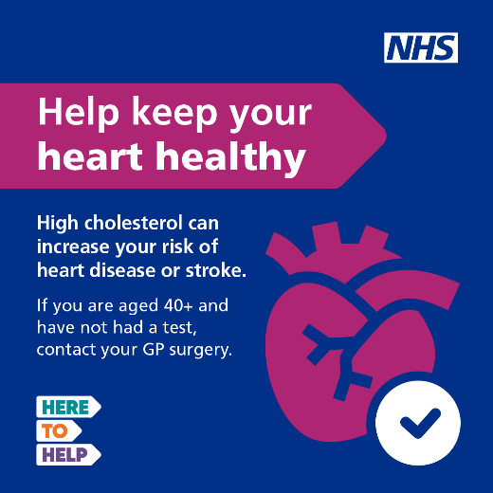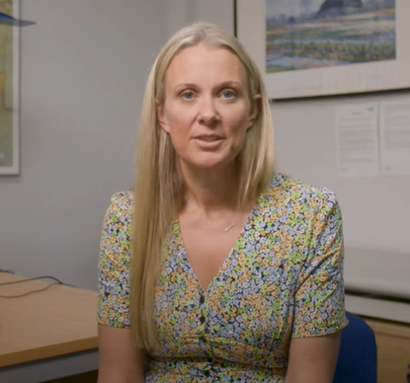  Dr Alex Kent video – cholesterol 2
2. | You have the power to protect your heart!  A simple cholesterol check can go a long way in preventing heart disease. Whether it’s at your GP surgery or during an NHS Health Check, make sure you know your cholesterol numbers.  If you're aged over 40 and haven't had a cholesterol test before - or it’s been more than five years since your last one, please contact your GP surgery to book a quick and simple cholesterol test.  👉 https://www.nhs.uk/conditions/high-cholesterol/ | 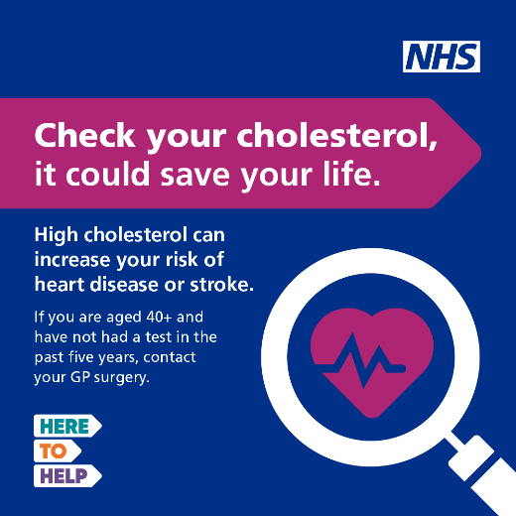
3. | Did you know high cholesterol can be caused by your diet, lack of exercise, or even your family history?  It doesn’t usually show symptoms, but it can block your blood vessels and lead to heart problems or a stroke.  If you're aged over 40 and haven't had a cholesterol test before - or it’s been more than five years since your last one, please contact your GP surgery to book a quick and simple cholesterol test.  https://www.nhs.uk/conditions/high-cholesterol/ | 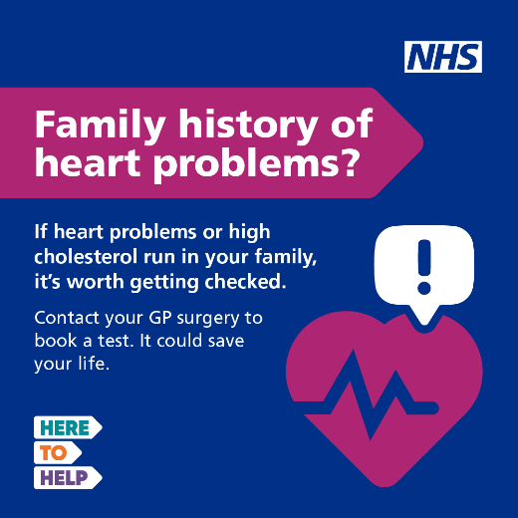
4. | Take control of your cholesterol!  Eating healthier, exercising more, and quitting smoking can all help lower your cholesterol levels. If needed, medication can help too.  High cholesterol doesn’t usually have symptoms, but it can lead to heart disease or stroke.  If you have a family history of heart disease, or are aged over 40 years and have not been tested in the last 5 years, please contact your GP surgery and get your levels checked with a simple blood test.  https://www.nhs.uk/conditions/high-cholesterol/how-to-lower-your-cholesterol/ | 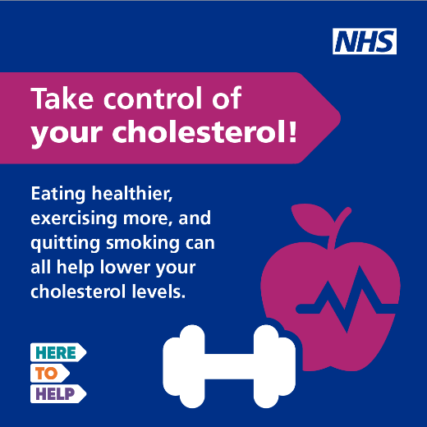  Dr Alex Kent video – cholesterol 4
5. | Are you aged over 40 and haven’t had a cholesterol test in the past 5 years? It’s important to get checked!  High cholesterol often doesn’t have symptoms, but it can increase your risk of heart problems or stroke. If heart issues or high cholesterol run in your family, it’s worth getting tested too.  You can get a cholesterol test at your GP practice, during your NHS Health Check (when eligible), or even at some pharmacies.  Take control of your health and get your cholesterol checked today—it could make a big difference! 💙  https://www.heartuk.org.uk/cholesterol/getting-a-cholesterol-test | 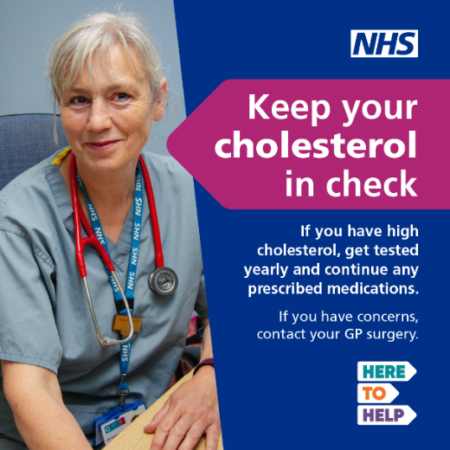
6. | If you’ve been diagnosed with high cholesterol, you can keep your cholesterol in check with healthy lifestyle changes like eating a balanced diet and staying active. For some people, medication may also be needed - and there are different treatment options available.  Contact your GP surgery to find the best treatment for you.  Don’t forget, a cholesterol check is the first step! It’s quick and easy, and you can get it done at your GP surgery or even at some pharmacies. | 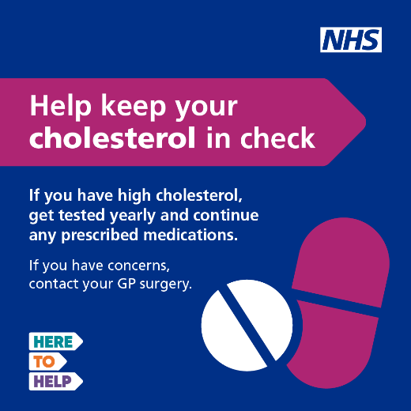
 | If you’ve been diagnosed with high cholesterol, it’s important you have a test yearly to keep it in control and continue taking your prescribed medication if needed. 💊  There are a variety of treatment options available – contact your GP surgery to find what’s best for you.  https://www.nhs.uk/conditions/high-cholesterol/ | Dr Alex Kent video – cholesterol 5
 | 🩺 Time for a Cholesterol Check? 🧡  If you're aged over 40 and haven't had a cholesterol test before—or it’s been more than five years since your last one—it’s time to book a test! 📅  It's especially important if heart problems or high cholesterol runs in your family. Early detection can make a big difference to your heart health! Contact your GP surgery to book a cholesterol test💖 | 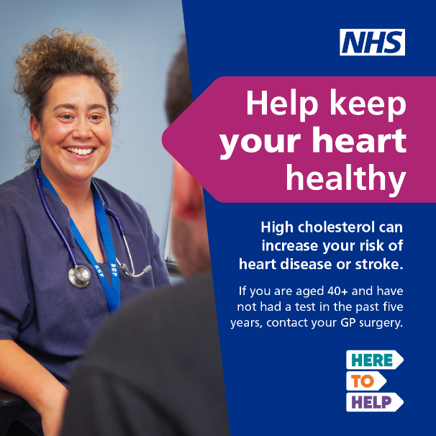  Dr Alex Kent video – cholesterol 3
 | 🧠💡 Did You Know?  Cholesterol is a type of fat found in our bodies, and while we do need some, there are both good and bad types. Too much bad cholesterol can increase the risk of strokes and heart attacks.  If you’re aged over 40 or haven’t had a check in the last 5 years, contact your GP surgery to book a quick and simple cholesterol test. | Dr Alex Kent video – cholestrol 1

