Find Your Place toolkit
Encouraging new medical trainees to our region

Introduction

The Find Your Place campaign aims to promote the North East and North Cumbria region as a place to live, train, work and thrive with one key goal to attract more medical trainees (with a focus on specialty training).

The campaign, built on insights, used a research led approach to understand what drives trainee decision making, and how we can influence them to step outside their comfort zones and head north.

The campaign's success - which has seen year-on-year improvements in trainee fill rates - is very much down to the engagement of all organisations across the region – who have joined the 'find your place' movement to promote the quality of medical training, the support on offer for trainees who do choose us, as well as the lifestyle on offer.

We still need your support!

This guide sets out how you can access content which you can use on your own channels, provides top tips on how to access this content, as well as sample social media messages etc.

All assets are available to download here https://northeastnorthcumbria.nhs.uk/find-your-place-toolkit/ and can be adapted within your own organisations.

We also have a dedicated Find Your Place website
https://www.nhsfindyourplace.co.uk/

Build our movement

Help us build our movement and raise awareness of the North East and North Cumbria region as a great place to train and live. Please feel free to create your own content and share it on your own channels. For example, this could be photos or videos from induction events or with your own trainees or short films with people within your organisations sharing their #toptipsfornewdocs. Find your place film book ends are also available in the toolkit.

Some questions you might want to ask?

- Why did you choose the North East and North Cumbria for your training?
- What advice would you give to new medical trainees who are about to start their training in our region?
- What's your top tip for places to visit and see when you get downtime?

Remember to tag us in and follow us!
For reference, our social media accounts can be found using the following handles and links:

Facebook - https://www.facebook.com/nhsfindyourplace
Twitter - @NHSFYP
Instagram - @nhsfyp
LinkedIn - @Find your place North East and North Cumbria

TikTok - @find.your.place.nenc

We ask that all trusts use our Twitter, Instagram, Facebook, TikTok and Linked in handles to tag us in all welcome posts to new medical trainees where possible.

Hashtags for the campaign - #findyourplace #medtrainees #northeastnorthcumbria

Please feel free to like and share from @NHSFYP across Twitter, Instagram and Facebook or schedule from your own social media accounts.

For any queries please contact:
alastair.railton2@nhs.net 07388014980 or sarah.mckellar3@nhs.net

The toolkit
Includes the following:

- Specialty films

These can be used to promote the fantastic medical specialty training offered by trusts throughout the North East and North Cumbria. Ideally aimed at foundation year doctors or year 4/5 medical students at universities.

Each film comes with a link to the relevant specialty page on our website.
Each specialty has a three minute video case study and two/three supporting 30 second films ideal for social media. The specialty's covered are:

- Histopathology
- Acute medicine
- Public health
- Dermatology
- Cardiology
- Trauma & orthopaedics
- Respiratory
- Psychiatry
- ENT
- Gastrointestinal
- Vascular surgery
- Anaesthetics
- Infectious diseases/microbiology
- Oncology
- Renal

- Quality of training content

Contains content showcasing additional opportunities available to medical trainees in our region. Opportunities include:

- Clinical teaching fellowship films

These can be used to promote the clinical teaching fellowship teaching positions for foundation doctors who want to add to their portfolio.

- Digital health opportunity films

These can be used to promote the digital health research positions for foundation doctors who want to add to their portfolio.

- Academic clinical fellowships

These can be used to promote the academic research positions for foundation doctors who want to add to their portfolio.

- North East Mentorship Scheme

A wellbeing and development offer available to all medical trainees.

- Lifestyle content
Contains content showcasing our region and things medical trainees can do in their downtime. Opportunities include:

- Getting the right balance animations

A series of animations promoting the affordable and quality lifestyle available in the North East and North Cumbria

- Affordable housing
- Great outdoors
- Easy connections
- Darkest skies
- Arts and culture
- Quality training
- Nightlife

Regional promotions:

- Hidden Gems and Dawn to Dusk films

Content *please edit to fit (twitter handles are included) | Image reference | Content description and possible tags
Meet Emmy Abu, a year five histopathology trainee who chose the North East & North Cumbria for its mix of city life, nature, and supportive medical teams. Find out why she loves it here!  Learn more #findyourplace  https://www.nhsfindyourplace.co.uk/doctors/training/our-specialties/cellular-pathology/ | 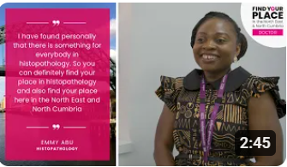 | Histopathology film  @NHSFYP  @nenc_nhs  @madeinheene
👩‍⚕️ Meet Alisha Gupta, a foundation year trainee in acute medicine. She values the supportive team culture and unique two-year research programme in the North East & North Cumbria. Discover why she chose this region!  Learn more #findyourplace  https://www.nhsfindyourplace.co.uk/doctors/training/our-specialties/acute-medicine/ | 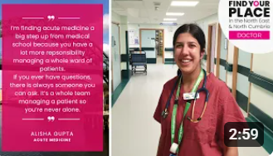 | Acute medicine film  @NHSFYP  @nenc_nhs  @madeinheene
🌍 Dr. Emer Cullen sees public health as a chance to make lasting changes at community level, focusing on prevention and behind-the-scenes impact. Find your place in this rewarding field!  Learn more #findyourplace  https://www.nhsfindyourplace.co.uk/doctors/training/our-specialties/public-health/ | 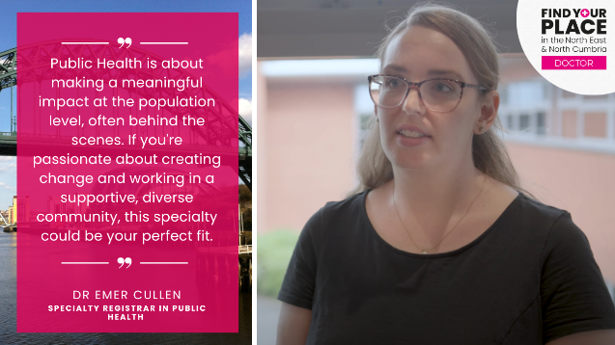 | Public health film  @NHSFYP  @nenc_nhs  @madeinheene
🏥 Dr. Mark Eisner shares why North East & North Cumbria is ideal for dermatology training—broad clinical exposure, research opportunities, and supportive mentors.  Learn more #findyourplace  https://www.nhsfindyourplace.co.uk/doctors/training/our-specialties/dermatology/ | 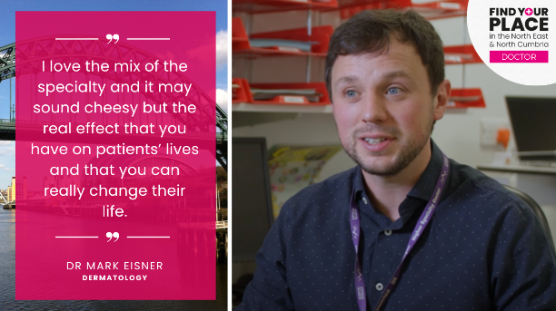 | Dermatology film  @NHSFYP  @nenc_nhs  @madeinheene
Listen to @paul_galaway, cardiology registrar talking about the care offered in the North East and North Cumbria❤️👨️👩‍  #findyourplace  https://www.nhsfindyourplace.co.uk/doctors/training/our-specialties/cardiology/ | 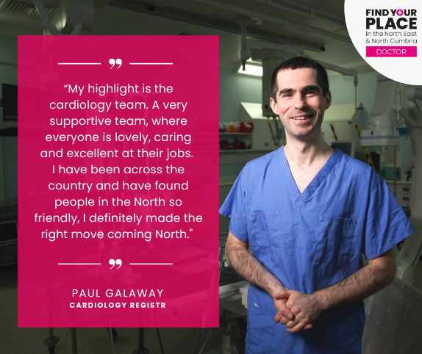 | Cardiology specialty film  @NHSFYP  @nenc_nhs  @madeinheene
🦴Interested in working in trauma & orthopaedics in the North East and North Cumbria? @MiloKostusiak shares insights on the supportive training on offer in our region that can shape your surgical career 💪🏥  #findyourplace  https://www.nhsfindyourplace.co.uk/doctors/training/our-specialties/trauma-and-orthopaedics/ | 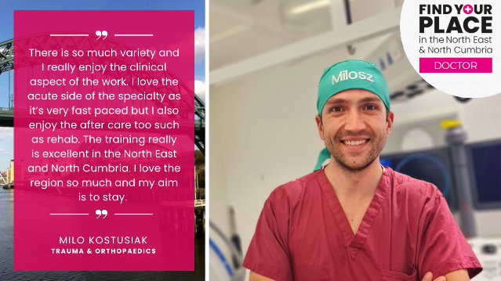 | Trauma and orthopaedics specialty film  @NHSFYP  @nenc_nhs  @madeinheene
🌟 Deciding which specialty to choose and in which region? Join Peter Ireland, a respiratory registrar, as he shares the opportunities for growth and impact in this specialty in the North East and North Cumbria 💨👨‍⚕️👩‍⚕️  #findyourplace  https://www.nhsfindyourplace.co.uk/doctors/training/our-specialties/respiratory/ | 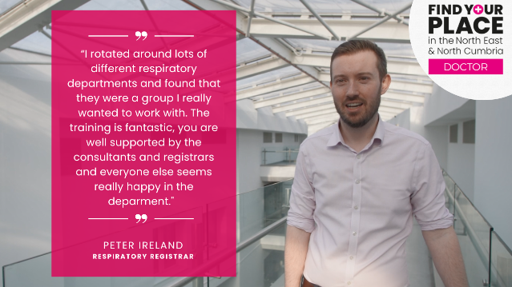 | Respiratory specialty film  @NHSFYP  @nenc_nhs  @madeinheene
👂👃👅 Amar Ragjor, an ENT registrar, highlights the incredible hands-on experience you can gain as a medical trainee in the North East and North Cumbria ENT department.  #findyourplace  https://www.nhsfindyourplace.co.uk/doctors/training/our-specialties/ear-nose-and-throat/ | 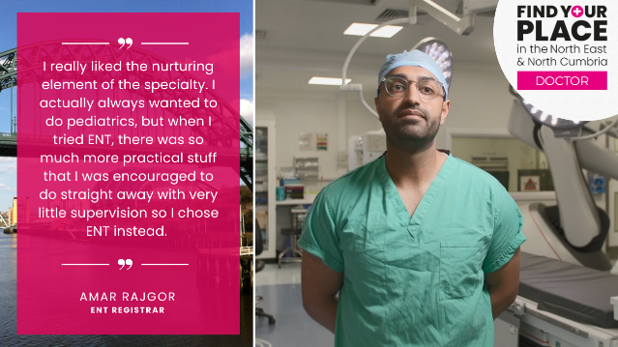 | ENT specialty film  @NHSFYP  @nenc_nhs  @madeinheene
🔬 Deciding which specialty to choose and in which region? Jeevan Barn, gastroenterology registrar, discusses how his specialty allows you to work with a variety of organs, making each day a new and exciting experience! 🌟👩‍⚕️👨‍⚕️  #findyourplace  https://www.nhsfindyourplace.co.uk/doctors/training/our-specialties/gastrointestinal/ | 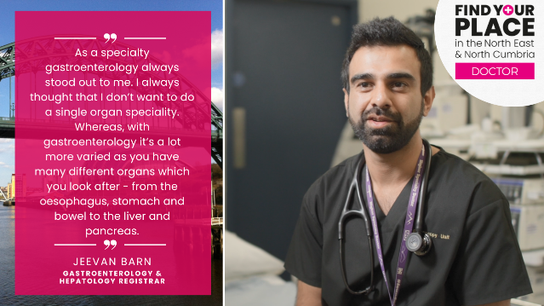 | Gastro specialty film  @NHSFYP  @nenc_nhs  @madeinheene
Deciding which specialty to choose and in which region? Check out this film about what's on offer in our region from consultant vascular surgeon, @JamesMcCaslin. 🚑  #findyourplace https://www.nhsfindyourplace.co.uk/doctors/training/our-specialties/vascular-surgery/ | 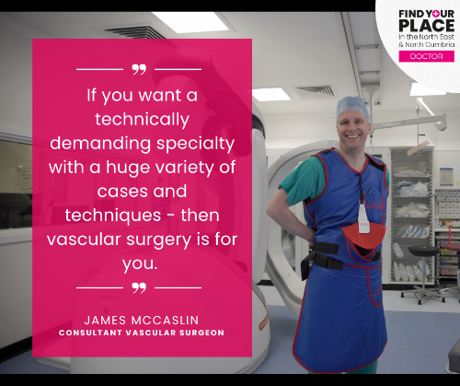 | Vascular surgery specialty film  @NHSFYP  @nenc_nhs  @madeinheene
🌡️ Join Julie James, a specialist trainee in anaesthesia, as she talks about the fantastic support network provided by the North East and North Cumbria anaesthetics teams. 🏥 This makes our region an ideal place for your medical training! 👩‍⚕️👨‍⚕️  #findyourplace  https://www.nhsfindyourplace.co.uk/doctors/training/our-specialties/anaesthetics/ | 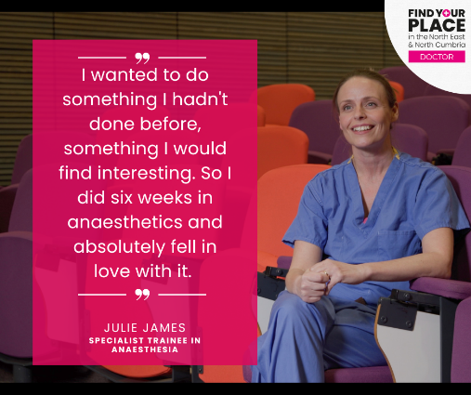 | Anaesthetics specialty film  @NHSFYP  @nenc_nhs  @madeinheene
🔍 Seeking a dynamic career in infectious diseases or microbiology? 🦠 Amy Belfield and Ashleigh McMaster have discover the unparalleled training opportunities in the North East & North Cumbria! And you can too!  #findyourplace  https://www.nhsfindyourplace.co.uk/doctors/training/our-specialties/combined-infection-training/- | 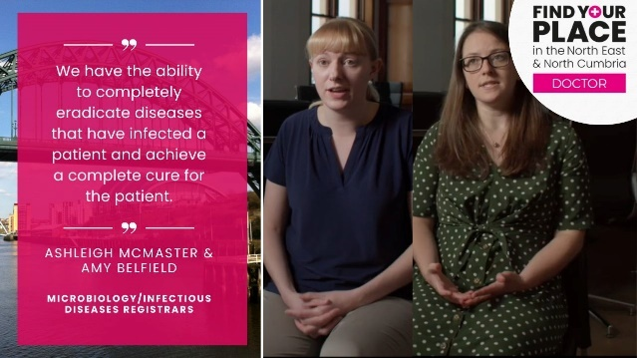 | Infectious diseases and microbiology specialty film  @NHSFYP  @nenc_nhs  @madeinheene
🌟 Interested in becoming a clinical teaching fellow? Discover the unique world of clinical teaching fellowships! Jess has gained one-of-a-kind skills and experiences that enrich her journey in medical education! 📚👩‍🏫  #findyourplace  https://www.nhsfindyourplace.co.uk/doctors/training/teaching-fellowships/ | 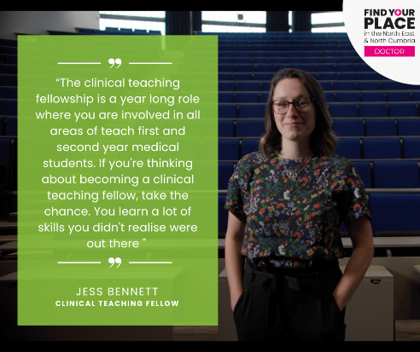 | Clinical teaching fellowships film  @NHSFYP  @nenc_nhs  @madeinheene
📚 Interested in becoming a clinical teaching fellow? Jonathon Foggin shares his story of how teaching in the North East and North Cumbria has boosted his self-confidence. 🌟👨‍🏫  #findyourplace  https://www.nhsfindyourplace.co.uk/doctors/training/teaching-fellowships/ | 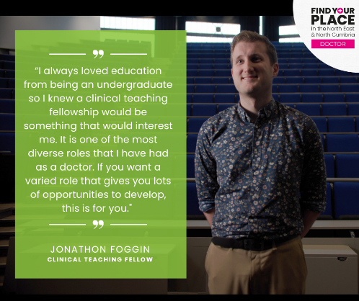 | Clinical teaching fellowships film  @NHSFYP  @nenc_nhs  @madeinheene
💻 Interested in digital health opportunities?! Explore opportunities that will shape your career and help you make a meaningful impact. 🚀👩‍⚕️👨‍⚕️  #findyourplace  https://www.nhsfindyourplace.co.uk/digital-health-opportunities/ | 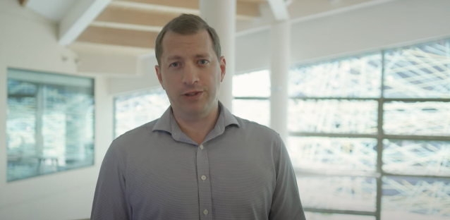 | Digital health opportunities film  @NHSFYP  @nenc_nhs  @madeinheene
North East & North Cumbria medical trainees can dive into arts & culture for a wellness boost! 🎨✨ Unleash creativity and find inspiration beyond the clinic! #findyourplace #gettherightbalance  https://www.nhsfindyourplace.co.uk/our-region/arts-and-culture/ |  | Arts and culture animation  @NHSFYP  @nenc_nhs  @madeinheene
🌌 Stargazers, rejoice! 🌠 Come and do your medical training in the North East and North Cumbria & in your downtime experience the darkest skies in Europe! 🌙⭐  #findyourplace #gettherightbalance  https://www.nhsfindyourplace.co.uk/our-region/star-attractions/ |  | Darkest skies animation  @NHSFYP  @nenc_nhs  @madeinheene
🌟 Want to do your medical training in a region consistently ranked highly in the GMC trainee survey? Join us in North East & North Cumbria! Exceptional medical training awaits you. 🏥💡 #findyourplace  https://www.nhsfindyourplace.co.uk/doctors/ | 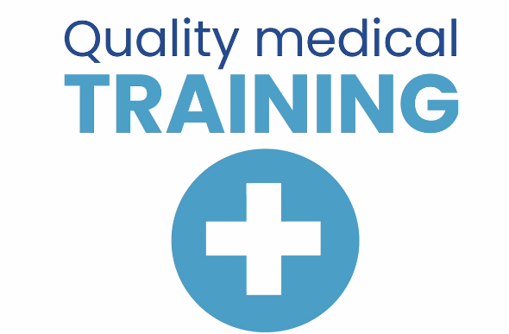 | Quality training animation  @NHSFYP  @nenc_nhs  @madeinheene
🏡 Are you a medical trainee looking for affordable housing? North East and North Cumbria have you covered! Your dream home awaits in this budget-friendly region! 🏠💰 #findyourplace  https://www.nhsfindyourplace.co.uk/our-region/cost-of-living/ |  | Affordable housing animation  @NHSFYP  @nenc_nhs  @madeinheene
🌿 Are you someone who likes exploring the great outdoors? Then head to the North East and North Cumbria! We are home to stunning landscapes, beaches, castles and hidden gems to explore, as well as quality medical training.🏞️🚵‍♂️  #findyourplace #gettherightbalance  https://www.nhsfindyourplace.co.uk/our-region/going-off-road/ |  | Great outdoors animation  @NHSFYP  @nenc_nhs  @madeinheene

